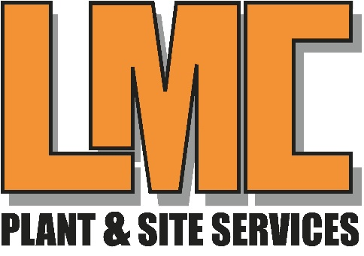

Health and Safety Policy Statement

Approved by Ryan Campbell

A paper copy of this policy is kept in the office

An electronic copy of this policy is available on LMC Plant & Site Services Website

A copy of this policy has been made available to the persons listed below, who are responsible for circulating this policy as appropriate to interested parties

- Employees, customers, suppliers, General public

By virtue of creating this interactive Health and Safety policy, LMC Plant & Site Services has ensured that it remains legible and is fully identifiable

This policy will be reviewed annually

Definitions
For the purposes for the document, the following terms apply:
Senior management is defined as the directors, officers and senior managers of the organization
Policy Statement
LMC plant & Site Services commits to:
- Provide adequate control of the health and safety risks arising from our work activities
- Consult with our employees on matters affecting their health and safety;
- Provide and maintain safe plant and equipment
- Ensure safe handling and use of substances;
- Provide information, instruction and supervision for employees;
- Ensure all employees are competent to do their tasks, and to give them adequate training and employees will be consulted directly on health and safety matters

Safe plant and equipment
Ryan Campbell will be responsible for:
- Identifying all equipment/plant requiring maintenance
- Ensuring effective maintenance procedures are drawn up;
- Ensuring that all identified maintenance is implemented; and
- Checking that new plant and equipment meets health and safety standards before it is purchased.
Problems with plant/equipment should be reported to Ryan Campbell
All employees are responsible for reporting problems with plant/equipment and for completing any maintenance tasks they have been assigned.

Safe handling and use of substances (COSHH)
Ryan Campbell will be responsible for:
- Identifying all substances that need a COSHH assessment;
- Undertaking COSHH assessments;
- Ensuring that all actions identified in the assessments are implemented;
- Ensuring that all relevant employees are informed about applicable COSHH assessments; and checking that new substances can be used safely before they are purchased
Assessments will be reviewed whenever the work activity changes

Information, instruction and supervision
The Health and safety Law poster can be found in the office
Health and safety advice are available from The Office
Supervision of young workers/ trainees will be arranged and monitored by Ryan Campbell
Young workers/ trainees will be supervised by Line manager.

Training and Competency
The Director will be responsible for:
Induction training
Job-specific training
Keeping training records;
Identifying training; and
Monitoring training
Training records are kept in the office

Accidents, first aid and work-related ill health
First aid boxes are kept in the following locations:
- office
- workshop
- side van door compartments
The appointed first aider is Ryan Campbell for the Workshop and Lisa Campbell of the Office; all accidents and cases of work-related ill health are to be recorded in the accident book. The book is kept in the office.
Ryan Campbell responsible for reporting accidents, diseases and dangerous occurrences to the local authority.

Monitoring
To check our working conditions and to ensure that our safe working practices are being followed, we will:
Regular checks, inspection, and investigations into accidents or near misses or ill health

Lisa Campbell is responsible for investigation accidents and work-related causes of sickness absences.
Lisa Campbell is responsible for acting on those investigation findings to prevent recurrence.
Emergency procedures
Ryan Campbell will be responsible for ensuring that the fire risk assessment is undertaken and implemented.
Ryan Campbell will be responsible for checking escape routes.
Ryan Campbell will be responsible for maintaining and checking fire extinguishers.
Ryan Campbell will be responsible for testing alarms.
Escape routes are to check every time location changes.
Fire extinguishers are to be checked every 12 Months
Alarms are to be tested every 12 Months.
Emergency evacuation will be tested every 6 months
Instruction;
- Prevent accidents and cases of work-related ill health;
- Maintain safe and healthy working conditions; and
- Review and revise this policy as necessary at regular intervals
Signed by Ryan Campbell, Director on behalf of LMC Plant & Site Services:
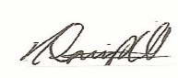

Responsibilities
The overall and final responsibility for health and safety is that of the company director

All employees must:
- Co-operate with supervisors and managers on health and safety matters;
- Not interfere with anything provided to safeguard their health and safety;
- Take reasonable acre of their own health and safety; and
- Report all health and safety concerns to an appropriate person or a director of the company.

Arrangements
Risk assessment
Risk assessment will be undertaken by all employees.
Findings of risk assessment will be reported to Ryan campbell.
Actions required to remove, or control risks will be approved by Ryan Campbell.
Ryan Campbell will be responsible for ensuring that the actions required are implemented.
Assessments will be reviewed whenever the work activity charges.

