How to sew a DIY Drawstring Backpack
You’ll need ½ yard of quilting cotton for the main fabric, 2/3 yard of quilting cotton for the lining fabric, and 4 yards of cotton rope or cording.

Some terms to know
If you’re new to sewing, here are some terms that will be helpful to know:
Raw edge –An unfinished edge of a piece of fabric
Right sides together – Placing layers of fabric with their right sides (the pretty sides) facing each other.
Seam allowance – The distance between the seam and the raw edge. If we say, “sew with a ½” seam allowance”, make your stitch line ½” from the raw edge.
Baste– Sewing temporary stitching to hold layers together until more permanent stitches can be sewn. Sometimes basting stitches are large stitches sewn by hand and are later pulled out. In our project, though, basting will be just regular machine stitches that won’t be visible in the final product.
Now let’s get started!

Supplies:
Outer Bag – 2 pieces, 13” wide x 17” tall from your main fabric
Lining – 2 pieces, 13” wide x 17” tall of your accent fabric
Casings – 2 pieces, 12” wide x 3” tall from your accent fabric
Tabs – 1 piece, 12” wide x 2” tall from your accent fabric OR 12” of grosgrain ribbon or twill tape
Cotton rope or cording – 2 pieces, 66” – 70” long
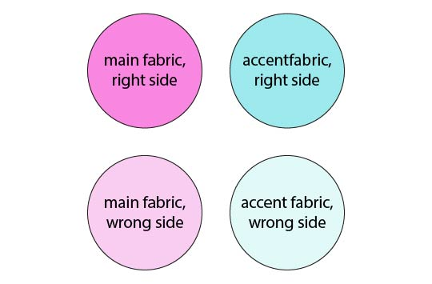

Sew the tabs – Optional
If you are using grosgrain ribbon or twill tape for the tabs, you can skip this section and just cut the ribbon into 3 pieces: 6”, 3” and 3”.
Press the Tab piece (12” wide x 2” tall) in half lengthwise, then open up and fold long edges to the center and press again.
Stitch close to the edge down both sides.
Cut the strip of fabric into 3 pieces: 6”, 3”, and 3”.

Sew the hanging loop – Optional
Take the 6” tab strip (or piece of ribbon) and place the ends side by side centered along the top of one of the Outer Bag pieces, raw edges aligned and right sides up. (The loop will be pointed down.)
Baste in place with 1/4” seam allowance.
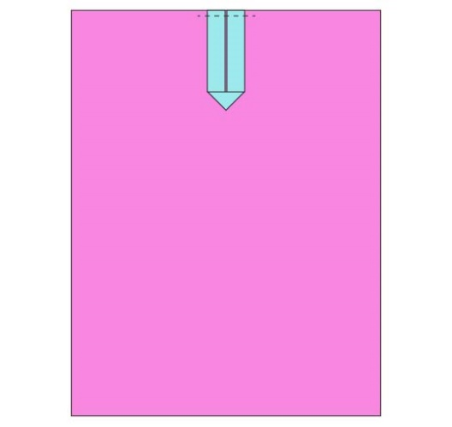

Sew the casings
Press the ends of the Casing pieces ½” to the back. Stitch down close to the edge.
Fold the Casing pieces in half lengthwise, with wrong sides together.
Place the Casings across the tops of the Outer Bag pieces, centered and with raw edges aligned. Baste in place with ¼” seam allowance.
If you chose to add the optional hanging loop, the Casing will be layered over the loop.
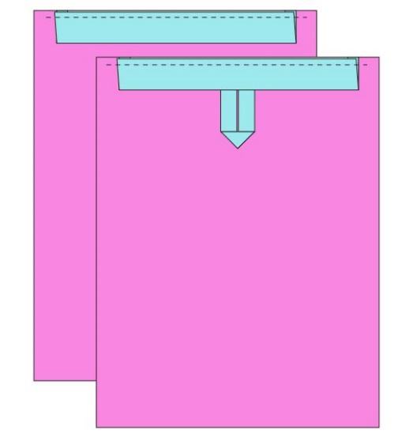

Baste down the tabs
Place one of your Outer bag pieces right side up.
Fold one of the 3” long Tab strips in half, and place it along the left edge of the Outer bag piece, 1” from the bottom and with raw edges aligned. (The loop will be facing the inside of the bag.)
Baste in place with a ¼” seam allowance.
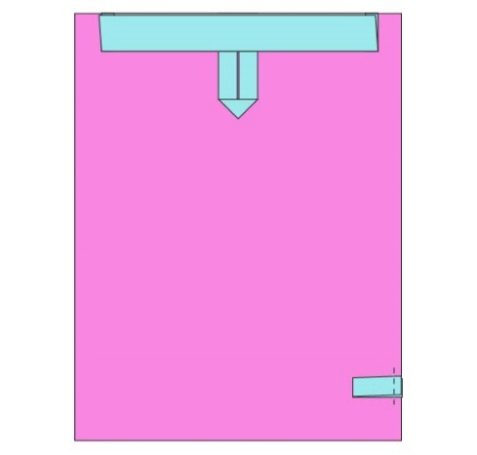
Repeat with the remaining 3” long Tab strip on the right edge of the Outer bag piece.
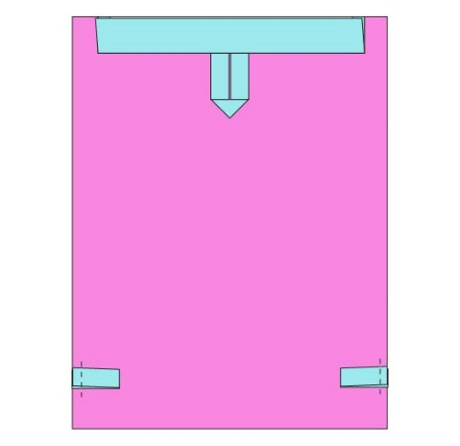
Sew the outer bag
Place the Outer Bag pieces right sides together.
Sew around the sides and the bottom with a ½” seam allowance. Leave the top open.
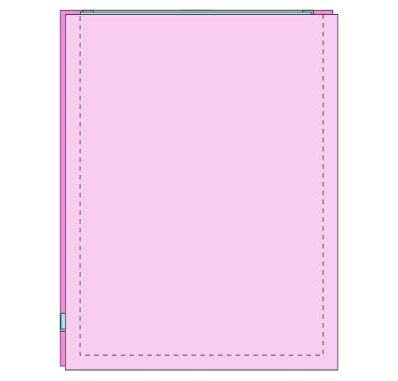
Clip off the seam allowance at the corners. Cut close to but not through the stitch line. Clipping the corners reduces the bulk of fabric in the corner when you turn it right side out.
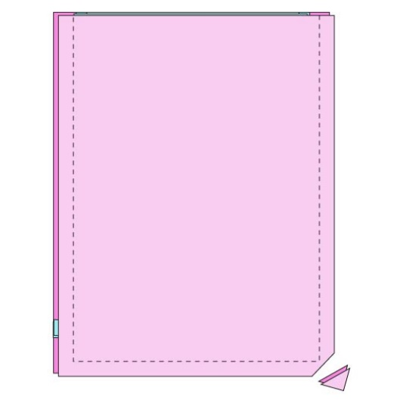
Turn the Outer Bag right side out.

Sew the lining
Place the Lining bag pieces right sides together.
Sew around the sides and the bottom with a ½” seam allowance but leave 3” open on one of the sides. This will create a hole you’ll use to turn the bag right side out later.

Assemble the bag
Place the Outer Bag inside the Lining, with right sides together. Sew all the way around the top of the bag with a ½” seam allowance.
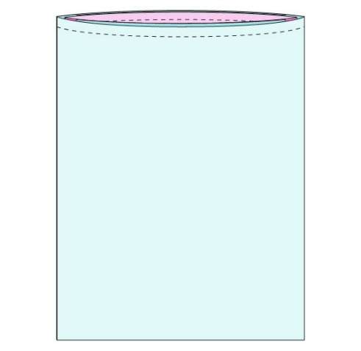
Turn the bag right side out through that hole in the side of the Lining. Don’t push the Lining down inside the Outer Bag yet.
Now let’s close that hole. Press the raw edges to the inside of the hole. Sew the hole closed, close to the edge.
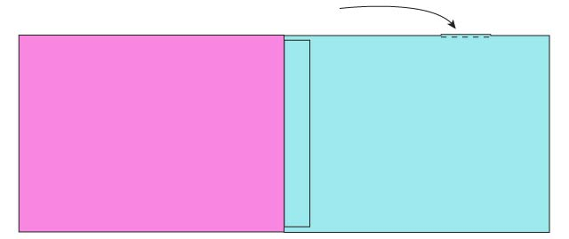
NOW push the Lining down inside the Outer Bag.
Finally, let’s thread the cord through to the casings to make the drawstring.
Thread one of the pieces of cording through one casing, back through the other. Thread one of the ends through the tab at the bottom. Tie the ends together in a knot.
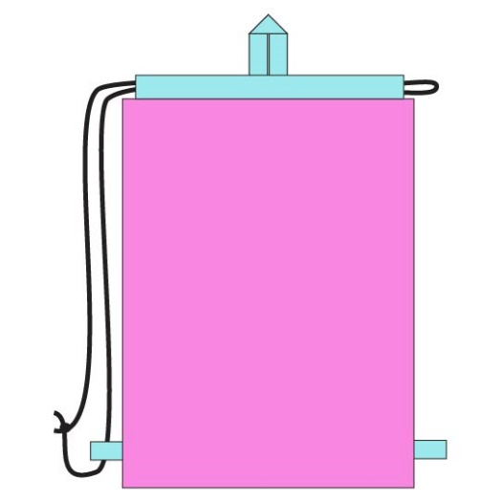
Repeat with the other piece of cording, but starting on the opposite side of the pouch.
