SLAMM 2020 COLLEGE INTERN ORIENTATION: May 27 – June 5
SLAMM 2020 for Refugee and Immigrant Youth Ages 6-15: June 8 – August 7

SLAMM VISION Refugee youth who are academically supported and inspired to be successful in school and confidently pursuing future individual goals

SLAMM MISSION Provide summer literacy and enrichment experiences for refugee and immigrant youth that lead to increased literacy and school success

SLAMM COLLEGE INTERN GOALS To create community, have fun, and grow in professionalism as we lead volunteers and participants in a summer of: Leadership, Learning, and New Experiences

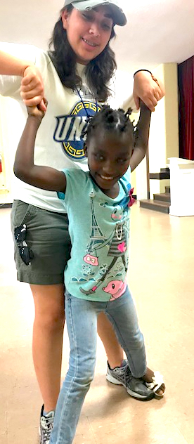
New Arrivals Institute (NAI) is located at Peace United Church of Christ 2714 West Market Street in Greensboro, NC and seeks college interns to plan, lead and manage a summer literacy-based program under the direction of NAI staff. SLAMM (Summer Literacy Art Music and Movement) offers refugee and immigrant youth opportunities to improve their literacy in a fun, inclusive environment. SLAMM takes place Monday through Friday and intern hours are 9:00am to 1:00(or later). Interns may serve 2-5 days per week. The program includes literacy activities, science, technology, soccer, art, crafts, financial literacy, dance, drama, music, Legos, and more.

View the NAI website at www.newarrivalsinstitute.org and Contact Lynn Thompson, NAI Community Engagement Director, at lthompson@newarrivalsinstitute.com
