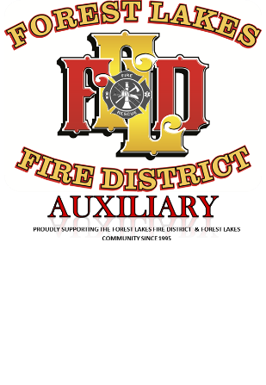
Our mission is to raise funds to support the
Forest Lakes District and Emergency Medical
Services and act as a liaison between the Fire
District and the community

Membership year Jan 1 - Dec. 31, 2022
Type - Single $6 ________Family $10_________
Please list all household members 18 or older:
Last Name __________________ First______________
___________________ ______________
___________________ ______________

FILL OUT BELOW PORTION ONLY IF YOU ARE A NEW MEMBER OR YOUR PERSONAL INFORMATION HAS CHANGED
Local contact information
Address_________________________________
City____________________ State__________ Zip Code _________
Home phone__________________ Cell phone _________________ Email___________________________
Other contact information
Address__________________________________
City ____________________ State__________ Zip Code_________
Home phone________________ Cell phone___________________
Email__________________________
Are you a Full time or Summer resident? Full-time ____ Summer ____

Please submit completed application by mail to the Forest Lakes Fire District Auxiliary PO Box 2015 Forest Lakes, AZ 85931. Or you can drop off the application and dues at the Fire Station during normal business hours.

