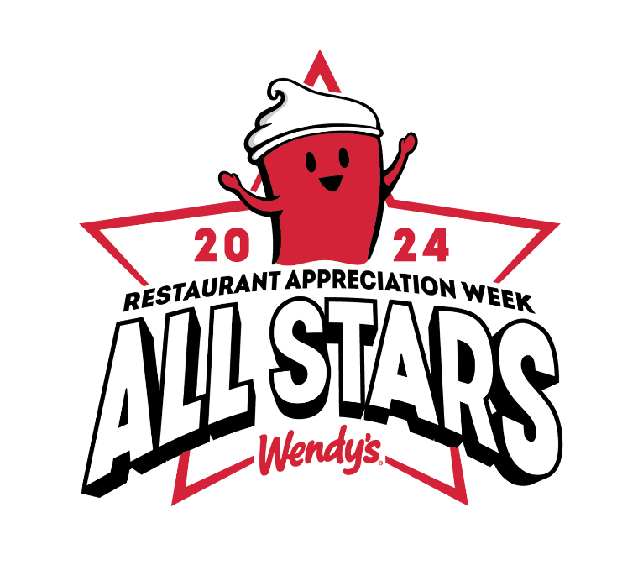
For your excellent performance, your dedication to the Wendy's brand and providing great service to each and every customer.

8641, Broadway

Site:
Selected by:

