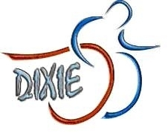
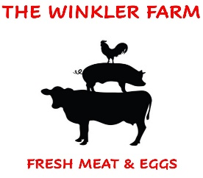2023 WINKLER FARM INVITATIONAL/DIXIE GAMES

Sponsorship Levels
Event October 14, 2023

GOLD
$2,000 plus
Recognition on Dixie Website, premium size and placement of logo on banner, name on T-Shirt

SILVER
$1,000 plus
Recognition on Dixie website, excellent size and placement of name on banner, name on T-Shirt

BRONZE
$500 plus
Recognition on Dixie website, good size and placement of name on banner, name on T-shirt

CONTRIBUTING SPONSOR
$250 plus
Recognition on Dixie website, placement of name on banner, name on T-Shirt

FRIENDS OF WINKLER FARMS AND DIXIE GAMES
$100 +/-
Recognition on Dixie website,

Contact: Meet Director, Scott Winkler
Scottwinkler73@gmail.com

