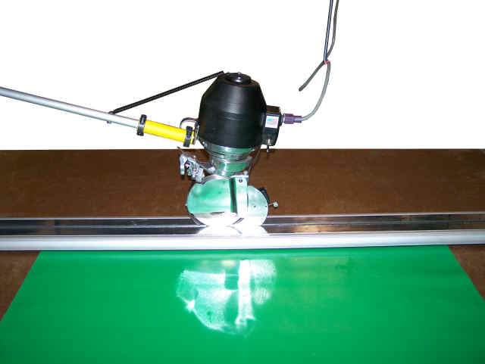
M-105 Manual Heavy Duty End Cutter
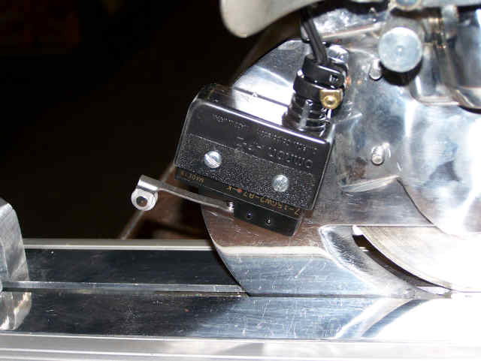
The Maimin model M-105 heavy duty end cutter operates like the traditional K-105 and adds a linear ball bearing rail for stability and accuracy. Like the K-105, an end-rail holds the fabric, allowing the operator to quickly and accurately cut the fabric along the cutting rail at the other end of the lay. Each ply receives a right angle cut at the same length, and the system is adjustable to any length of lay.

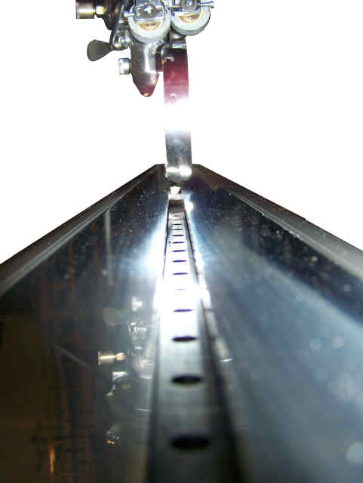
With the addition of the linear ball bearing rail, we are able to mount any cutting machine to the rail giving you the ability to cut just about any type of fabric, synthetic, non-woven or other industrial material. The cutting machine is also mounted inside a heavy duty aluminum track and secured to the linear rail with two ball bearing blocks. The stability and accuracy of this system is unmatched with any other end cutting system available.

The M-105 system is also available with an automatic-on home position switch. When the operator pulls the machine from the home position, the machine automatically starts and is immediately ready for cutting. This feature eliminates the need for a handle switch that must be held by the operator during the cut cycle (eliminating operator fatigue).
Semi-Automatic Heavy Duty End Cutter M-205
Maimin Technology is proud to introduce the M-205 Semi-Automatic Heavy Duty End Cutter. Featuring a touch screen operator interface, variable speed motor control, and linear ball bearing track system, the M-205 is the most accurate and versatile end cutter available. The M-205 can be manufactured to any length cutting track and works with any Maimin cutting machine.

The variable speed motor control enables the operator (this feature may be password protected for management only) to control the speed in which the machine is sent across the track. Adjusting this speed can allow for accurate cutting of thicker lies (more plies at once) and more difficult to cut industrial fabrics. The touch screen allows the operator to control cut length and speed and features a ply counter, countdown function, sharpening function, and a lifetime counter.

M-205 Straight Knife Heavy Duty End Cutter

Maimin Technology is the only manufacturer to offer a straight knife variable speed end cutter. The M-205 Straight Knife, featuring a touch screen operator interface, variable speed motor control and linear ball bearing track system, is perfect for exact cuts on taller lays of material and items such as cushions. The M-205 Straight Knife can also be manufactured for any length cutting track and works with any Maimin cutting machine.
M-405 Fully-Automatic Heavy Duty End Cutter

For ultimate efficiency, this end cutter offers all of the features of the M-205, plus completely automatic cut and lift functions. The operator sets the machine to cut only the exact number of plies required. Then, the operator draws the material from the roll, over the cutting track, and on to the end of the table (or pull). A touch of the button sends the cutting head across the track, cleanly cutting the fabric. The machine then automatically lifts and lowers, locking the newly cut fabric into place.

