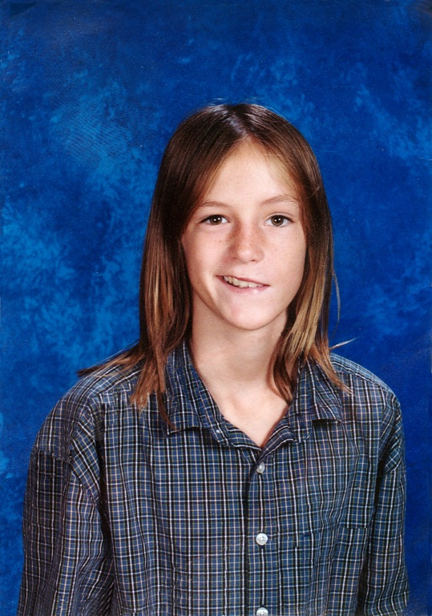
Michael Abt Jr. Have a Heart Foundation
1322 U.S. Highway One
Sebastian, FL 32958
www.haveaheartformichael.org
CH21741

November 1993------------March 2006

Thank you for contacting us about equipping yourself with the knowledge to save a life! Please fill out the questionnaire below and email or fax back to us. A representative from our organization will contact you after it has been received.
CPR/AED Training Scholarship Application
Name: __________________________________________ Date: _________
School or Sports Program Name: ____________________________________
Title: _______________________ Phone: _____________________________
Email: __________________________________________________________
Why do you want to learn CPR/AED? ________________________________________________________________________________________________________________________________________________________________________________________________________________________________________________________________________________________
Have you been trained before? Y_____ N_____
If so, how many times and how long ago? _____________(Qty) _______________________________________________________________(When)
Is being trained in CPR/AED a required certification through your school or Sports
Program? Y _____ N _____
Approximately how many students/children are in attendance? ___________________
Approximately how many other staff are CPR/AED trained? ______________________
Does your School or Sports Program have a Cardiac Emergency Response Plan (CERP) in place? Y_____ N_____
Do they practice a drill of this CERP?
If so, please describe in short detail what they do and how often __________________________________________________________________________________________________________________________________________________________________________________________________________________
If not, would you be willing to implement a plan into your School or Sports Program?
Y _____ N _____
Any additional comments that you feel may help your application?____________________________________________________________________________________________________________________________________________________________________________________________________________________________________________________________________________________________________________________________________________________________________________________________________________________________________________________________________________________________________________________________________________________________________________________________________________________________________________
Phone:772-589-0435 Fax:772-589-0997 Email: melfishermuseum@comcast.net

