BUILDING A WEB PAGE TO COMPLEMENT YOUR TURTLE TOUR
Here we have provided an example of how your Turtle Tour webpage may look like. You may use this as a guide and edit as needed to fit your Local Council’s needs and context.
This page acts as an additional educational resource for your community and visitors to the turtle tour. You may wish to embed this page within your Local Council’s website. Hope you find this helpful.

Main Heading: Welcome TO 'TURTLES OF LAKE ALEXANDRA' TOUR PAGE!
Are you ready to embark on your Turtle Tour? As you go around Lake Alexandra, you will find five signages that will help you learn more about the local turtles found at this Lake.
This is a self-paced tour has been put together by the 1 Million Turtles Community Conservation Program and [Insert name of your Local Council].

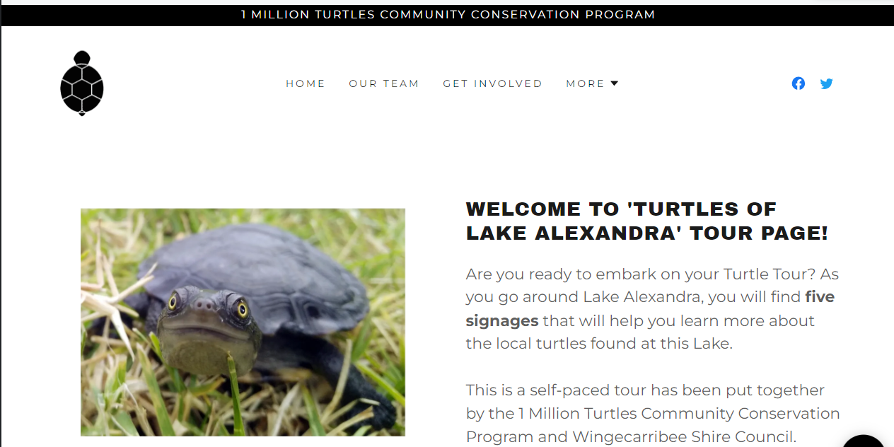

Main Heading: What's in store for you on this page?

Sub-Heading: Turtle Species

Click 'Learn More' to find out about the turtle species living at Lake Alexandra.

Sub-Heading: Learn more about Turtles

In this section, you will learn more about the importance of turtles, the threats they face and what is a turtle island?

Sub-Heading: Turtle Behaviour
In section, you will learn more about why they bask and more about their nesting habits.

Sub-Heading: Report Turtle Sightings
Running a holiday sale or weekly special? Definitely promote it here to get customers excited about getting a sweet deal.

Sub-Heading: Ways you can help
Have you opened a new location, redesigned your shop, or added a new product or service? Don't keep it to yourself, let folks know.

Sub-Heading: Share Pictures of You in Action
Customers have questions, you have answers. Display the most frequently asked questions, so everybody benefits.

See an example of page set up for this section below:
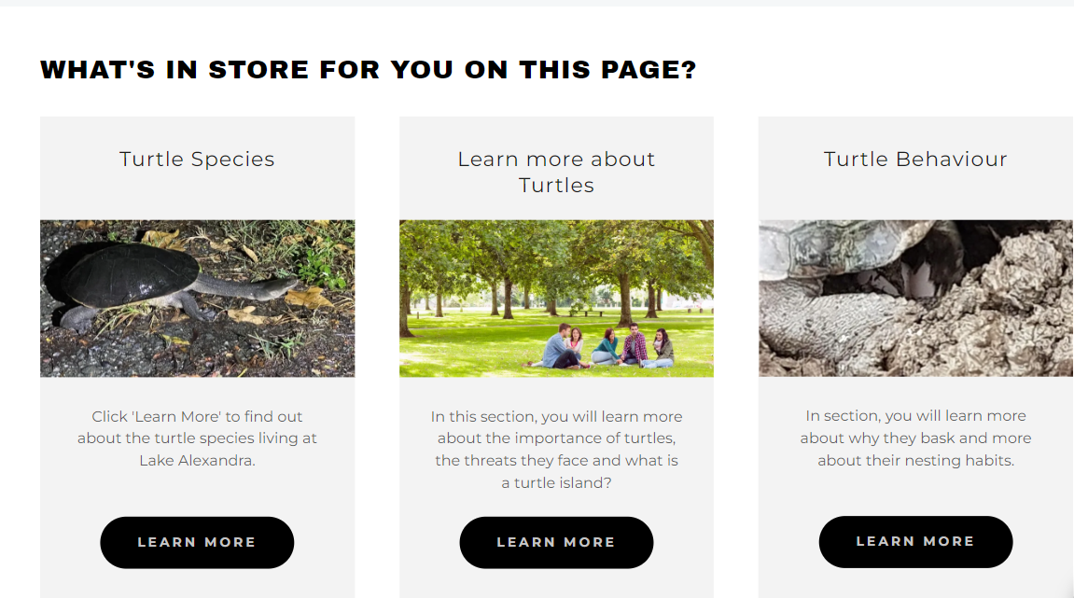

Main Heading: WHICH TURTLE SPECIES LIVE AT THIS LAKE?

Sub-Heading 1: Eastern Long Neck Turtle (Chelodina longicollis)
Australia is home to 23 species of freshwater turtle. In New South Wales, 7 of these species can be found. Freshwater turtles in Australia can be divided into long-necked and short-necked turtles. The Eastern long-neck turtle is one of the two native Australian freshwater turtle species found at Lake Alexandra.
- Adults can grow as large as a bread plate.
- They have black markings on their underside known as ‘plastron’.
- Commonly seen on land.
- In the wild, they can live up 75 years.
- Diet: Bugs, shrimp, dead fish.
- Most significant threats faced by them - Being run over by cars. pick them up and move them across the road if you can stop.
- Conservation status in Australia- Considered common but have had the most significant declines in many areas.
- Distribution- Throughout most of eastern Australia, but check the light green icons on TurtleSAT. it is the most common turtle recorded.

Sub-Heading 1A: Did you know?
When you pick them up off the road they can smell very 'musky'. They might "pee' on you. BUT it is neither pee nor poop. If you get wet, it is only water that they can carry as they walk across land and the smell is actually a small amount of liquid coming from the near their legs- a bit like BO, but it is to warn off predators. See an example of page set up for this section below:
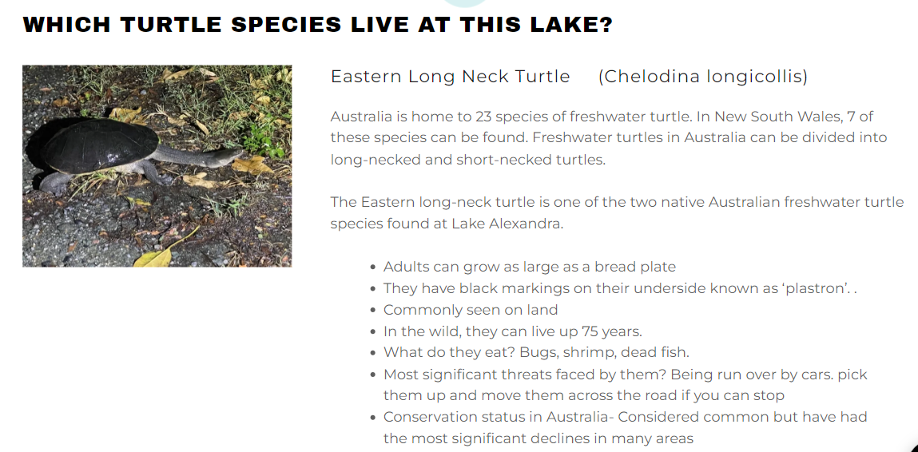

Sub-Heading 2: Short Neck Turtle (Emydura macquarii)
This is the other native Australian freshwater turtle species found at Lake Alexandra.
- Adults can grow to the size of a dinner plate.
- Conservation status in Australia- common but also suffered significant declines
- Distribution- South- Eastern Australia and the Murray -Darling
- They are rarely seen on land but often be spotted basking on logs.
- They have a short and broad neck compared to the eastern long neck
- In the wild, they can live up 75 years.
- Diet: They love to eat plants and algae, but they love to eat dead fish and anything else that they can catch.
- Threats: Most significant threats faced by them - foxes eat their eggs and kill nesting females too.

Fun Facts: Their eggs can communicate with one another underground. We don't know how, but they can coordinate to hatch at the same time.

Sub-Heading 2A: Did you know?
Despite their declines in their native range, they have flourished in some east coast rivers where they don't normally occur. It is why we say not to move turtles too far when you move them away from danger. These turtles were likely introduced to these east coast rivers by people moving them off highways in a different catchment. See an example of page set up for this section below:

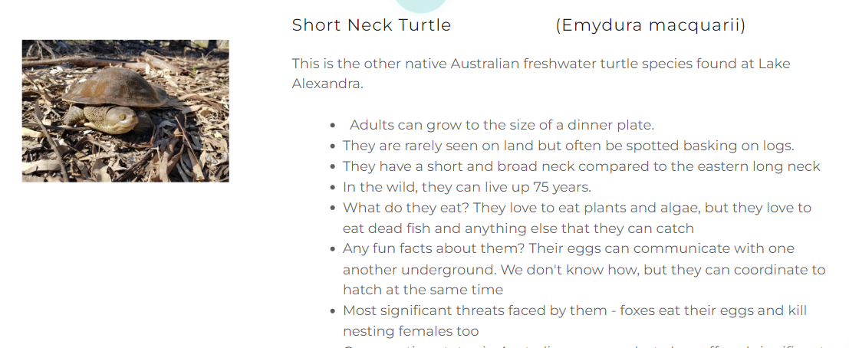

Sub-Heading 3: Red-eared slider – introduced
This is an introduced species. Fortunately, there have been no sightings of Red-eared Sliders reported at Lake Alexandria but we encourage you to always keep your eyes peeled for this species.

This species poses a threat to our freshwater species across Australia. So, if you spot them anywhere else – please report your sightings to TurtleSAT. See an example of page set up for this section below:

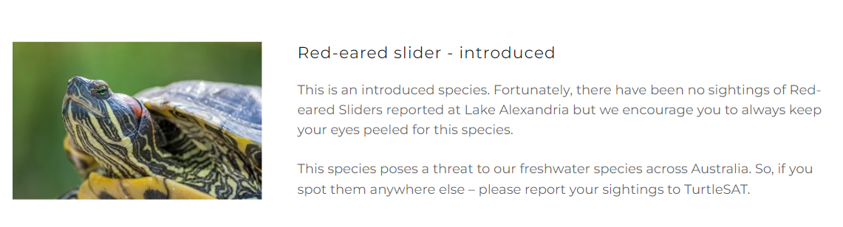

Main Heading: Why are turtles important?
Turtles are an important species for our waterways and wetlands. They act as a vacuum to help maintain the health of a waterways. Research at Western Sydney University has shown that they are vital to maintain water quality after a fish kill because they quickly clean up the river of dead fish.

Main Heading: Threats faced by turtles

Sub-Heading: Threat 1: Predation from feral species such as foxes and pigs
Turtle nests are vulnerable to fox and pig predation. Foxes destroy up to 95% of turtle nests. Our ‘National Nest Predation Survey’ studies the impact of such feral species on our turtle species.

If you are keen to get involved and get trained as a citizen scientist, please visit our nest predation survey page to learn more.
Foxes and pigs have been found to easily detect turtle nests, dig their nests up and eat the eggs laid in them. This can happen relatively quickly when a female turtle leaves her nest.
If you find any damaged or intact turtle nests, it is important to record your sightings into TurtleSAT, which is a data collection platform designed and used by 1 Million Turtles program to collect data on freshwater turtles across Australia. TurtleSAT is available in a web version and a mobile app (for both iPhones and Androids).
Keen to join us as a citizen scientist and help protect turtle nests? Visit our Nest Protection page for more information about how you can get involved.

Sub-Heading: Threat 2: Habitat Loss
Drought, urbanisation, and other land use factors have resulted in the loss of habitat critical for freshwater turtles to survive and thrive. With increasing human population, it is likely that unless we protect available habitat, it is anticipated more habitat may be lost over the coming years.

Sub-Heading: Threat 3: Hit by moving vehicles
In our warmer months turtles emerge from the water to bask and to nest. On the side of the lake that is closer to the roads, it is likely that turtles will cross the road to nest in the park area on the other side of the road. This leaves them vulnerable to being hit or run over by moving vehicles on the road. Drive slowly around any wetland or water bodies such as rivers, creeks, and lakes during peak nest season (i.e., November). See an example of page set up for this section below:

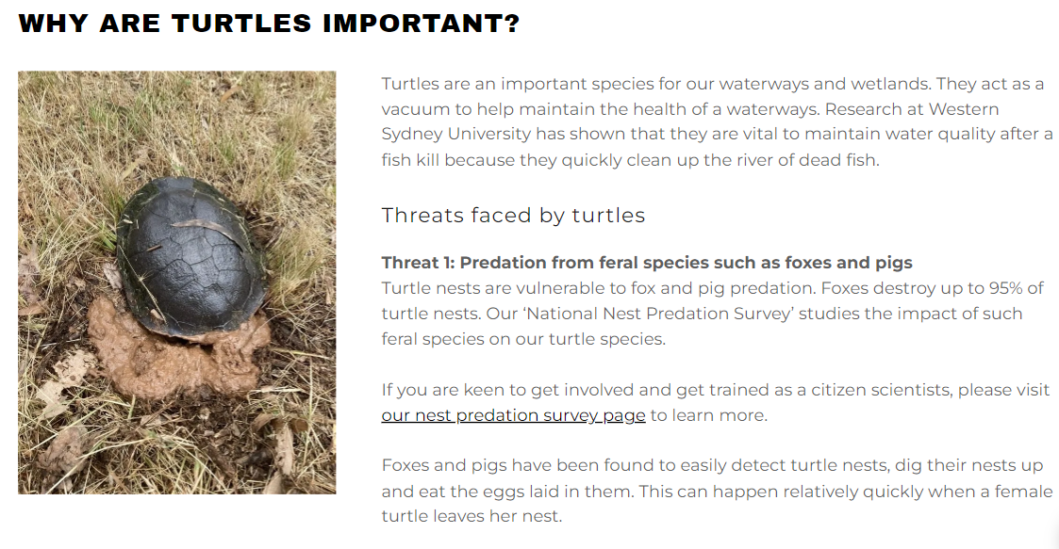

Main Heading: What is a ‘Turtle Island’ and why is it important?
See that patch of flat ground in the Lake? You are looking at the ‘Turtle Island’! This island is home to many species which nest here such as turtles, birds and water dragons. During peak nesting seasons (i.e., November), keep a close lookout to catch the wonderful sight of a female turtle nesting. Remember, when you do witness that, keep your distance and keep noise levels to a minimum so that she is not disturbed or stressed. The safety of the island provides a fox free zone for turtles to nest and repopulate Lake Alexandra. See an example of page set up for this section below:
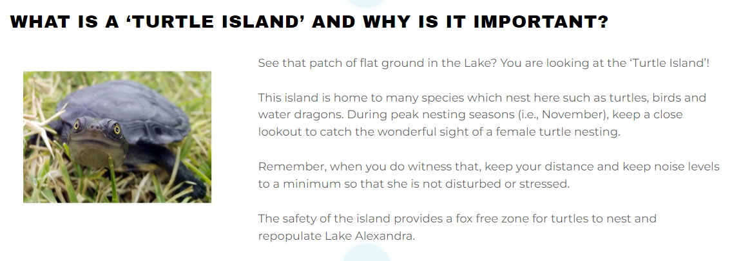

Main Heading: TURTLE BEHAVIOUR

Sub-Heading: What happens when turtles nest?
Turtles need to come out of the water to nest. During late spring and early summer, particularly during storms and rains, they will emerge from the water. The female turtles need to find a nice open area to construct its nest.
Once the female turtle has found a suitable spot - she digs a hole with her back legs and drops up to 20 eggs into the hole. She then fills the hole with the loose soil (from the initial digging of the hole). The hatchlings usually emerge about 2-3 months later but this duration may vary depending on the species. For example, it is also likely that it can take up to 12 months before emerging.

When walking around the lake during the nesting season, you may spot a female constructing her nest. If you witness this, it is important to stop and move slowly around the turtle. We recommend that you try and keep 10-15m away to quietly enjoy watching her create the nest.

Important: Please keep your dog away from turtles and let others know (as you pass them) about the turtle that is nesting nearby.

Once the female turtle has completed building her nest, she will raise up on her back legs and drop herself on the soil to flatten it. She will repeat this a few more times. This act helps to disguise the nest and makes it very difficult to find it. However, despite this – foxes and pigs have been found to be quite capable in detecting and damaging turtle nests. See an example of page set up for this section below:

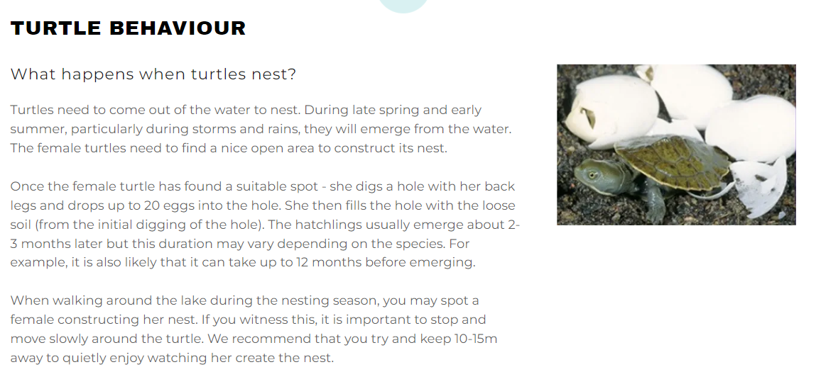

Sub-Heading: When is the best time to see a female turtle nesting?
To view turtles nesting, the best time to come and visit is Spring and early summer each year. Particularly after and during a storm or rain. We highly recommend that you bring your binoculars to enjoy this beautiful sight while keeping a good distance. See an example of page set up for this section below:
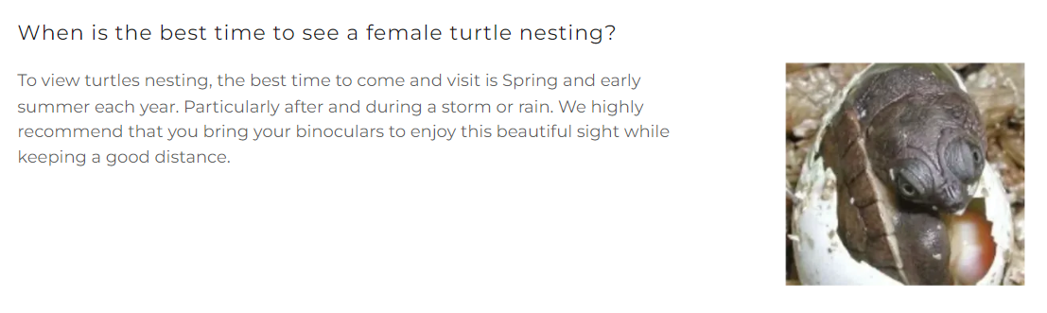

Sub-Heading: Why do turtles bask and where can I see them?
Turtles are ectothermic, meaning they need external sources to remain warm. Hence, you can find them typically basking on warm surfaces such as logs and rocks. When you spot a turtle basking, we recommend keeping noise levels to a minimum and move slowly to avoid startling them or else they will disappear into the water. See an example of page set up for this section below:

Basking is important for turtles to go about their normal activities like feeding and producing eggs. It also dries out their shells and keeps them nice and healthy and free of disease.

Sub-Heading: Best times to see a turtle basking
Turtles bask between September – June. Best times to see them is mid-morning but you can spot them any time during warmer months. Also, check out the fallen tree and the rocks surrounding the lake - you might be lucky and spot a turtle. If you see a turtle basking, please report your sighting to TurtleSAT. See an example of page set up for this section below:

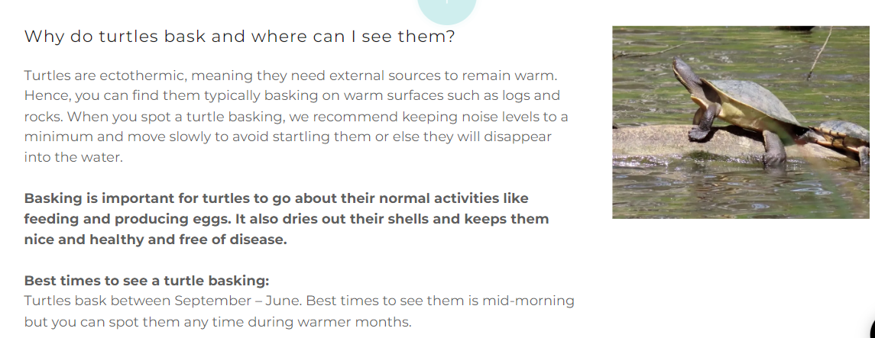

Main Heading: What should I do when I see a turtle?
If you have seen a turtle, alive or dead – we highly encourage you to report your sightings to TurtleSAT. So, what is TurtleSAT? TurtleSAT is a data collection platform available as a web version and as a mobile app to record turtle and nest sightings anywhere in Australia. You can effectively use this app even if you are unable to identify specific turtle species and can use this to report turtle sightings from anywhere in Australia.

Sub-heading: What sort of data can be submitted to TurtleSAT?
- Adult turtles, juvenile or hatchlings.
- Turtles on the move – e.g., along the roads.
- Turtles basking – e.g., on logs, fallen tree branches.
- Roadkills – stop only when safe to do so. Turtles found dead along the road, possibly run over or hit by a moving vehicle.
- Turtles nesting – November is peak nesting season for turtles and is one of the best times to spot a nesting turtle near to water bodies such as wetlands, rivers, lakes or creeks. When you spot a nesting turtle, it is very important to keep a good distance from the female to give her the space to lay her eggs with minimal disturbance.
- Damaged or intact turtle nests.
- Introduced species such as a ‘Red-eared Slider’.

Sub-heading: What happens to the data that I submit?
Australia's freshwater turtles are under serious threat, and the data you submit contributes to informing research and conservation actions to save them. The data that you submit to TurtleSAT helps us to answer the following important questions:
Where do turtles live?
- Where do they breed?
- Are there important breeding 'hotspots'?
- What are the major causes of turtle decline?
- Do the causes of decline differ throughout Australia?
- How far do they disperse?
- Are there important 'source' populations that help to populate other areas?
The answers from these questions results in supporting freshwater turtle conservation actions such as mapping their distributions, planning targeted conservation efforts and understand impacts from feral species such as foxes and pigs (i.e., through nest predation surveys).

Main heading: What else can I do to save turtles?

Sub-heading: Nest Protection Survey

The National Nest Predation Survey was designed to study the impact of foxes and pigs on freshwater turtles.

To get involved, first you will need to complete an online training module and quiz. Following this, you will setup the survey, collect and report the data that will be analysed by the 1 Million Turtles team and displayed on an interactive map.

The survey set-up will involve getting together some required equipment to dig artificial turtle nests, some chicken eggs to bury, and some markers to identify your artificial nests and survey site. Once set-up, you will return after three weeks to check and report the data to TurtleSAT.

Click 'Find Our More' to find out more information and to get involved.

Sub-heading: Nest Protection
With this activity, you will be helping to manage the impact of foxes and pigs on turtles by getting trained to go out there to protect turtle nests. You will protect the nests using commonly available materials such as mesh, turf pegs and a hammer. As with the National Nest Predation Survey, you will need to complete the online training and quiz. You can carry out nest protection either on a private or public land, but only with proper approvals in place for access. Click 'Find Out More' to get started or you may also wish to contact our Local Council.

Main Heading: Have a photo of your turtle tour or turtle art?
If you have a photo, we would love to see it! If you would like to share photos of you and your family taking the turtle tour, or doing anything turtley under the sun - we would love to showcase that on this page.

This way, we have the opportunity to share your amazing contributions and engagement with turtle conservation and our 1 Million Turtles program with others.

If you would like us to showcase your photos, please email them to 1millionturtles@1millionturtles.com with subject heading 'Photos from [Insert name of your tour location]'. Please include your full name, a caption for your photo (optional) and written permission to use the photo on our webpage and social media channels.
Thank you so much and we look forward to hearing from you! In the meantime, please feel free to browse the image gallery below from a former event that was delivered at [Insert name of your tour location] in partnership with the [Insert name of your Local Council].

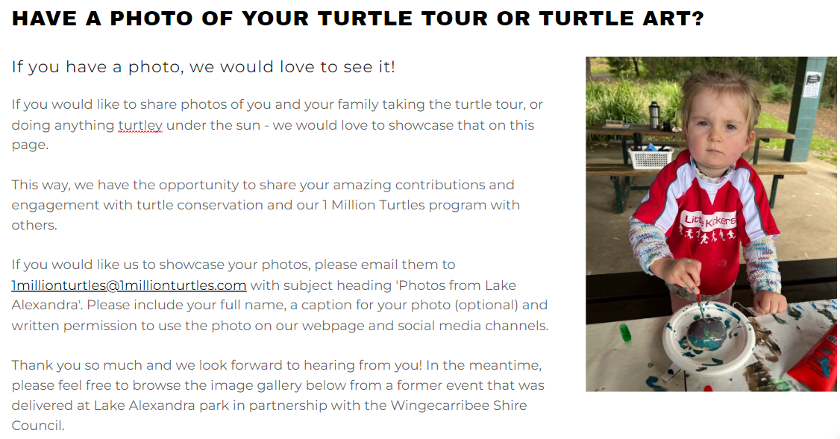

Main Heading: Photo Gallery
You could also add a photo gallery on your webpage.

