HMCDDO Annual Notifications Form

Annual Notification Acknowledgment and Consent for:
Individual Rights:
I have received Information about my rights under the Kansas Developmental Disabilities Reform Act of 1995.
Dispute Resolution:
I understand that should I have a dispute between myself and my service provider I should first follow my service provider’s internal grievance/dispute resolution policy. If my grievance/dispute cannot be resolved, I can contact Harvey-Marion County CDDO for assistance. I understand that Harvey-Marion County CDDO has a policy regarding dispute resolution that I can request should I need it.
Consent to Share/Withhold Consent: Some or all the affiliates listed on the provider directory may want to make contact with me to explain their services.

My decision is:

I withhold consent - please do not share my name with any affiliates.
I give consent to receive information from area service providers.
** PLEASE NOTE: This consent allows all available service providers in the HMCDDO area to distribute advertising and marketing materials to you.
I would like to receive information from providers of the following services:
 | Targeted Case Management (TCM) |  | Respite Care (Children) |  | Self-Directed Supports (FMS)
 | Personal Care Services (PCS – in home) |  | Adult Day Supports |  | Adult Residential Supports

*** I would like to be contacted by: (if left incomplete, providers can’t contact you) ***
Mail to this address:
Phone to this number:
Email to this address:

My signature below verifies that a representative from Harvey-Marion County CDDO has informed me of my individual rights, dispute resolution, and options to consent or withhold consent from sharing contact information with affiliated service providers. This notice does not guarantee services or providers.

Individual Signature: |  | Date:
Guardian Name: |  | Date:
Guardian Signature: |  | Date:
Witness if no guardian: |  | Date:
HMCDDO Comprehensive Options Counseling Meeting
I have received comprehensive options counseling about service options, including agency or self-directed supports, and available choices of services providers affiliated with Harvey-Marion County. This notice does not guarantee services, or service providers. If I have funding, I have the right to receive services from the available provider(s) of my choice. I understand I can change service providers at any time. I understand I must contact the Harvey-Marion County CDDO to change service providers or change from agency-directed services to self-directed services.
HMCDDO Service Options:
 | Targeted Case Management |  | Respite Care birth to age 16
 | Adult Day Supports |  | Residential Supports-children not in custody
 | Adult Residential Supports |  | Specialized Medical Care (RN/LPN)
 | Personal Care Services in the family home |  | Wellness Monitoring
 | Choice of Agency-Directed Supports |  | Medical Alert Device
 | Self-Directed Supports (w/ FMS) |  | Assistive Services:(home mods, ramps, lifts, assistive tech)
What would you like to receive more information about?

What other needs or questions do you have?

Participants in Options Counseling Meeting:

My signature below verifies that a representative from the Harvey-Marion County CDDO has informed me of all service options and all available service providers in the HMCDDO area. This notice does not guarantee services or providers.

Individual Signature: |  | Date:
Guardian Signature: |  | Date:
CDDO Member Signature: |  | Date:

I/DD-1
Revised 5/20/2019
Home & Community Based Services
I/DD Medicaid Waiver Individual Choice

Name of Participant: |  | DOB:

If assessment results indicate that I meet functional eligibility criteria qualifying me for long-term care services that are essential to my health and welfare, I have two choices on where to receive my services. My choices are to receive services in my home or other community-based setting, within cost limitations of the program, or in the institutional equivalent (ICF-IID). I have been informed if I am determined eligible for Home and Community-Based Services (HCBS), I have the option to remain in the community and receive the services designated on my Person-Centered Service Plan.

My initials mean I understand that I am not guaranteed to receive either choice, and may be placed on a waiting list, depending upon the availability of either service.

It is my choice to:

Receive HCBS under the Intellectual/Developmental Disability (I/DD) Medicaid waiver when offered.
Apply for ICF/IID facility placement - Please contact the HMCDDO @ 316-283-7997 to discuss further.

My signature verifies I have read, or had read to me, my rights and responsibilities and have made the choices as indicated. I am also indicating willingness to participate in the design of my Person-Centered Service Plan.

Individual Signature: |  | Date:
Guardian Signature: |  | Date:
CDDO Member Signature: |  | Date:

Receipt of the HMCDDO Privacy Practices

My Signature/Date below verifies the I have received the
HMCDDO’s Notice of Privacy Practices
(Effective date of Policy: 07/01/2007, Revised: 01/09/2012)

Individual Name:
Address:
City/State/Zip:
Individual’s Signature:
Date:

(If applicable)
Guardian Name:
Address:
City/State/Zip:
Individual’s Signature:
Date:

AUTHORIZATION FOR RELEASE OF PROTECTED HEALTH INFORMATION

Name of Participant: |  | DOB:
I / Guardian hereby authorize the use and/or disclosure of my individually identifiable health information as described below. I understand that signing this form is voluntary.
Providing Information:
Harvey-Marion County CDDO (HMCDDO)
Receiving Information:
Kansas Department of Aging and Disability Services (KDADS)
Description of Information to be Used:
Personal demographic data and functional assessment information, IDD program access information.
Purpose of Use or Disclosure:
Enter data into KAMIS (Kansas Assessment and Management Information System) for IDD program eligibility and service access, request IDD program access, update changes as needed.

The Individual or the Individual’s Representative must read or have the following read to them and initial by each item below:
I understand that I may inspect or copy the protected health information to be used or disclosed under this authorization. I understand I may refuse to sign the authorization. I understand that the refusal to sign this authorization may mean that the use and/or disclosure described in this form will not be allowed.
I understand this Release is valid for one year from today’s date.
I understand that I may revoke this Release at any time by notifying the providing organization in writing. It will not have an effect on actions that were taken prior to the revocation.
I understand that once the uses and disclosures have been made pursuant to this authorization, the information released may be subject to re-disclosure by any recipient and will no longer be protected by federal privacy laws.
This will not condition treatment or payment on my providing authorization for this use or disclosure except to the extent the provision of health care is solely for the purpose of creating protected health information for disclosure to a third party.

My signature below certifies that I agree to the uses and disclosures listed above and that I have received a copy of this Authorization. (Form must be completed before signing).

Individual Signature: |  | Date:
Guardian Signature: |  | Date:

HMCDDO Functional Assessment Attendance Sheet

Individual Name:
Meeting Date: |  | Time:
Location: |  | Date of Birth:
Individual Present: |  | Individual Not Present:
Accommodation:
My signature below attests that I attended the functional assessment meeting for the above-named individual:
- The Information I provided was truthful and accurate.
- I understand that the State of Kansas/CDDO contract requires that functional assessors complete a review of available documentation in order to substantiate the answers submitted on the Functional Assessment (medication, medical conditions, behavior plans, behavior data, PCSP, and seizure data)
- I understand that I may request a review of how a question was scored.

Individual:
Parent(s):
Guardian(s):
DPOA:
Targeted Case Manager:
Day Representative:
Residential Representative:
Personal Care Services:
MCO Representative:
Other:
Assessor:
Question Review: To request review of how a question was scored, complete next page.

HMCDDO Functional Assessment Question Review Request

Instructions: Please list below the question number and description (for example, #9-Copy circle from example) and provide a DETAILED DESCRIPTION of the information you are requesting the Harvey- Marion County CDDO to review, as well as your signature.

What to Expect: Harvey-Marion County CDDO will provide a written response to the individual’s case manager, as well as any other individual whose signature is listed below. Please note that for providers, the findings will be provided to the contact person for that particular agency. A review response will be provided in writing within 3 (three) working days.

Appeal: If the outcome of the functional assessment is that an individual scores ineligible for HCBS-IDD supports, the individual will be provided a Notice with appeal rights and procedures.

Question#: DETAILED Description of Information for CDDO review: Signature(s):

Assessor:
Enter 3-Day Review Due Date Here:

Kansas Developmental Disability Reform Act
Your Rights in Plain Words: Page 1

- You have the right to have help getting the supports you want. If you want more choices, ask the CDDO for help.

- You have the right to pick where you get a case manager. You have the right to not have a case manager if you do not need to have one.

- You have the right to get supports in the community even if you need a lot of support because of your disability. If you are very, very unsafe and harmful to yourself or to other people, you may be too unsafe to live in the community. Only the top person at the Kansas Department of Aging and Disability Services in Topeka can decide if you are too unsafe to live in the community.

- You have the right to have a person-centered support plan and get the supports that are in your plan. You have the right to get to make choices. You have the right to have staff who know about your rights and help you learn about your rights.

- You have the right to keep getting supports as long as there is funding from the government to pay for them. You have the right to move to a different place in Kansas and move your funding with you.
Kansas Developmental Disability Reform Act
Your Rights in Plain Words: Page 2

- You have the right to get the supports you need in 60 days after you get funding. Until there is funding, you have the right to be on the waiting list for funding.

- You have the right to get help to fix a problem when people do not agree on what to do. If you are not sure, ask your case manager for help. You have the right to follow your service provider’s policy on disputes/grievances. If you still need help after that, you have the right to ask our office, Harvey-Marion County CDDO, for help to solve the problem. Call (316) 283- 7997.

- You have the right to know about the Harvey-Marion County CDDO Quality Assurance Committee. Call (316) 283-7997.

- You have the right to know about the Harvey-Marion Community Council. Call (316) 283-7997.

- You have the right to know about self-advocacy (standing up for yourself and letting others know what is important to you), and when the local self-advocacy group meets. Call (316) 283- 7997.

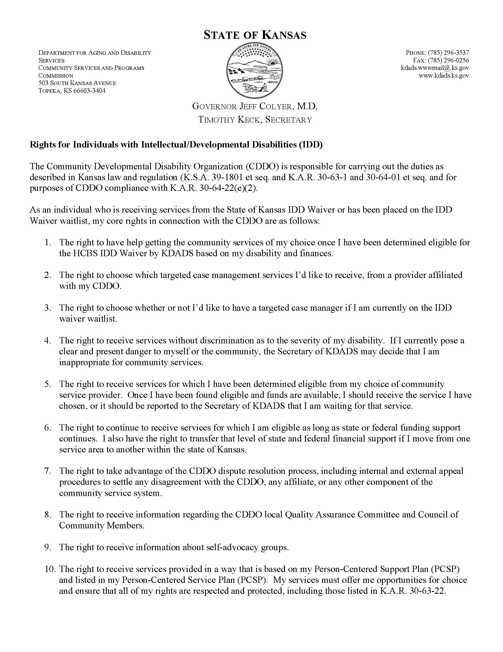
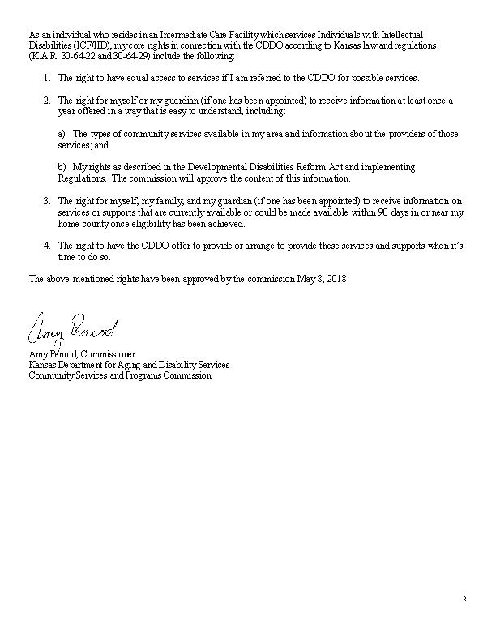
HMCDDO NOTICE OF PRIVACY PRACTICES

THIS NOTICE DESCRIBES HOW YOUR PRIVATE HEALTH INFORMATION MAY BE USED AND DISCLOSED AND HOW YOU CAN OBTAIN ACCESS TO THIS INFORMATION. PLEASE REVIEW IT CAREFULLY.

HOW HARVEY-MARION COUNTY CDDO MAY USE AND DISCLOSE YOUR HEALTH INFORMATION
HARVEY-MARION COUNTY CDDO may use and disclose your health information for the following purposes without your express consent or authorization. We will obtain your express written authorization before using or disclosing your information for any other purpose. You may revoke such authorization, in writing, at any time to the extent the HARVEY-MARION COUNTY CDDO has not relied on it.
Treatment. We may use your health information to determine your eligibility to receive home and community-based services and supports for individuals with intellectual/developmental disabilities. We may use and disclose health information to discuss with your options for services and supports to meet your needs, and to place your name on the statewide waiting list for the services and supports you want to receive. We may disclose your eligibility for services to the affiliated community service providers you have chosen to provide your services and supports. We may use and disclose your health information to remind you of upcoming meetings or the need for your annual BASIS assessment. Unless you direct us otherwise, we may leave messages on your telephone answering machine identifying the HARVEY-MARION COUNTY CDDO and asking for you to return our call. We will not disclose any health information to any person other than you, except to leave a message for you to return the call.
Payment. We may use and disclose your health information as necessary for reimbursement for the home and community-based services and supports for individuals with intellectual/developmental disabilities that you receive through HARVEY-MARION COUNTY CDDO and/or its affiliated providers. We also may provide information to affiliated providers to assist them in obtaining reimbursement for the services and supports which they provide to you.
Health Care Operations. We may use and disclose your health information for our internal CDDO operations as well as Quality Assurance/Quality Enhancement oversight of the services and supports that you receive. These uses and disclosures are necessary for our day-to-day operations and to make sure that you receive quality, responsive services and supports that respect your rights and offer you choices.
Business Associates. The HARVEY-MARION COUNTY CDDO may provide some services through contracts or arrangements with business associates. Before doing so, HARVEY-MARION COUNTY CDDO will require the business associate to appropriately safeguard your health information.
Creation of de-identified health information. We may use your health information to create de-identified health information. This means that all data items that would help identify you are removed or modified.
Uses and disclosures required by law. We will use and/or disclose your health information when required by law to do so.
Disclosures for public health activities. We may disclose your health information to a government agency authorized (a) to collect data for the purpose of preventing or controlling disease, injury, or disability; or (b) to receive reports of child abuse or neglect. We also may disclose such information to a person who may have been exposed to a communicable disease if permitted by law.
Disclosures about victims of abuse, neglect, or domestic violence. We may disclose your health information to a government authority, including protective services, if we reasonably believe you are a victim of abuse, neglect, or domestic violence.
Health Oversight Activities. We may disclose your health information during audits, compliance reviews, investigations, inspections, and other proceedings related to CDDO oversight.
Disclosures for judicial and administrative proceedings. Your protected health information may be disclosed in response to a court order or in response to a subpoena, discovery request, or other lawful process if certain legal requirements are satisfied.
Disclosures for law enforcement purposes. We may disclose your health information to a law enforcement official as required by law or in compliance with a court order, court-ordered warrant, a subpoena, or summons issued by a judicial officer; a grand jury subpoena; or an administrative request related to a legitimate law enforcement inquiry.
Disclosures regarding victims of a crime. In response to a law enforcement official’s request, we may
disclose information about you with your approval. We may also disclose information in an emergency situation or if you are incapacitated if it appears you were the victim of a crime.
Disclosures to avert a serious threat to health or safety. We may disclose information to prevent or lessen a serious threat to the health and safety of a person or the public or as necessary for law enforcement authorities to identify or apprehend an individual.
Disclosures for specialized government functions. We may disclose your protected health information as required to comply with governmental requirements for national security reasons or for protection of certain government personnel or foreign dignitaries.

YOUR RIGHTS REGARDING YOUR HEALTH INFORMATION
Right to Inspect and Copy. You have the right to inspect and copy your protected health information maintained by the HARVEY-MARION COUNTY CDDO. To do so, you must submit a written request to the HARVEY-MARION COUNTY CDDO Privacy Officer at the contact below, with information needed to process your request. If you request copies, we may charge a reasonable fee.
Right to Request Amendment. If you believe your records contain inaccurate or incomplete information, you may ask us to amend the information. To request an amendment, you must submit a written request to the Privacy Officer at the contact below, with information needed to process your request including your supporting reason(s).
Right to an Accounting of Disclosures. You have the right to request a list of disclosures of your health information we have made, except for disclosures for Treatment, Payment, or Health Care Operations; disclosures authorized by you; and disclosures made to you. To request this list, you must submit a written request to the Privacy Officer at the contact below.
Right to Request Restrictions. You have the right to request a restriction on our uses and disclosures of your health information for treatment, payment, or health care operations. To do so, you must submit a written request to the Privacy Officer at the contact below.
Right to Request Alternative Methods of Communication. You have the right to request that we communicate with you in a certain way or at a certain location. You must submit a written request with information needed to process your request to the Privacy Officer at the contact below. We will accommodate all reasonable requests.
Right to Paper Copy. You have a right to receive a paper copy of this Notice of Privacy Practices at any time. To do so, send a written request to the Privacy Officer at the contact below.

CHANGES TO THIS NOTICE

HARVEY-MARION COUNTY CDDO reserves the right to change the terms of this Notice and to make the revised Notice effective with respect to all protected health information regardless of when the information was created.

COMPLAINTS
If you believe your rights with respect to health information have been violated, you may take action by filing a written complaint with the HARVEY-MARION COUNTY CDDO Privacy Officer at the contact below, or with the Secretary of the Department of Health and Human Services. You will not be penalized for filing a complaint.

PRIVACY OFFICER CONTACT

Privacy Officer: HARVEY-MARION COUNTY CDDO; 500 N. Main Street, Suite #204, Newton, KS 67114
Web: harveymarioncddo.com EFFECTIVE July 1, 2007

