N137PB  
**MSN:** 4128   **Mfr Date:** July 14, 1941   **Current Reg:** N137PB   **Current location:** Cape Cod Airfield, Barnstable, MA  
  
After the demise of PBA in 1988, N137PB spent more than 2 decades parked at Fremont, Ohio (14G), registered to the Northern Illinois Aircraft Museum. After the owner passed away, the aircraft was sold, returned to airworthy condition and flown to Thomaston, Georgia in 2014 where it remained for over two years.  
  
On May 4, 2017, N137PB, still adorned in the late 1980s colors of Eastern Express, departed Thomaston for its new home at Cape Cod Airfield where it joined another former PBA DC-3, N35PB (now N61981).  
  
In late October 2018, the aircraft was repainted in basic 1970s PBA colors minus the titles and logo. Here it is on October 24, 2018 with one side freshly painted in red, white and black. Photo credit: Chris Siderwicz Jr. via Pete Johnson.

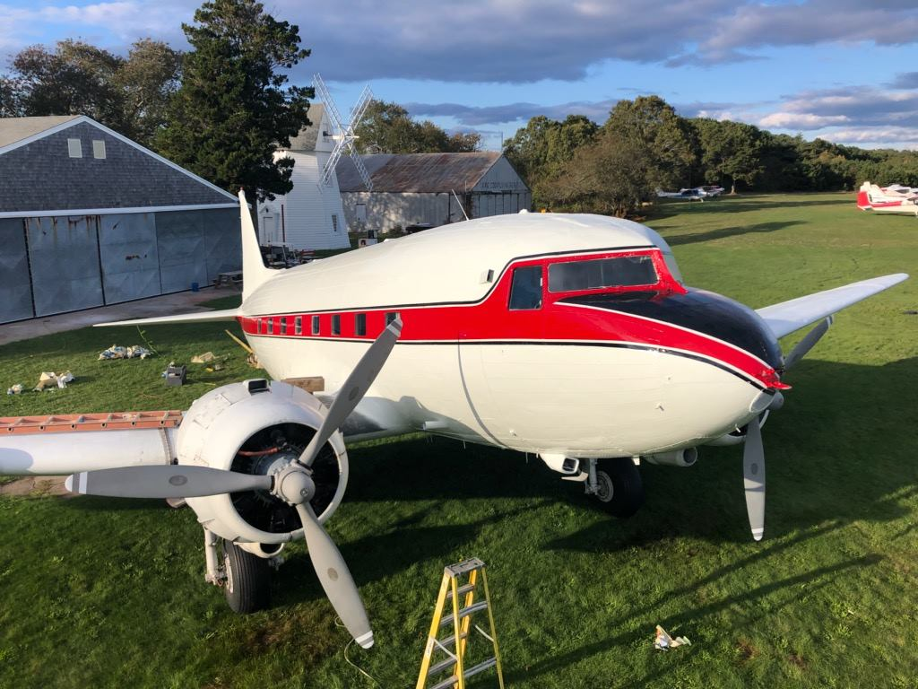

Thanks to Richard Hancock for sending in this fantastic photo of N137PB departing Thomaston on May 4, 2017.

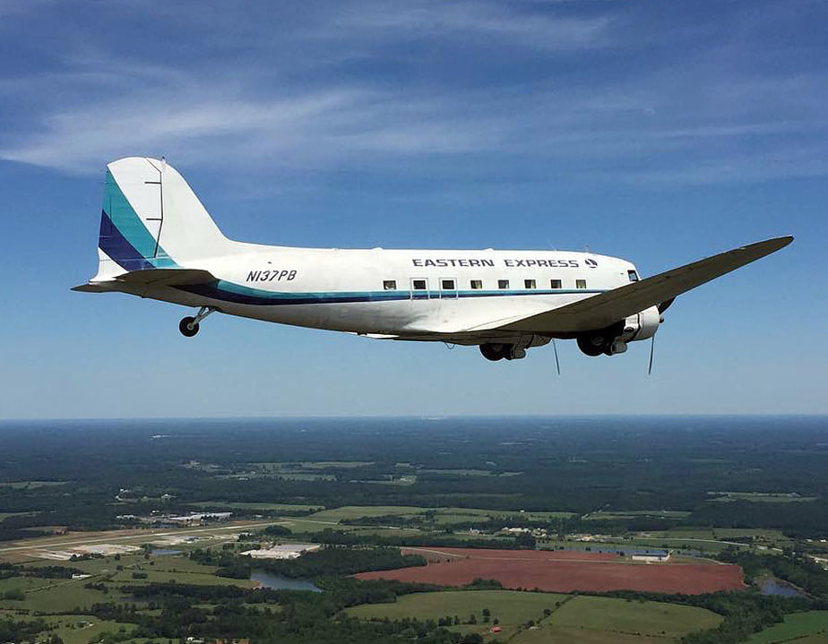

N137PB at Thomaston, Georgia on May 24, 2015. The props were back in place a month later. Many thanks to Norbert Raith for this photo!

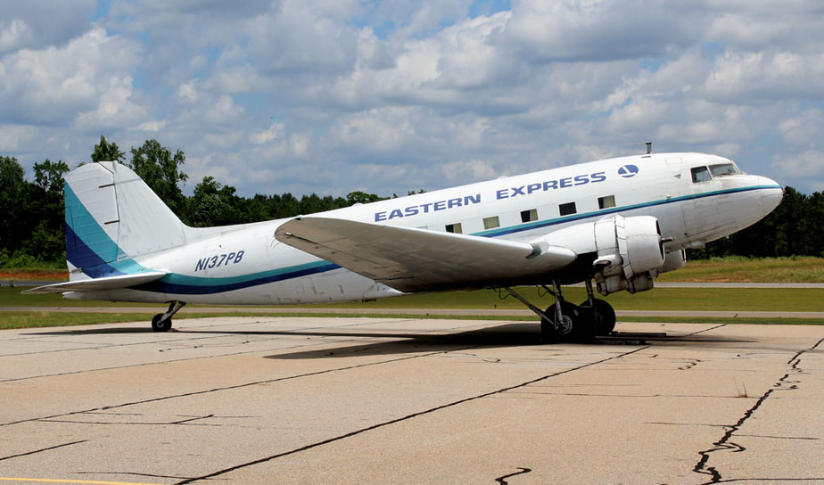

Two former PBA DC-3s reunited! N28AA, formerly N139PB, poses with N137PB at Thomaston, GA on June 29, 2015. Photo courtesy of the Candler Field Museum.

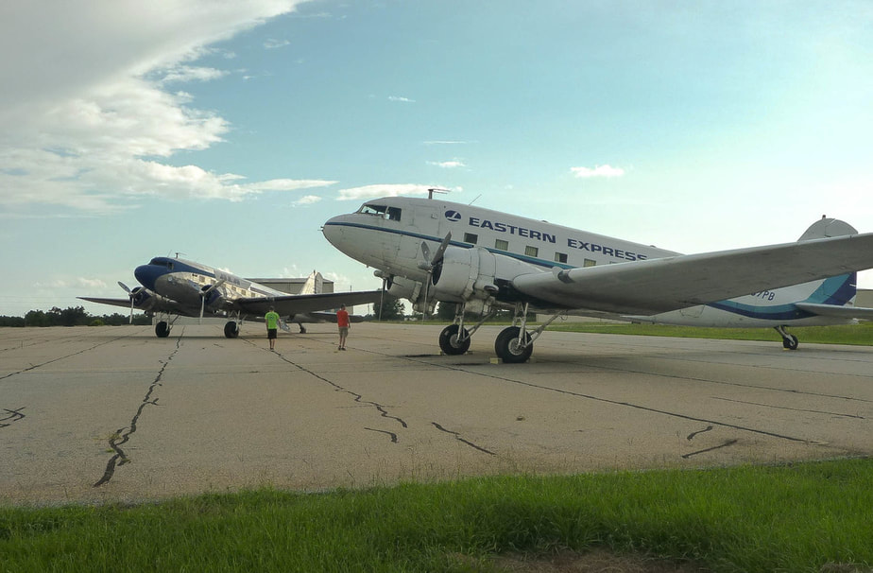

N137PB was the last DC-3 to still retain the original PBA / Eastern Express passenger cabin configuration. This photo came from the Fremont Airport Facebook page in May 2010. Presumably the interior is still intact. I flew as a passenger on this aircraft between Miami and Marathon in December 1981 and it's a joy to see this in such good condition.

