**Market Chicken Record Book**

**Senior (ages 15-19)**

**Project Year:_____**

**Which project(s)?**

**❒ Broiler ❒ Cornish**

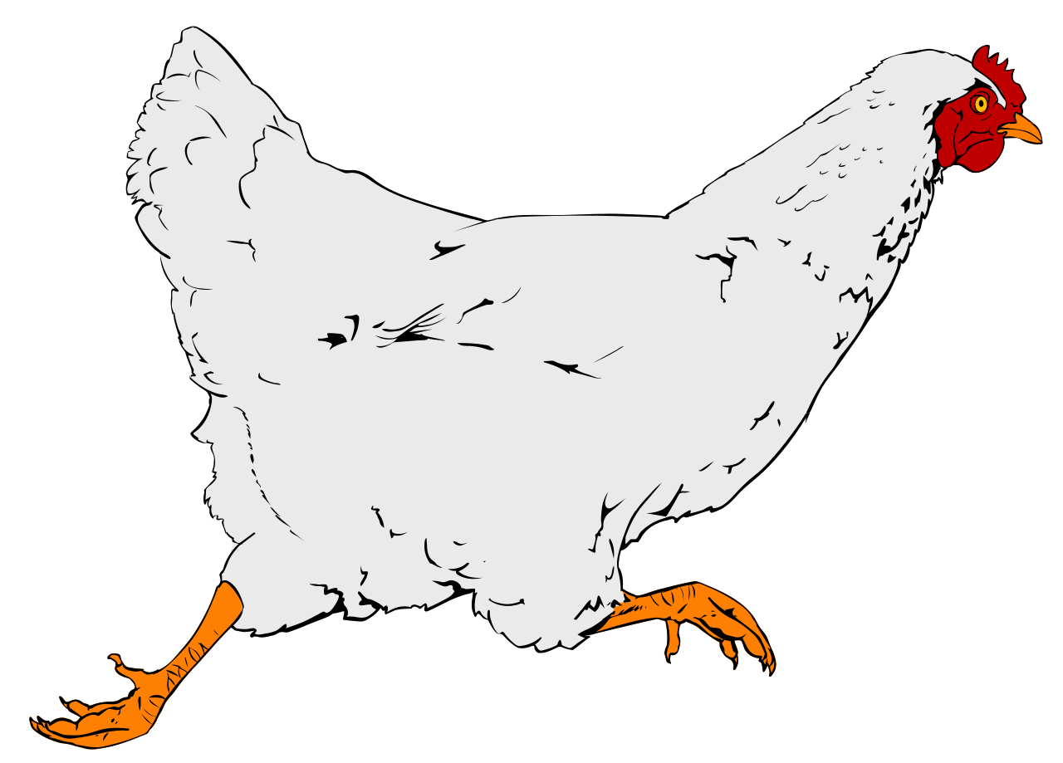

Name: ________________________________________________

Number of years in the Project: ____________________________

Fair Age as of January 1, of the current year: __________________

Club or Organization: _____________________________________

Club/Organization Leader: _________________________________

Record Started: _____________ Record Closed: ______________

Month/Day/Year Month/Day/Year

***\*\*RECORD BOOKS ARE DUE ON FIRST DAY OF FAIR\*\****

**WHY KEEP RECORDS?**

This record is a part of your Market Livestock Project and must be entered for judging at the Northern District Fair. A record book per market animal is required for auction. Keep this book as part of your personal records. This information is helpful for you to plan future year's market projects, as well as if you ever apply for awards or a scholarship.

**Project Objectives:**

* Develop a love for agriculture and a humane attitude toward animals while experiencing the pride and responsibility of ownership of the project.
* Help youth acquire information and an understanding of scientific production and management practices through the experience of keeping records, owning, and caring for livestock.
* Allow youth to learn and employ efficient procedures and methods in marketing poultry and their products.
* Allow youth to experience and cope with the “value” and “attitudes” of responsibility in a relatively unsupervised environment. Supervision will be on a periodic basis.
* Encourage integrity, sportsmanship, cooperation and ability to communicate through related activities such as demonstrations, talks, judging events, and at local fairs.

Exhibitor Signature:

Leader Signature:

The Northern District Fair values every exhibitor’s experience. Did you need assistance or accommodations to fill out this record book? Please describe how below:

____________________________________________________________________________________________________________________________________________________________________________________________________________________________________________________________________________________________________________________________________________________________________________________________________

**My Chicken Turkey Project**

Name and/or description of animal(s): __________________________________________________

Breed(s): ________________________________________________________________________

Date of ownership or pick-up date:_____________________________________________________

How many chickens purchased:_______________________________________________________

Cost of your chickens: ______________________________________________________________

How many chickens are in a broiler pen?____________ Cornish pen? _____________

How old were your chickens at pick up:_________________________________________________

What kind of feeder did you use? _____________________________________________________

What is the maximum weight for a cornish chicken at this year’s fair? _________________________

What shelter did you have once your chickens left their brooder? ________________________________________________________________________________ ________________________________________________________________________________

Roughly, how much water did your chickens drink daily?:___________________________________

**Please explain three goals that you have for your turkey project:**

1. _________________________________________________________________________ _________________________________________________________________________
2. _________________________________________________________________________ _________________________________________________________________________
3. ________________________________________________________________________________________________________________________________________________

**Expense Record**

**Project Inventory:** Use the chart below to track the items you purchased to complete your project. Only calculate for the birds that you bring to fair. You may list items already owned with a cost of $0.

| Item | Cost |
| --- | --- |
| Purchase Cost of Chickens |  |
|  |  |
|  |  |
|  |  |
|  |  |
|  |  |
| Total value of your turkeys and equipment at the beginning of your project: |  |

**Feed Cost Record:** Use the chart below to track your feed and supplement expenses. Only calculate for the birds you bring to the fair (Pen of 2 Turkeys). For example, if you raised 3 turkeys, subtract 1/3 of the cost from each item.

| Date | Type of Food | Cost |
| --- | --- | --- |
|  |  |  |
|  |  |  |
|  |  |  |
|  |  |  |
|  |  |  |
|  |  |  |
| Total cost of feed and supplements to raise your project: | |  |

**Total Project Expenses**(add both totals from above)**: $_____________**

**Growth Record**

Weighing your chickens is a good way to monitor their health. You should weigh your chickens each week. It is recommended to take an average of 3 weights per week.

**Broiler Weight Chart**

Broiler’s weight on Day 1: _____________

|  | Weight: | Comments/Notes: |
| --- | --- | --- |
| Week 1 |  |  |
| Week 2 |  |  |
| Week 3 |  |  |
| Week 4 |  |  |
| Week 5 |  |  |
| Week 6 |  |  |
| Week 7 |  |  |
| Week 8 |  |  |

**Cornish Weight Chart**

Cornish’s weight on Day 1: _____________

|  | Weight: | Comments/Notes: |
| --- | --- | --- |
| Week 1 |  |  |
| Week 2 |  |  |
| Week 3 |  |  |
| Week 4 |  |  |

**Health Record**

Enrolling in an animal project requires you to take responsibility for the health and treatment of your animal. Record all health care for your animal including medications, immunizations (shots), dewormers, as well as management care such as fly prevention, nail trimming, and washing. Remember to record the cost of healthcare services and supplies on the Project Inventory record.

| Date | Reason for treatment/symptoms | treated with, dosage, and method of administration | withdrawal time if applicable |
| --- | --- | --- | --- |
|  |  |  |  |
|  |  |  |  |
|  |  |  |  |
|  |  |  |  |
|  |  |  |  |

# Project Summary & Analysis

# Note, you may have kept records for more than the chickens you bring to auction. Be sure to divide total expenses by the number of animals you raised to get an accurate summary for your fair year. Information for the sheet below should reflect only the animal brought to fair.

|  | Date Acquired | Beginning Average Weight | Final Weight |
| --- | --- | --- | --- |
| Broiler |  |  |  |
| Cornish |  |  |  |

**Expected income:** The market value of livestock will be posted in the barns on arrival day at the fair. This section of your record book should be finalized after final weigh-in but before giving it to your barn superintendent for judging. Be sure to use information from your Expense Records above.

Market Value(per lb) × Final Weight = Expected Income

$____________________ × _____________ = $ ________________

**Break-Even Cost:** The hope with any financial endeavor is to earn more money than spent on the project. The break-even cost is the price of your project when your expense and income are the same. Anything higher than your break-even cost is total income, anything lower is your total loss. Use the equation to calculate your break-even cost.

Total Expenses ÷ Final Weight(lbs) = Break-Even Cost/Lb.

$______________ ÷ _____________ = $ ________________

**Parts of a Chicken (anatomy)**

Label each arrow with the number of the body part from the word bank below.

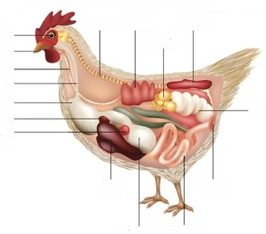

**Word Bank**

1. Osophagus
2. Spine
3. Kidney
4. Spleen
5. Crop
6. Heart
7. Trachea
8. Beak
9. Ovary
10. Lungs
11. Gizzard
12. Oviduct
13. Intestine
14. Gizzard
15. Liver
16. Cloaca
17. Eye

**Parts of a wing**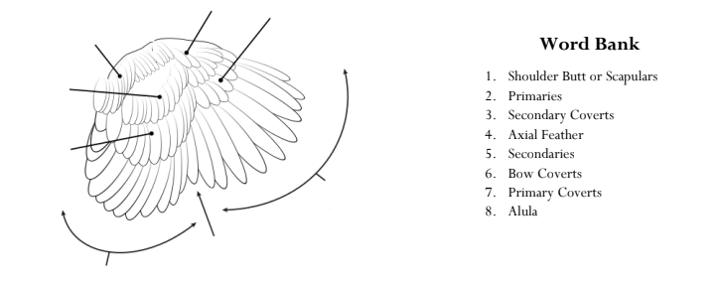

**Word Bank**

1. Shoulder Butt or Scapulars
2. Primaries
3. Secondary Coverts
4. Axial Feather
5. Secondaries
6. Bow Coverts
7. Primary Coverts
8. Alula

**I Know Chicken**

Name one poultry disease, the cause, and possible treatments ________________________________________________________________________________________________________________________________________________________________List three ways to avoid heat stress in birds

1. ___________________________________________________________________________
2. ___________________________________________________________________________
3. ___________________________________________________________________________

When discussing processing yields, will a fat animal give a greater yield than a lean animal? Explain.

________________________________________________________________________________________________________________________________________________________________________________________________________________________________________________

Why is ventilation so important in raising poultry?

________________________________________________________________________________________________________________________________________________________________________________________________________________________________________________

Name & briefly describe 6 types of combs

1. ___________________________________________________________________________
2. ___________________________________________________________________________
3. ___________________________________________________________________________
4. ___________________________________________________________________________
5. ___________________________________________________________________________
6. ___________________________________________________________________________

What are breast blisters and how do you prevent them?

________________________________________________________________________________________________________________________________________________________________

Name two internal parasites that can affect chickens.

1. _______________________________ 2) _______________________________

**Personal Development**

List 3 people or companies you sent/delivered a buyer letter to:

1. __________________________________
2. __________________________________
3. __________________________________

List 3 people, places, or resources you used to help you with your projet this year:

1. ___________________________________
2. ___________________________________
3. ___________________________________

What skills did you practice or learn with your chicken project this year? _______________________________________________________________________________________________________________________________________________________________________________________________________________

How did this project push you outside of your comfort zone?

_______________________________________________________________________________________________________________________________________________________________________________________________________________

How did you contribute to your livestock club this past year?

_______________________________________________________________________________________________________________________________________________________________________________________________________________

**Project Essay** Pick one of the following topics to write an essay on. The essay should be a minimum length of 5 paragraphs. You may type or handwrite the assignment. Please attach it to the end of your record book.

Topic options, please circle your choice:

* My Project Goals and How I Met Them or Why I Didn’t Achieve Them
* What/Who influenced Me to Complete a Chicken Project and If I Plan to do it Again Next Year
* My Career Opportunities in Agriculture
* How to Care for Chickens and What Supplies I Need

**Project Pictures** share a minimum of 6 pictures of your project. Record books must contain photos from Day 1 of the project, all the way through to the end of the project. Pictures should be on paper(s) attached to your record book. Artistic display is encouraged but not required.

**Scoring Rubric**

| Page | Topic | Points Possible | Points Awarded |
| --- | --- | --- | --- |
| 1 & 2 | Cover & Project Certification | 5 |  |
|  | Completed & signed by both |  |  |
| 3 | My Chicken Project | 5 |  |
|  | Completed |  |  |
| 4 | Expense Records | 10 |  |
|  | Clear and detailed records kept |  |  |
| 5 | Growth and Health Records | 10 |  |
|  | Clear and detailed records kept |  |  |
| 6 | Project Summary & Analysis | 10 |  |
|  | Completed |  |  |
| 7 | Parts of a Chicken & Parts of a Wing | 10 |  |
|  | Correctly completed |  |  |
| 8 | I Know Chicken | 10 |  |
|  | Correctly completed |  |  |
| 9 | Personal Development | 5 |  |
|  | Completed and detailed |  |  |
| 10 (+) | Project Essay | 20 |  |
|  | 3 thorough paragraphs attached |  |  |
| 10 (+) | Project Pictures | 15 |  |
|  | 6 pictures start-finish attached |  |  |
|  | **TOTAL:** | **100** |  |

**Comments:** **____________________________**

Record Book Judge: ___

**Total Points:**

A – 90-100

B – 80-89

C – 60-79

DQ: Below