**Market Turkey Record Book**

**Junior (age 6-9)**

**Project Year:_____**

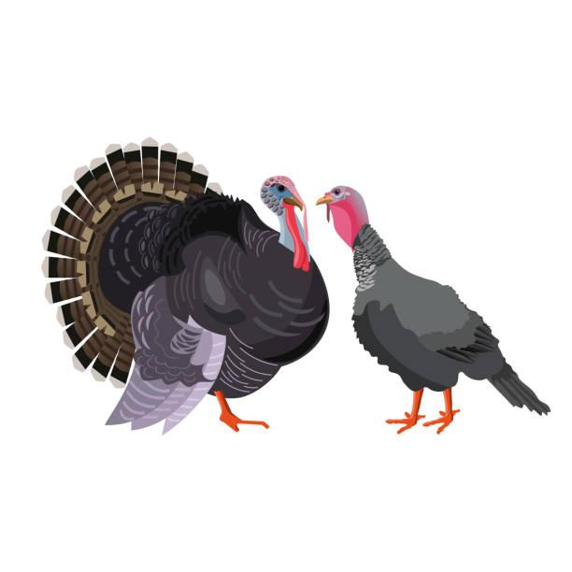

Name: ________________________________________________

Number of years in the Project: ____________________________

Fair Age as of January 1, of the current year: __________________

Club or Organization: _____________________________________

Club/Organization Leader: _________________________________

Record Started: _____________ Record Closed: ______________

Month/Day/Year Month/Day/Year

***\*\*RECORD BOOKS ARE DUE ON FIRST DAY OF FAIR\*\****

**WHY KEEP RECORDS?**

This record is a part of your Market Livestock Project and must be entered for judging at the Northern District Fair. A record book per market animal is required for auction. Keep this book as part of your personal records. This information is helpful for you to plan future year's market projects, as well as if you ever apply for awards or a scholarship.

**Project Objectives:**

* Develop a love for agriculture and a humane attitude toward animals while experiencing the pride and responsibility of ownership of the project.
* Help youth acquire information and an understanding of scientific production and management practices through the experience of keeping records, owning, and caring for livestock.
* Allow youth to learn and employ efficient procedures and methods in marketing poultry and their products.
* Allow youth to experience and cope with the “value” and “attitudes” of responsibility in a relatively unsupervised environment. Supervision will be on a periodic basis.
* Encourage integrity, sportsmanship, cooperation and ability to communicate through related activities such as demonstrations, talks, judging events, and at local fairs.

Exhibitor Signature:

Leader Signature:

The Northern District Fair values every exhibitor’s experience. Did you need assistance or accommodations to fill out this record book? Please describe how below:

____________________________________________________________________________________________________________________________________________________________________________________________________________________________________________________________________________________________________________________________________________________________________________________________________

**Your Project**

How many turkeys did you buy?

How old were your baby turkeys when you picked them up?

What is a baby turkey called?

When you took your turkeys home, you put them in a brooder. What temperature did you keep your brooder?

What did you use to keep them warm?

What breed of turkeys did you purchase?

What type of feed did you give your turkeys at the start of the project?

Did you feed them anything different as they got older?

How often did you feed your turkeys?

What did your market turkey weigh on entry day?

**Parts of a Turkey**

Label each arrow with the number of the body part from the word bank below.

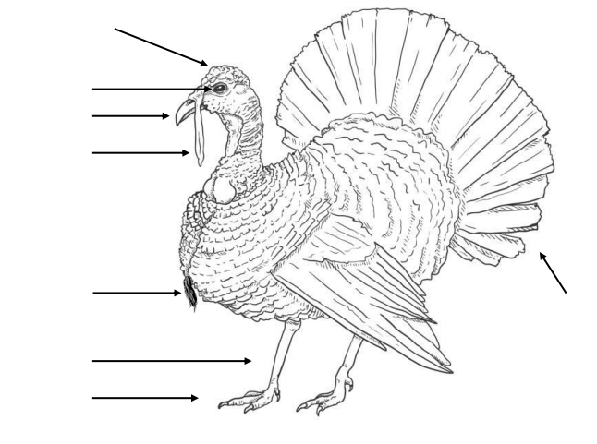

**Word Bank**

1. Head
2. Foot
3. Beak
4. Feathers
5. Snood
6. Leg
7. Beard
8. Eye

**Expense Record**

**Project Inventory:** Use the chart below to track the items you purchased to complete your project. Only calculate for the birds that you bring to fair (Pen of 2 Turkeys). You may list items already owned on one line with a cost of $0.

| Item | Cost |
| --- | --- |
| Purchase Cost of Turkeys |  |
|  |  |
|  |  |
|  |  |
|  |  |
|  |  |
| Total value of your turkeys and equipment at the beginning of your project: |  |

**Feed Cost Record:** Use the chart below to track your feed and supplement expenses. Only calculate for the birds you bring to fair (Pen of 2 Turkeys). For example, if you raised 3 turkeys, subtract 1/3 of the cost from each item.

| Date | Type of Food | Cost |
| --- | --- | --- |
|  |  |  |
|  |  |  |
|  |  |  |
|  |  |  |
|  |  |  |
|  |  |  |
| Total cost of feed and supplements to raise your project: | |  |

**Total Project Expenses**(add both totals from above)**: $_____________**

**Growth Record**

**Project Weight Chart**

Weighing your turkeys is a good way to monitor their health. You should weigh your turkeys each week. Choose one bird to report in the chart below every other week. Try to report with the same bird.

Turkey’s weight on Day 1: _____________

|  | Weight: | Comments/Notes: |
| --- | --- | --- |
| Week 1 |  |  |
| Week 3 |  |  |
| Week 5 |  |  |
| Week 7 |  |  |
| Week 9 |  |  |
| Week 11 |  |  |
| Week 13 |  |  |
| Week 15 |  |  |
| Week 17 |  |  |
| Week 19 |  |  |

**Financial Summary**

**Expected income:** The market value of livestock will be posted in the barns on arrival day at the fair. This section of your record book should be finalized after final weigh-in but before giving it to your barn superintendent for judging. Be sure to use information from your Expense Records above.

Market Value(per lb) × Final Weight = Expected Income

$____________________ × _____________ = $ ________________

**Break-Even Cost:** The hope with any financial endeavor is to earn more money than spent on the project. The break-even cost is the price of your project when your expense and income are the same. Anything higher than your break-even cost is total income, anything lower is your total loss.

Use the equation to calculate your break-even cost.

Total Expenses ÷ Final Weight(lbs) = Break-Even Cost/Lb.

$______________ ÷ _____________ = $ ________________

**Project Story**

Tell us about your project. It can be something funny that happened, an interesting experience, or something you learned. Write complete sentences and include details.

________________________________________________________________________________________________________________________________________________________________________________________________________________________________________________________________________________________________________________________________________________________________________________________________________________________________________________________________________________________________________________________________________________________________________________________________________________________________________________________________________________________________________________________________________________________________________________________________________________________________________________________________________________________________________________________________________________________________________________________________________________________________________________________________________________

**Project Photos**

Take photos of your project throughout. Attach at least 6 photos of your project from beginning to end. Record books must contain photos from Day 1 of the project, all the way through to the end of the project. You are to use your own pictures. Attach more paper for photos as needed.

**Scoring Rubric**

| Page | Topic | Points possible | Points awarded |
| --- | --- | --- | --- |
| 1 | Cover Sheet | 5 |  |
|  | All info complete |  |  |
| 2 | Certification | 5 |  |
|  | Signed by both |  |  |
| 3 | Your Project | 6 |  |
|  | Answered all questions |  |  |
| 4 | Body parts | 8 |  |
|  | complete |  |  |
| 5 | Expense record | 20 |  |
|  | Details recorded in tables; totals calculated |  |  |
| 6 | Growth record | 15 |  |
|  | Table complete |  |  |
| 7 | Financial Summary | 12 |  |
|  | completed |  |  |
| 8 | Project story | 20 |  |
|  | Appropriate effort |  |  |
| 9 | Project Photos | 9 |  |
|  | 6 minimum, start to finish |  |  |
| Total: | | 100 |  |

**Comments:**

Record Book Judge: ___

**Total Points:**

A – 90-100

B – 80-89

C – 60-79

DQ: Below 60