**Northern District Fair**

**Market Beef**

**Record Book**

**Senior (15-19)**

Project Year ___________

|  | | Place Ending Project Picture Here | | --- | |
| --- | --- | --- |

Name: ________________________________________________

Number of years in the Project: ____________________________

Fair Age as of January 1, of the current year: __________________

Club or Organization: _____________________________________

Club/Organization Leader: _________________________________

Record Started: _____________ Record Closed: ______________

Month/Day/Year Month/Day/Year

***\*\*RECORD BOOKS ARE DUE ON FIRST DAY OF FAIR\*\****

**WHY KEEP RECORDS?**

This record is a part of your Market Livestock Project and must be entered for judging at the Northern District Fair. A record book per market animal is required for auction. Keep this book as part of your personal records. This information is helpful for you to plan future year's market projects, as well as if you ever apply for awards or a scholarship.

Good records will:

* Help you learn about your animals, their rate of growth, the feed they require, the cost of

their feed and their overall health.

* Let you know if you made or lost money and how much.
* Improve your management practices.
* Give you a record of your project activities.

Objectives for exhibitors before fair:

* Learn the responsibilities to care, keep, and document animal husbandry.
* Set goals related to your animal projects and personal development.
* Foster relationships and make professional connections within your community.

Exhibitor Signature:_______________________________

Leader Signature: ________________________________

The Northern District Fair values every exhibitor’s experience. Did you need assistance or accommodations to fill out this record book? Please describe how below:

______________________________________________________________________________________________________________________________________________________________________________________________________________________________

__________________________________________________________________________

**My Market Beef Project**

Name and/or description of animal(s): ___________________________________________

Breed(s): __________________________________________________________________

Identification of animal(s) (Tattoo/Ear tag): ________________________________________

__________________________________________________________________________

Estimated Birth date of animal(s): _______________________________________________

Date of ownership or purchase date:_____________________________________________

Estimated beginning value of animal(s): __________________________________________ ( or the cost of your animal)

**Please tell us about your project animal** (check all that apply):

_______ Purchased my project animal(s)

_______ Project animal(s) are bred & owned (from an animal on my family farm)

_______ Other (please explain): _____________________________________________

__________________________________________________________________________

**Please explain three goals that you have for your animal project:**

1. ________________________________________________________________ ________________________________________________________________
2. ________________________________________________________________ ________________________________________________________________
3. ________________________________________________________________________________________________________________________________

**Record Keeping** The next 4 pages are for you to keep track of your project’s weight, health, and expenses. Some exhibitors raise more than one steer/heifer and decide at the time of fair which is best to compete with. The tables below are created for exhibitors to choose between recording one or multiple cattle. Please note, the Project Summary Analysis (page 8) should be calculated using only data from the animal brought to fair. Notating the “Animal ID” where applicable is necessary for accurate final calculations.

**Weight Records** Methods for weighing your projects include scale at fairgrounds, personal scale, or using a measuring tape with calculations. Resources for weighing your animal with a measuring tape can be found online. Print more as needed.

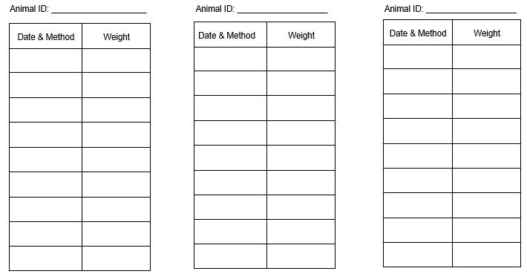

**Feed Amount & Expense Record** If recording for a herd, be sure to divide totals by the number in the herd for accurate Project Summary & Analysis results.

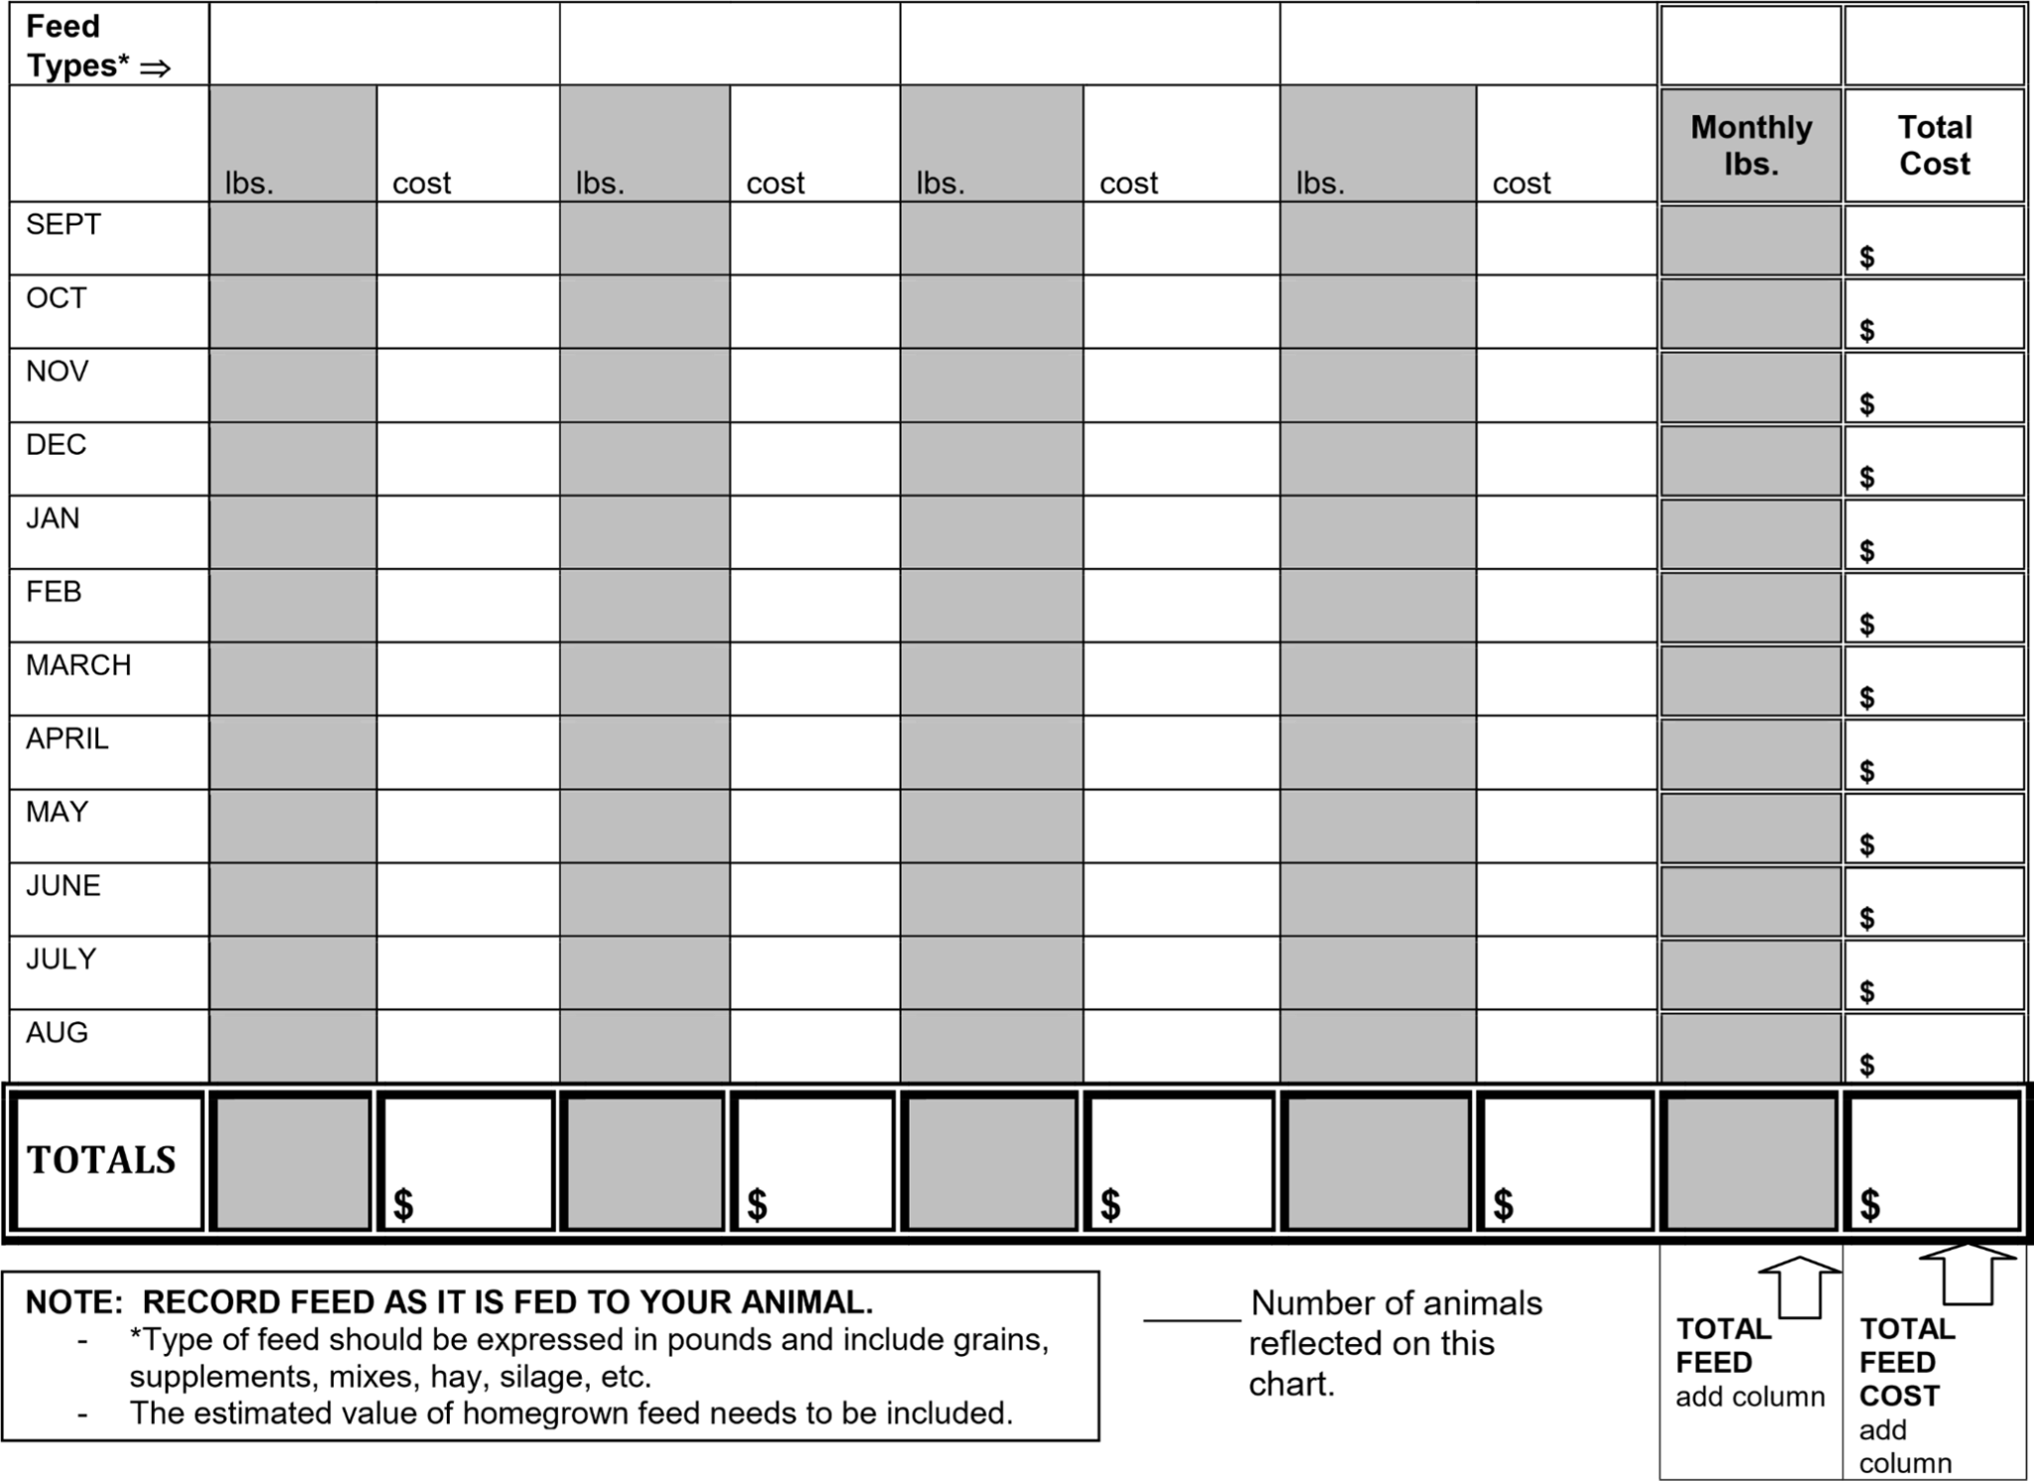

# Project Expenses

# Costs associated with your project work, excluding feed, should be listed here. Consider expenses such as materials, supplies, breeding fees, veterinary expenses, barn-rental, machinery, equipment, tack, clinic/lesson fees, farm utilities, tagging fees, fuel/transportation, etc. Please include income, whether from selling animals, equipment or tack, or earnings from show-winnings, barn work, etc.

| Date | Item | Paid-To or Sold-To | $ Amount |
| --- | --- | --- | --- |
|  |  |  |  |
|  |  |  |  |
|  |  |  |  |
|  |  |  |  |
|  |  |  |  |
|  |  |  |  |
|  |  |  |  |
|  |  |  |  |
|  |  |  |  |
|  |  |  |  |
|  |  |  |  |
|  |  |  |  |

# Number of animals reflected in this chart: Total Expenses:

**Health Record**

Enrolling in an animal project requires you to take responsibility for the health and treatment of your animal. Record all health care for your animal including medications, immunizations (shots), dewormers, as well as management care such as fly prevention, nail/hoof trimming, shearing, or clipping. Also include supplement and medicated feeds (check the feed tag). Remember to record the cost of healthcare services and supplies on the Project Expenses record (page 6).

Use “N/A” where applicable. Not all rows need to be filled out.

| Date | Animal Name or  Identification # | Reason for Treatment/Symptom(s) | Treated with, Dosage, and Method of Administration | Lot Number Expiration Date | Person Who Administered the Treatment | Withdrawal Time | Date of Completed Withdrawal |
| --- | --- | --- | --- | --- | --- | --- | --- |
|  |  |  |  |  |  |  |  |
|  |  |  |  |  |  |  |  |
|  |  |  |  |  |  |  |  |
|  |  |  |  |  |  |  |  |
|  |  |  |  |  |  |  |  |
|  |  |  |  |  |  |  |  |
|  |  |  |  |  |  |  |  |

# Project Summary & Analysis

# Note, you may have kept records for more than the one market beef you bring to auction. Be sure to divide total expenses by the number of animals you raised to get an accurate summary for your fair year. Information for the sheet below should reflect only the animal brought to fair.

| Ear Tag # | Breed | Gender | Date Acquired | Beginning Weight | Final Weight |
| --- | --- | --- | --- | --- | --- |
|  |  |  |  |  |  |

| Price of Animal at Purchase (or Beginning Value) |  |
| --- | --- |
| Total Cost of Animal Feed pg 5 |  |
| Other Animal Expenses pg 6 |  |
| Total Expenses | $ |

***Break-Even Cost:***



**_____________ ______________ $ _______________**

Total Expenses Final Weight Break-Even Cost per lb.

***Estimated Project Income:***



**___________________ _____________________ $ ______________________** Total Estimated Income

* Market Price per lb. Final Weight Expected Project Income 

**$ ______________________** 

** Other Income

*Market Price is the price you would receive under normal sale conditions (such as an auction sale yard).

These prices are published in agriculture newspapers, magazines, or TV and Radio Farm Reports, also available online. Market Price can be found at fair grounds where

**Other Income could include premiums from another show or sale of by-products (wool, eggs, milk, manure, etc.) generated prior to the fair.

# Parts of a Steer

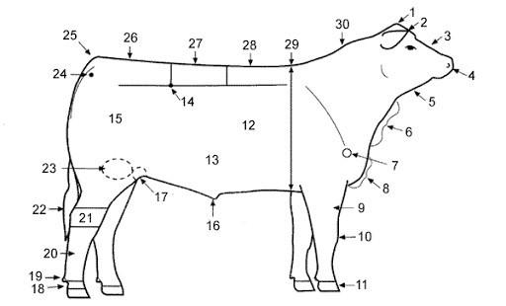

Write the number next to the matching body part name

| Back | Crest | Face | Hoof | Muzzle | Point of Shoulder | Rib | Tail Head |
| --- | --- | --- | --- | --- | --- | --- | --- |
| Belly | Dew Claw | Forearm | Hook | Sheath | Poll | Rump | Throat |
| Brisket | Dewlap | Heart Girth | Knee | Pastern | Quarter | Stifle Joint |  |
| Cannon Bone | Ear | Hock | Loin | Pin | Rear Flank | Switch |  |

## Beef Cut Identification

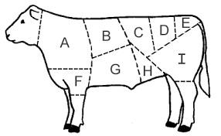

Short Loin Rump Chuck Brisket Flank

Round Short-plate Sirloin Shank

***Please identify cuts*** Put the cut identification next to the letter

| A. | D. | G. |
| --- | --- | --- |
| B. | E. | H. |
| C. | F. | I. |

# I Know Cattle, Short Answers Answer with complete sentences and thorough responses. Use a separate sheet of paper and attach it to your record book if you need more space.

1. **Describe a health concern that may affect your project and how to prevent and treat it.**
2. **Explain the ruminant digestive system, use correct anatomical names in your description.**
3. **Describe the ideal conformation of beef cattle.**

**Personal Development**

List 3 people or companies you sent/delivered a buyer letter to:

1. __________________________________
2. __________________________________
3. __________________________________

List 3 people, places, or resources you used to help you with your project this year:

1. ___________________________________

2. ___________________________________

3. ___________________________________

What skills did you practice or learn with your project?

1. _________________________________
2. _________________________________
3. _________________________________

**Project Essay** Pick one of the following topics to write an essay on. The essay should be a minimum length of 5 paragraphs. You may type or handwrite the assignment. Please attach it to the end of your record book.

Topic options, please circle your choice:

* My Project Goals and How I Met Them or Why I Didn’t Achieve Them
* What/Who influenced Me to Complete a Beef Cattle Project and If I Plan to do it Again Next Year
* My Career Opportunities in Agriculture
* How to Care for Beef Cattle and What Supplies I Need
* Explain rotational grazing and how it interrupts parasitic life cycles.

**Project Pictures** share a minimum of 3 pictures of your project. Pictures should be on a piece of paper attached to your record book. Artistic display is encouraged but not required.

| Page | **Grading Rubric** | Point Possible | Your Points |
| --- | --- | --- | --- |
| **1 & 2** | **Cover Sheet & Why Keep Records** | **5** |  |
|  | (5) Completed  (0) Incomplete |  |  |
| **3** | **My Market Beef Project** | **5** |  |
|  | (5) Completed  (0) Incomplete |  |  |
| **4** | **Weight Records** | **10** |  |
|  | (10) Thoughtfully and thoroughly filled out  (8-9) Good attempt to complete, improperly filled out  (5-8) Record attempted  (0-5) Record barely or not attempted |  |  |
| **5** | **Feed Amount & Expense Record** | **10** |  |
|  | (10) Thoughtfully and thoroughly filled out  (8-9) Good attempt to complete, improperly filled out  (5-8) Record attempted  (0-5) Record barely or not attempted |  |  |
| **6** | **Project Expenses** | **10** |  |
|  | (10) Thoughtfully and thoroughly filled out  (8-9) Good attempt to complete, improperly filled out  (5-8) Record attempted  (0-5) Record barely or not attempted |  |  |
| **7** | **Health Record** | **10** |  |
|  | (10) Thoughtfully and thoroughly filled out  (8-9) Good attempt to complete, improperly filled out  (5-8) Record attempted  (0-5) Record barely or not attempted |  |  |
| **8** | **Parts of a Cattle & Beef Cut Identification** | **10** |  |
|  | (5) all parts correct (3) half or more correct (0) Not completed/mostly wrong  (5) all cuts correct (3) half or more correct (0) Not completed/mostly wrong |  |  |
| **9** | **I Know Cattle, Short Answers** | **10** |  |
|  | (10) Questions are correct and full sentences  (8) Most questions are correct, full sentences  (5) No correct answer, full sentences  (0) incomplete sentences |  |  |
| **10** | **Personal Development** | **10** |  |
|  | (10) Completed  (5) More than half completed  (0) Not completed |  |  |
| **11** | **Project Essay** | **10** |  |
|  | (10) Organized, on topic, and thorough, 5 paragraphs  (6-9) Mostly on topic, lacking sustenance, 5 paragraphs  (4-5) Less than 5 paragraphs, topic mostly covered  (1-3) Not on topic, disorganized, lacking  (0) Not done |  |  |
| **11** | **Project Pictures** | **10** |  |
|  | (10) 3 relevant pictures attached to record book  (5) Less than 3 pictures or not attached to record book  (0) No pictures |  |  |
| **ALL** | **Total** | **100** |  |

Grading Points:

A: 85-100

B: 65-84

C: less than 64

Judge’s Comments: