**Northern District Fair**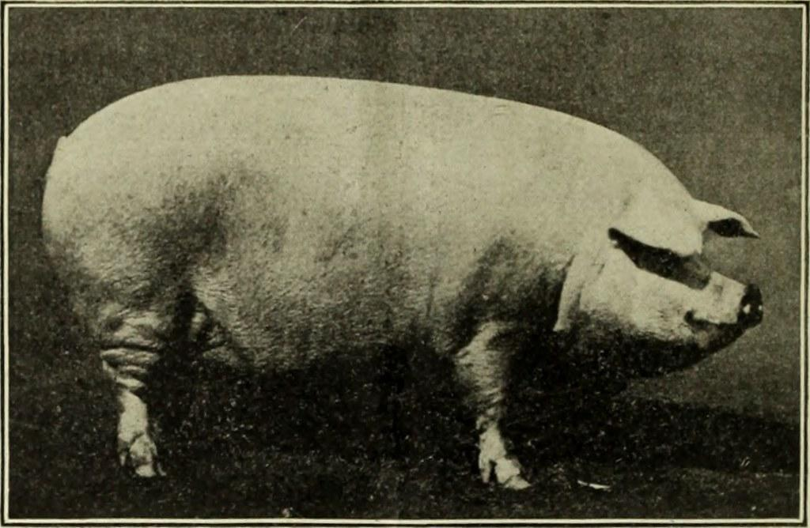

**Swine**

**Record Book**

**Intermediate (10-14)**

Project Year ___________

|  | | Place Ending Project Picture Here | | --- | |
| --- | --- | --- |

Name: ________________________________________________

Number of years in the Project: ____________________________

Fair Age as of January 1, of the current year: __________________

Club or Organization: _____________________________________

Club/Organization Leader: _________________________________

Record Started: _____________ Record Closed: ______________

Month/Day/Year Month/Day/Year

***\*\*RECORD BOOKS ARE DUE ON FIRST DAY OF FAIR\*\****

**WHY KEEP RECORDS?**

This record is a part of your Market Livestock Project and must be entered for judging at the Northern District Fair. A record book per market animal is required for auction. Keep this book as part of your personal records. This information is helpful for you to plan future year's market projects, as well as if you ever apply for awards or a scholarship.

Good records will:

* Help you learn about your animals, their rate of growth, the feed they require, the cost of

their feed and their overall health.

* Let you know if you made or lost money and how much.
* Improve your management practices.
* Give you a record of your project activities.

Objectives for exhibitors before fair:

* Learn the responsibilities to care, keep, and document animal husbandry.
* Set goals related to your animal projects and personal development.
* Foster relationships and make professional connections within your community.

Exhibitor Signature:_______________________________

Leader Signature: ________________________________

The Northern District Fair values every exhibitor’s experience. Did you need assistance or accommodations to fill out this record book? Please describe how below:

______________________________________________________________________________________________________________________________________________________________________________________________________________________________

__________________________________________________________________________

**My Market Swine Project**

Name and/or description of animal(s): ___________________________________________

Breed(s): __________________________________________________________________

Identification of animal(s) (Tattoo/Ear tag): ________________________________________

__________________________________________________________________________

Estimated Birth date of animal(s): _______________________________________________

Date of ownership or purchase date:_____________________________________________

Estimated beginning value of animal(s): __________________________________________ ( or the cost of your animal)

**Please tell us about your project animal** (check all that apply):

_______ Purchased my project animal(s)

_______ Project animal(s) are bred & owned (from an animal on my family farm)

_______ Other (please explain): _____________________________________________

__________________________________________________________________________

**Please explain three goals that you have for your animal project:**

1. ________________________________________________________________ ________________________________________________________________
2. ________________________________________________________________ ________________________________________________________________
3. ________________________________________________________________________________________________________________________________

**Record Keeping** The next 4 pages are for you to keep track of your project’s weight, health, and expenses. Some exhibitors raise more than one or two hogs and decide at the time of fair which are best to compete with.The tables below are created for exhibitors to choose between recording one or multiple hogs. Please note, the Project Summary Analysis (page 8) should be calculated using only data from the hog(s) brought to fair. Notating the “Animal ID” where applicable is necessary for accurate final calculations.

**Weight Records** Methods for weighing your projects include scale at fairgrounds, personal scale, or using a measuring tape with calculations. Resources for weighing your animal with a measuring tape can be found online. Print more as needed.

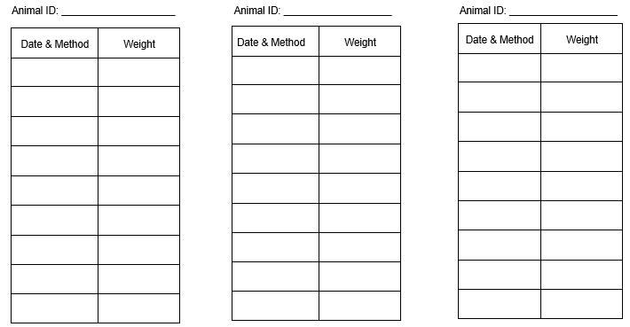

**Feed Amount Record** Types of feed should be expressed in pounds or by bales. Include grain, hay, silage, supplements, homegrown feed or any other feed given to your project. *Remember to record feed costs under Project Expenses.*

Amount of Animals fed in record below: _________

| Feed Type → |  |  |  |  |  |
| --- | --- | --- | --- | --- | --- |
|  | Lbs/bales | Lbs/bales | Lbs/bales | Lbs/bales | Lbs/bales |
| December |  |  |  |  |  |
| January |  |  |  |  |  |
| February |  |  |  |  |  |
| March |  |  |  |  |  |
| April |  |  |  |  |  |
| May |  |  |  |  |  |
| June |  |  |  |  |  |
| July |  |  |  |  |  |
| August |  |  |  |  |  |
| Total Amount: |  |  |  |  |  |

# Project Expenses

# Costs associated with your project work, including feed, should be listed here. Consider expenses such as materials, supplies, breeding fees, veterinary expenses, barn-rental, machinery, equipment, tack, clinic/lesson fees, farm utilities, tagging fees, fuel/transportation, etc

| Date | Item | Paid-To | $ Amount |
| --- | --- | --- | --- |
|  |  |  |  |
|  |  |  |  |
|  |  |  |  |
|  |  |  |  |
|  |  |  |  |
|  |  |  |  |
|  |  |  |  |
|  |  |  |  |
|  |  |  |  |
|  |  |  |  |
|  |  |  |  |
|  |  |  |  |

# Number of animals reflected in this chart: Total Expenses:

**Health Record**

Enrolling in an animal project requires you to take responsibility for the health and treatment of your animal. Record all health care for your animal including medications, immunizations (shots), dewormers, as well as management care such as fly prevention, nail/hoof trimming, shearing, or clipping. Also include supplement and medicated feeds (check the feed tag). Remember to record the cost of healthcare services and supplies on the Project Expenses record (page 6).

Use “N/A” where applicable. Not all rows need to be filled out.

| Date | Animal Name or  Identification # | Reason for Treatment/Symptom(s) | Treated with, Dosage, and Method of Administration | Lot Number Expiration Date | Person Who Administered the Treatment | Withdrawal Time | Date of Completed Withdrawal |
| --- | --- | --- | --- | --- | --- | --- | --- |
|  |  |  |  |  |  |  |  |
|  |  |  |  |  |  |  |  |
|  |  |  |  |  |  |  |  |
|  |  |  |  |  |  |  |  |
|  |  |  |  |  |  |  |  |
|  |  |  |  |  |  |  |  |
|  |  |  |  |  |  |  |  |

# Project Summary & Analysis

# Note, you may have kept records for more than the one hog (or pen of 2) you bring to auction. Be sure to divide total expenses by the number of animals you raised to get an accurate summary for your fair year. Information for the sheet below should reflect only the animal(s) brought to fair.

| Ear Tag # | Breed | Gender | Date Acquired | Beginning Weight | Final Weight |
| --- | --- | --- | --- | --- | --- |
|  |  |  |  |  |  |
|  |  |  |  |  |  |

| Price of Animal at Purchase (or Beginning Value) |  |
| --- | --- |
| Other Animal Expenses (pg 6) |  |
| Total Expenses | $ |

***Break-even per pound:*** To calculate the break-even price divide your total expenses per animal by the finished weight.

***Break-even price per pound: $____________________________________***

***Market Price Summary:*** Market prices can be found posted in the barns. Please complete before turning into barn superintendent. Multiply market price per pound by the final weight of the project to find the total price your project would sell for at a stockyard auction.

Market Price of my swine: $____________________

Would you have been able to make a profit if you had sold your animal at a stockyard at this current market price rather than the fair’s livestock sale? Why or why not? _________________________________________________________________________________

___________________________________________________________________________________________________________

___________________________________________________________________________________________________________

**Parts of a Pig**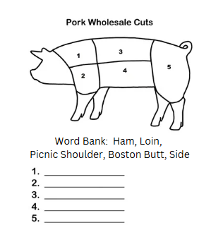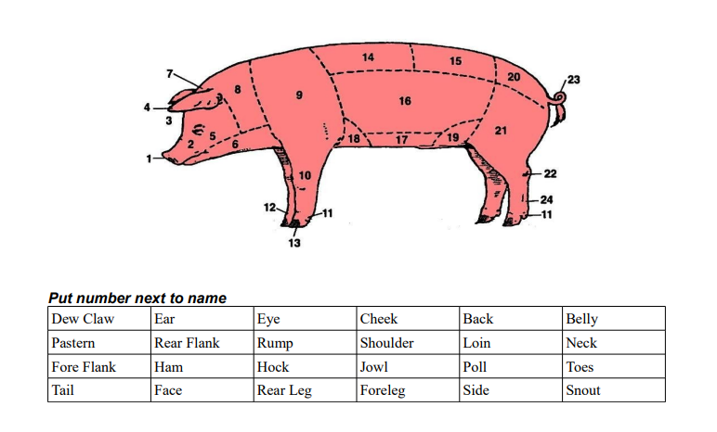

**I Know Swine, Short Answers** Answer with complete sentences and thorough responses. Use a separate sheet of paper and attach it to your record book if you need more space.

1. **Describe a health concern that may affect your project and how to prevent and treat it.**
2. **Pick one heritage swine breed and describe its origins and characteristics.**
3. **Describe the ideal conformation of a hog.**

**Personal Development**

List 3 people or companies you sent/delivered a buyer letter to:

1. __________________________________
2. __________________________________
3. __________________________________

List 3 people, places, or resources you used to help you with your project this year:

1. ___________________________________

2. ___________________________________

3. ___________________________________

What skills did you practice or learn with your project?

_______________________________________________________________________________________________________________________________________________________________________________________________________________

What was a challenge you faced with your swine project and how did you overcome it?

_______________________________________________________________________________________________________________________________________________________________________________________________________________

**Project Essay** Pick one of the following topics to write an essay on. The essay should be a minimum length of 3 paragraphs. You may type or handwrite the assignment. Please attach it to the end of your record book.

Topic options, please circle your choice:

* Why I liked or didn’t like working with swine.
* What I learned from this year’s swine project.
* Explain the life cycle of a parasite and how it affects swine.
* How to care for a hog, from birth to butcher.

**Project Pictures** share a minimum of 6 pictures of your project. Pictures should be on a piece of paper attached to your record book. Artistic display is encouraged but not required.

**Scoring Rubric**

| Page | Topic | Points Possible | Points Awarded |
| --- | --- | --- | --- |
| 1&2 | Cover Page & Signature | 5 |  |
|  | Completed |  |  |
| 3 | My Market Swine Project | 5 |  |
|  | Completed |  |  |
| 4 | Weight Record | 10 |  |
|  | Completed & detailed |  |  |
| 5 | Feed Record | 10 |  |
|  | Completed & detailed |  |  |
| 6 | Project Expenses | 10 |  |
|  | Completed & detailed |  |  |
| 7 | Health Record | 5 |  |
|  | Completed & detailed |  |  |
| 8 | Project Summary & Analysis | 10 |  |
|  | Completed & correct |  |  |
| 9 | Parts of a Pig and Pork Butcher Cuts | 5 |  |
|  | Completed & correct |  |  |
| 10 | I Know Swine, Short Answers | 10 |  |
|  | Completed, full sentences, correct |  |  |
| 11 | Personal Development | 5 |  |
|  | Completed and detailed |  |  |
| 12 | Project Essay | 20 |  |
|  | Complet, attached, correct, & quality work |  |  |
| 12 | Project Photos | 5 |  |
|  | attached |  |  |
|  | **Total:** | **100** |  |

**Comments:**

**________________________________**

Record Book Judge:

**Total Points:**

A – 90-100

B – 80-89

C – 60-79

DQ: Below 60