**Northern District Fair**

**Market Beef**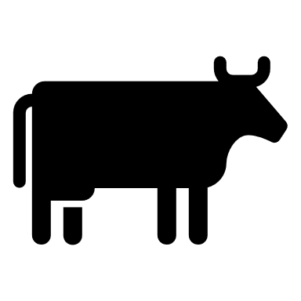

**Record Book**

**Junior, age 9**

Project Year ___________

|  | | Place Ending Project Picture Here | | --- | |
| --- | --- | --- |

Name: ________________________________________________

Number of years in the Project: ____________________________

Fair Age as of January 1, of the current year: __________________

Club or Organization: _____________________________________

Club/Organization Leader: _________________________________

Record Started: _____________ Record Closed: ______________

Month/Day/Year Month/Day/Year

***\*\*RECORD BOOKS ARE DUE ON FIRST DAY OF FAIR\*\****

**WHY KEEP RECORDS?**

This record is a part of your Market Livestock Project and must be entered for judging at the Northern District Fair. A record book per market animal is required for auction. Keep this book as part of your personal records. This information is helpful for you to plan future year's market projects, as well as if you ever apply for awards or a scholarship.

Good records will:

* Help you learn about your animals, their rate of growth, the feed they require, the cost of

their feed and their overall health.

* Let you know if you made or lost money and how much.
* Improve your management practices.
* Give you a record of your project activities.

Objectives for exhibitors before fair:

* Learn the responsibilities to care, keep, and document animal husbandry.
* Set goals related to your animal projects and personal development.
* Foster relationships and make professional connections within your community.

Exhibitor Signature:_______________________________

Leader Signature: ________________________________

The Northern District Fair values every exhibitor’s experience. Did you need assistance or accommodations to fill out this record book? Please describe how below:

______________________________________________________________________________________________________________________________________________________________________________________________________________________________

__________________________________________________________________________

**My Market Beef Project**

Name and/or description of animal(s): ___________________________________________

Breed(s): __________________________________________________________________

Identification of animal(s) (Tattoo/Ear tag): ________________________________________

__________________________________________________________________________

Estimated Birth date of animal(s): _______________________________________________

Date of ownership or purchase date:_____________________________________________

Estimated beginning value of animal(s): __________________________________________ ( or the cost of your animal)

**Please tell us about your project animal** (check all that apply):

_______ Purchased my project animal(s)

_______ Project animal(s) are bred & owned (from an animal on my family farm)

_______ Other (please explain): _____________________________________________

__________________________________________________________________________

**Please explain three goals that you have for your animal project:**

1. ________________________________________________________________ ________________________________________________________________
2. ________________________________________________________________ ________________________________________________________________
3. ________________________________________________________________________________________________________________________________

**Record Keeping** The next 2 pages are for you to keep track of your project’s weight and expenses. Some exhibitors raise more than one steer/heifer and decide at the time of fair which is best to compete with. The tables below are created for exhibitors to choose between recording for one or multiple cattle. Please note, the Project Summary Analysis (page 6) should be calculated using only data from the animal brought to fair. Notating the “Animal ID” where applicable is necessary for accurate final calculations.

**Weight Records** Methods for weighing your projects include scale at fairgrounds, personal scale, or using a measuring tape with calculations. Resources for weighing your animal with a measuring tape can be found online. Print more as needed.

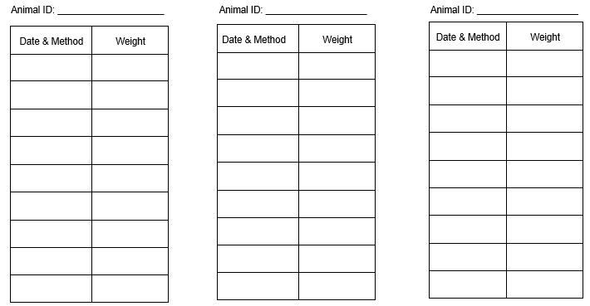

# Project Expenses

# Costs associated with your project work, including feed, should be listed here. Consider expenses such as materials, supplies, breeding fees, veterinary expenses, barn-rental, machinery, equipment, tack, clinic/lesson fees, farm utilities, tagging fees, fuel/transportation, etc.

| Date | Item | Paid-To | $ Amount |
| --- | --- | --- | --- |
|  |  |  |  |
|  |  |  |  |
|  |  |  |  |
|  |  |  |  |
|  |  |  |  |
|  |  |  |  |
|  |  |  |  |
|  |  |  |  |
|  |  |  |  |
|  |  |  |  |
|  |  |  |  |
|  |  |  |  |

# Number of animals reflected in this chart: Total Expenses:

# Project Summary & Analysis

# Note, you may have kept records for more than the one market beef you bring to auction. Be sure to divide total expenses by the number of animals you raised to get an accurate summary for your fair year. Information for the sheet below should reflect only the animal brought to the fair.

| Ear Tag # | Breed | Gender | Date Acquired | Beginning Weight | Final Weight |
| --- | --- | --- | --- | --- | --- |
|  |  |  |  |  |  |

| Price of Animal at Purchase (or Beginning Value) |  |
| --- | --- |
| Total Project Expenses (divided by total number in the herd) found on page 5 | + |
| **Total Expenses:** | $ |

***Break-Even Cost:***



**_____________ ______________ $ _______________**

**Total Expenses** Final Weight Break-Even Cost per lb.

***Estimated Project Income:***



**___________________ _____________________**

* Market Price per lb. Final Weight Expected Project Income

** Other Income

*Market Price is the price you would receive under normal sale conditions (such as an auction sale yard).

These prices are published in agriculture newspapers, magazines, or TV and Radio Farm Reports, also available online. Market Price can be found at fair grounds where

**Feed Information** 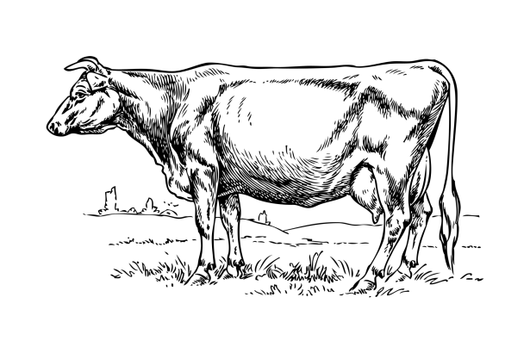

This is what I feed my beef project, check all that apply:

____ Hay ___ Pellets ___ Supplements

____ Grain ___ Other: ____________________________________________

I feed _______ % protein.

My cows like to eat ______________________________________________________ for treats.

Attached is a feed tag from a feed bag I used in my project:

**Health Information** Enrolling in an animal project requires you to take responsibility for the health and treatment of your animal. Draw a line connecting the common tools to their name. 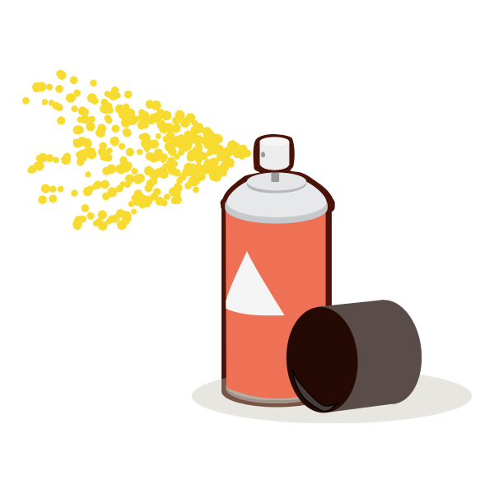

Immunization/Syringe & Needle

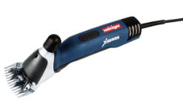

Drench Gun

Fly Prevention 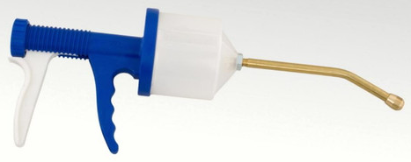

Hoof Trimmers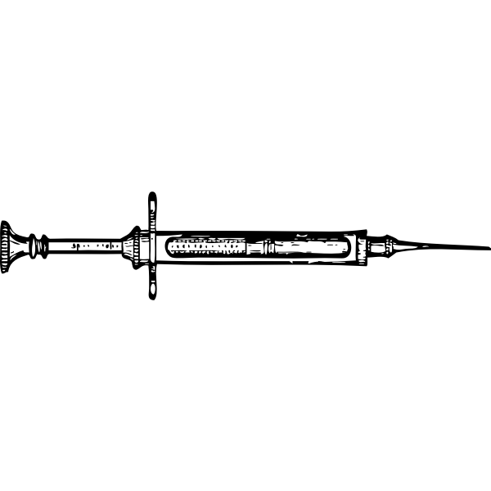

Shearers/Clippers

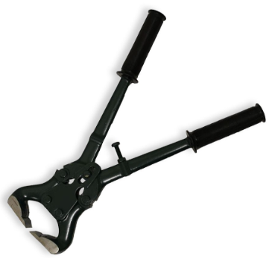

# Parts of a Steer

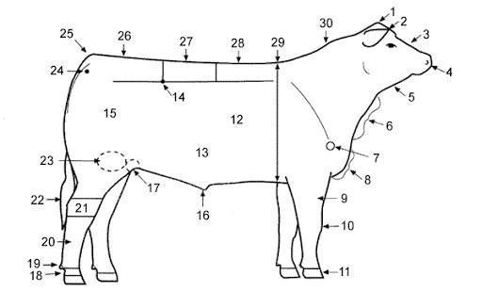

Write the number next to the matching body part name

| Back | Crest | Face | Hoof | Muzzle | Point of Shoulder | Rib | Tail Head |
| --- | --- | --- | --- | --- | --- | --- | --- |
| Belly | Dew Claw | Forearm | Hook | Sheath | Poll | Rump | Throat |
| Brisket | Dewlap | Heart Girth | Knee | Pastern | Quarter | Stifle Joint |  |
| Cannon Bone | Ear | Hock | Loin | Pin | Rear Flank | Switch |  |

## Beef Cut Identification

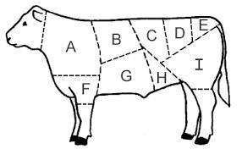

Short Loin Rump Chuck Brisket Flank

Round Short-plate Sirloin Shank

***Please identify cuts*** Put the cut identification next to the letter

| A. | D. | G. |
| --- | --- | --- |
| B. | E. | H. |
| C. | F. | I. |

# I Know Cattle

| **Digestive System** | **Health Concerns**  List three cattle diseases:  1.  2.  3. |
| --- | --- |
| **Breeds**  List three breeds of beef cattle  1.  2.  3. | **By-Products**  List three by-products of beef cattle  1.  2.  3. |

**Personal Development**

List 3 people or companies you sent/delivered a buyer letter to:

1. __________________________________
2. __________________________________
3. __________________________________

What is your favorite recipe to make with beef? _______________________________

What tools do you bring for a show? ________________________________________

_____________________________________________________________________

Did you earn other income from your beef project over the year, how? _____________

_____________________________________________________________________

What did you learn from your beef project this year? ___________________________

_____________________________________________________________________

What did you enjoy about your beef project? _________________________________

_____________________________________________________________________

What was your biggest challenge this year? __________________________________

_____________________________________________________________________

**Project Story** On a separate sheet of paper, tell us a story surrounding your project. You could share a funny moment, something new you learned, something you enjoyed or hated about your project, or something else that involves your beef project. You may type or handwrite the assignment. It should be a minimum of 1 paragraph long. Please attach it to the end of your record book.

**Project Pictures** share a minimum of 3 pictures of your project. Pictures should be on a piece of paper attached to your record book. Artistic display is encouraged but not required.

| Page | **Grading Rubric** | Point Possible | Your Points |
| --- | --- | --- | --- |
| **1 & 2** | **Cover Sheet & Why Keep Records** | **5** |  |
|  | (5) Completed  (0) Incomplete |  |  |
| **3** | **My Market Beef Project** | **5** |  |
|  | (5) Completed  (0) Incomplete |  |  |
| **4** | **Weight Records** | **10** |  |
|  | (10) Thoughtfully and thoroughly filled out  (8-9) Good attempt to complete, improperly filled out  (5-8) Record attempted  (0-5) Record barely or not attempted |  |  |
| **5** | **Project Expenses** | **10** |  |
|  | (10) Thoughtfully and thoroughly filled out  (8-9) Good attempt to complete, improperly filled out  (5-8) Record attempted  (0-5) Record barely or not attempted |  |  |
| **6** | **Project Summary & Analysis** | **10** |  |
|  | (10) Filled out and correct math  (5) Filled out with incorrect math  (0) Incomplete |  |  |
| **7** | **Feed Information** | **10** |  |
|  | (10) Thoughtfully and thoroughly filled out  (8-9) Good attempt to complete, improperly filled out  (5-8) attempted  (0-5) not attempted |  |  |
| **8** | **Health Information** | **10** |  |
|  | (10) done & correct  (5) Done and half or more correct  (0) Not done or more than half incorrect |  |  |
| **9** | **Parts of a Cattle & Beef Cut Identification** | **10** |  |
|  | (5) all parts correct (3) half or more correct (0) Not completed/mostly wrong  (5) all cuts correct (3) half or more correct (0) Not completed/mostly wrong |  |  |
| **10** | **I Know Cattle** | **10** |  |
|  | (10) All correct answers  (8) 75% of answers are correct  (5) 50% of answers are correct  (0) more than half of the answers are incorrect or incomplete |  |  |
| **11** | **Personal Development** | **10** |  |
|  | (10) Completed  (5) More than half completed  (0) Not completed |  |  |
| **11** | **Project Story & Pictures** | **10** |  |
|  | (10) Organized, on topic, and thorough, 3 photos  (6-9) Mostly on topic, lacking sustenance, 3 photos  (4-5) topic mostly covered, less than 3 photos  (1-3) Not on topic, disorganized, no photos  (0) No photos or story |  |  |
| **ALL** | **Total** | **100** |  |

Grading Points:

A: 85-100

B: 65-84

C: less than 64

Judge’s Comments: