Getting It Together Coaching & Consulting, LLC 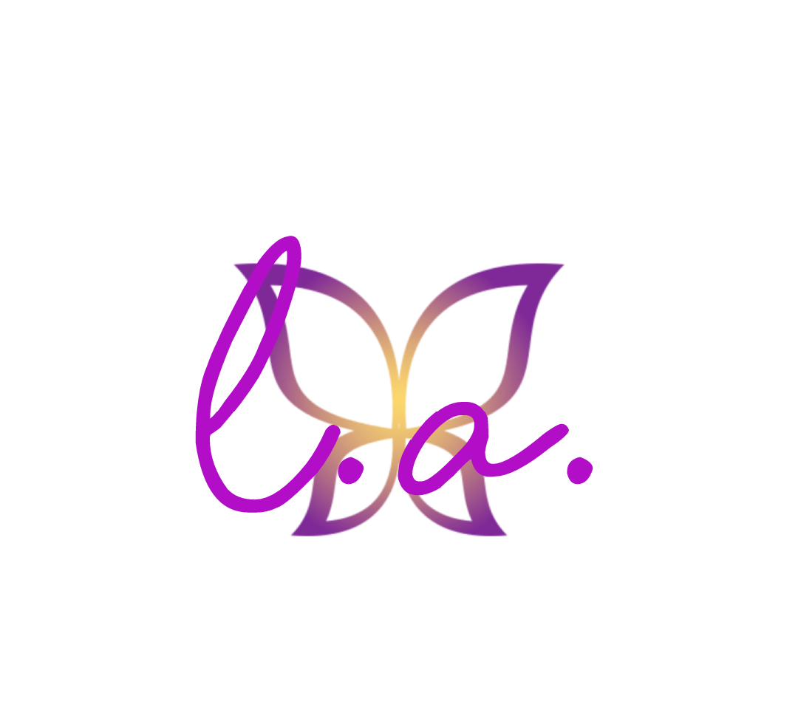

Self-Awareness Worksheet Who I am?

This Self-Awareness worksheet focuses on discovering “Who am I?” It is an all-encompassing worksheet that address talents, qualities, values, perception, and self-reflection.

Self-Awareness happens through reflection. You can have numerous experiences in your life, but still lack self-awareness. You need to take the time to step outside of your experiences and reflect on them. The key areas for self-awareness include our personality traits, personal values, emotions, habits, and the psychological needs that motivate our behaviors.

Self-awareness and/or Self Discovery is about knowing and understanding: your beliefs and principles What you value and what is important to you? What motivates you? Your own emotions , your thinking patterns, your tendencies to react to certain situations and what you want out of life

Who I am?

To get you thinking about your personal development plan and your mission statement, spend some time contemplating the following:

TALENTS: What are your greatest talents or skills?

Which of your talents or skills gives you the greatest sense of pride or satisfaction?

What talents or skills do you admire most in others?

What talent or skill do you wish to develop for yourself?

TRAITS/QUALITIES What are your five greatest strengths?
1.
2.
3.
4.
5.

What do you feel are your two biggest weaknesses?
1.
2.

What are your best qualities/characteristics?

What qualities do you wish you had?

What qualities or traits do you most admire in others?

What behaviors, traits, or qualities do you want other people to admire in you?

VALUES What are ten (10) things that are really important to you?
1.
2.
3.
4.
5.
6.
7.
8.
9.
10.

What are the three most important things to you?
1.
2.
3.
Do you spend enough time on/with the things you most value? Why or why not?

What are the values that you hold most near to your heart?

PERCEPTION How is the “public you” different from the “private you”?

What makes it hard to be yourself with others?

How are you trying to please others with the way you live your life?

What do you want people to think and say about you?

How do your behaviors and actions support what they think or say?

What do you least want people to think about you?

Is it more important to be like by others or to be yourself? Why?

Who are the people who allow you to feel fully yourself?

What places allow you to feel fully yourself?

What activities allow you to feel fully yourself?

How do you want people to remember you when you are gone?

ACCOMPLISHMENTS What three things are you most proud of in your life to date?
1.
2.
3.

What do you hope to achieve in life?

If you were to receive an award, what would you want that award to represent? Why?

If you could accomplish only one thing during the rest of your life, what would it be?

What do you believe you are here to accomplish or contribute to the world?

REFLECTION List three (3) things that you are:
1.
2.
3.

List three (3) things that you are not:
1.
2.
3.

What is something that represents you? (e.g. song, animal, flower, poem, symbol, jewelry, etc…) why?

What do you like best about yourself?

What do you like least about yourself?

What three things would you like to change most about yourself?
1.
2.
3.

Who are two people you most admire?
1.
2.

What do you admire about them?

What are five things you love to do?
1.
2.
3.
4. 5.

What matters to you most in my life?

What makes you happy?

What are three things you believe you need in order to have a great life?
1.
2.
3.

Why are those things important to you?

What do you stand for (Principles)?

How do you want to impact the lives of others?

Finish the sentence

I do my best when...

I struggle when…

I am comfortable when…

I feel stress when…

I am courageous when...

One of the most important things I learned was...

I missed a great opportunity when...

One of my favorite memories is…

My toughest decisions involve...

Being myself is hard because…

I can be myself when…

I wish I was more….

I wish I could…

I wish I would regularly….

I wish I had…

I wish I knew…

I wish I felt…

I wish I saw…

I wish I thought…

Life should be about…

I am going to make my life about…

