Anxiety Coping Card

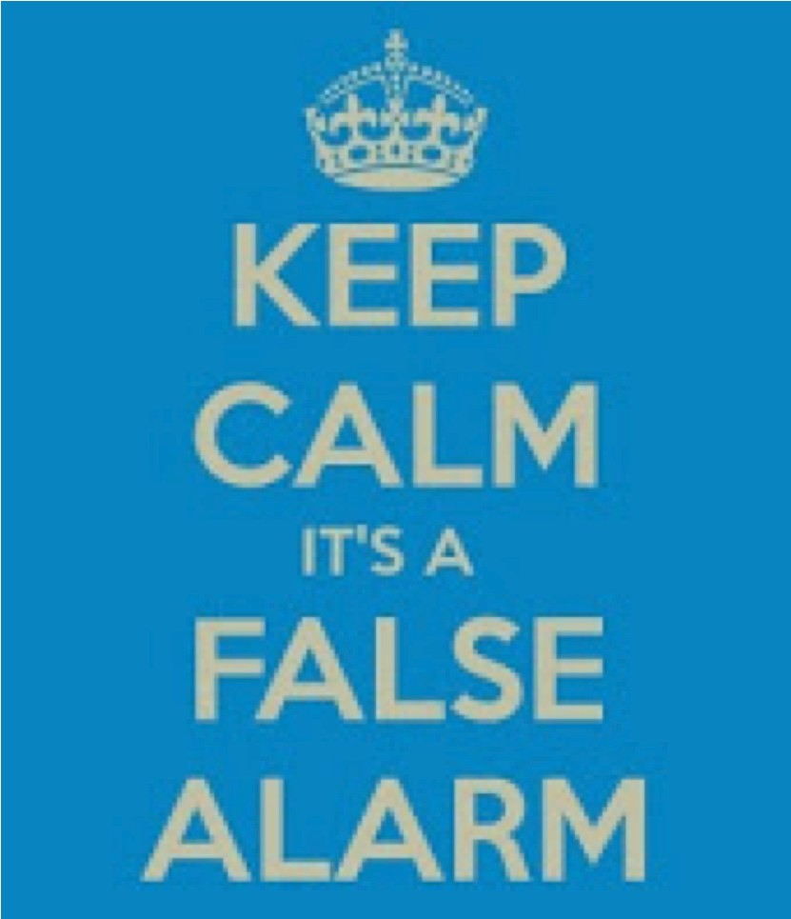

Positive statements encourage us and help us cope through distressing times.

**Anxiety Coping Card**

❖

A reminder that physical symptoms

(e.g. racing heart), are just anxiety

❖

A reminder that anxiety is not

dangerous and doesn’t last forever

❖

I am safe and this will pass. I have

survived this before. I am just going to let this pass through my body

❖

You may feel uncomfortable but this

is your body protecting you from danger, not hurting you