SECTION 1: Identification

1.1. Identification
Product form | : | Mixture
Product name | : | Extra Tough (TM) Multi-Purpose Cleaner/Degreaser

1.2. Recommended use and restrictions on use
Use of the substance/mixture | : | Cleaner  Degreaser
Restrictions on use | : | None known

1.3. Supplier
Extra Tough, LLC
4139 LM Gaines Blvd
Starke, FL 32091
USA
T: 1-800-951-0241 (9am-5pm Eastern Time Zone)
Email: info@extratoughcleaners.com
Website: https://extratoughcleaners.com/

1.4. Emergency telephone number
Emergency number | : | +1 855-237-5573

SECTION 2: Hazard(s) identification

2.1. Classification of the substance or mixture

GHS US classification
Skin corrosion/irritation Category 2 | H315 | Causes skin irritation
Serious eye damage Category 1 | H318 | Causes serious eye damage
Skin sensitization, Category 1 | H317 | May cause an allergic skin reaction
Full text of H statements : see section 16

2.2. GHS Label elements, including precautionary statements

GHS US labeling
Hazard pictograms (GHS US) | : | 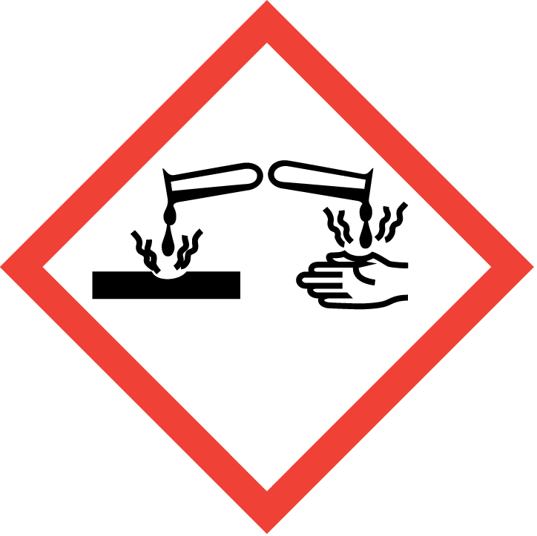 | 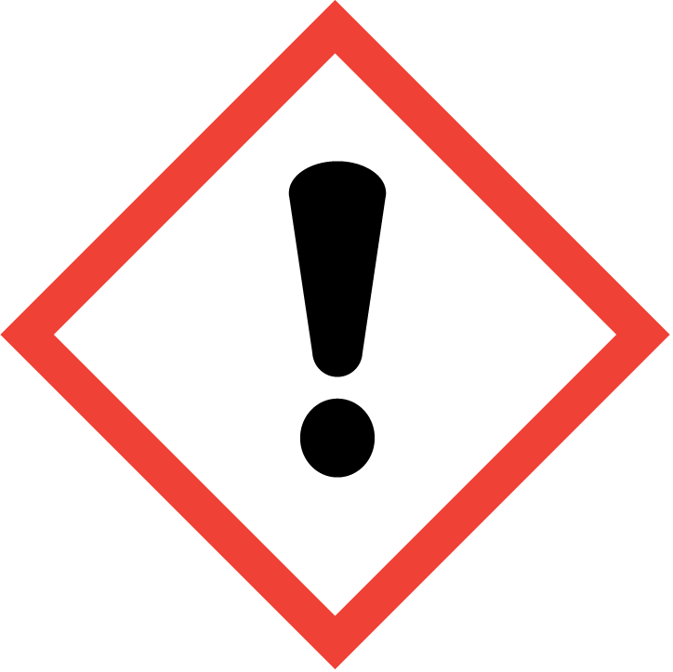
Signal word (GHS US) | : | Danger
Hazard statements (GHS US) | : | H315 - Causes skin irritation  H317 - May cause an allergic skin reaction  H318 - Causes serious eye damage
Precautionary statements (GHS US) | : | P261 - Avoid breathing mist, spray.  P264 - Wash hands thoroughly after handling.  P272 - Contaminated work clothing must not be allowed out of the workplace.  P280 - Wear protective gloves, eye protection.  P305+P351+P338 - If in eyes: Rinse cautiously with water for several minutes. Remove contact lenses, if present and easy to do. Continue rinsing.  P310 - Immediately call a POISON CENTER or doctor/physician.  P302+P352 - If on skin: Wash with plenty of water.  P333+P313 - If skin irritation or rash occurs: Get medical advice/attention.  P362+P364 - Take off contaminated clothing and wash it before reuse.  P501 - Dispose of contents/container to an approved waste disposal plant.

2.3. Other hazards which do not result in classification
Other hazards which do not result in classification | : | None known.

2.4. Unknown acute toxicity (GHS US)
No additional information available

SECTION 3: Composition/Information on ingredients

3.1. Substances
Not applicable

3.2. Mixtures
Name | Product identifier | %
Sodium Hydroxide | CAS-No.: 1310-73-2 | 1-<2
Polyethoxylated tert-dodecyl mercaptan | CAS-No.: 9004-83-5 | < 1
Sulfur based polyoxyethylene | CAS-No.: Proprietary | < 1
Full text of hazard classes and H-statements : see section 16

SECTION 4: First-aid measures

4.1. Description of first aid measures
First-aid measures after inhalation | : | Move the affected person to fresh air. Get medical attention if symptoms occur.
First-aid measures after skin contact | : | Wash skin with plenty of water. Take off contaminated clothing. If skin irritation or rash occurs: Get medical advice/attention.
First-aid measures after eye contact | : | Immediately flush eyes thoroughly with water for at least 20 minutes. Remove contact lenses, if present and easy to do. Continue rinsing. Get immediate medical advice/attention.
First-aid measures after ingestion | : | Call a poison center or a doctor if you feel unwell.

4.2. Most important symptoms and effects (acute and delayed)
Inhalation | : | May cause minor irritation to the respiratory tract and to other mucous membranes.
Skin | : | May cause an allergic skin reaction. Causes skin irritation.
Eyes | : | May cause severe irritation. Risk of serious damage to eyes.
Ingestion | : | May cause gastrointestinal irritation, nausea, vomiting and diarrhea.
Chronic symptoms | : | None known.

4.3. Immediate medical attention and special treatment, if necessary
Immediate medical attention is required for eye contact.

SECTION 5: Fire-fighting measures

5.1. Suitable (and unsuitable) extinguishing media
Suitable extinguishing media | : | Use extinguishing media appropriate for surrounding fire.
Unsuitable extinguishing media | : | None.

5.2. Specific hazards arising from the chemical
Fire hazard | : | This product is not classified as flammable or combustible.
Hazardous decomposition products in case of fire | : | Toxic fumes may be released. Sulfur oxides (SOx). Carbon oxides (CO, CO2).

5.3. Special protective equipment and precautions for fire-fighters
Protection during firefighting | : | Do not attempt to take action without suitable protective equipment.

SECTION 6: Accidental release measures

6.1. Personal precautions, protective equipment and emergency procedures
General measures | : | Wear suitable protective clothing. Avoid contact with eyes, skin and clothing.

6.1.1. For non-emergency personnel
Emergency procedures | : | Avoid contact with skin and eyes. Avoid breathing mist, spray, vapors.

6.1.2. For emergency responders
Protective equipment | : | Do not attempt to take action without suitable protective equipment. For further information refer to section 8: "Exposure controls/personal protection".

6.2. Environmental precautions
Avoid release to the environment.

6.3. Methods and material for containment and cleaning up
For containment | : | Contain any spills with dikes or absorbents to prevent migration and entry into sewers or streams.
Methods for cleaning up | : | Take up liquid spill into absorbent material.
Other information | : | Place in a suitable container for disposal in accordance with the waste regulations (see Section 13).

6.4. Reference to other sections
Refer to protective measures listed in Sections 7 and 8.

SECTION 7: Handling and storage

7.1. Precautions for safe handling
Precautions for safe handling | : | Avoid breathing mist, spray. Wear personal protective equipment. Avoid contact with eyes, skin and clothing. Wash hands with water and soap. Ensure adequate ventilation.
Hygiene measures | : | Contaminated work clothing should not be allowed out of the workplace. Wash contaminated clothing before reuse. Do not eat, drink or smoke when using this product. Always wash hands after handling the product.

7.2. Conditions for safe storage, including any incompatibilities
Storage conditions | : | No special storage required.
Incompatible materials | : | None known.

SECTION 8: Exposure controls/personal protection

8.1. Control parameters

Extra Tough (TM) Multi-Purpose Cleaner/Degreaser
No additional information available

Sodium Hydroxide (1310-73-2)
USA - ACGIH - Occupational Exposure Limits
Local name | Sodium hydroxide
ACGIH OEL Ceiling | 2 mg/m³
Remark (ACGIH) | TLV® Basis: URT, eye, & skin irr
Regulatory reference | ACGIH 2021
USA - OSHA - Occupational Exposure Limits
Local name | Sodium hydroxide
OSHA PEL (TWA) | 2 mg/m³
Regulatory reference (US-OSHA) | OSHA Annotated Table Z-1

Polyethoxylated tert-dodecyl mercaptan (9004-83-5)
No additional information available

Sulfur based polyoxyethylene (Proprietary)
No additional information available

8.2. Appropriate engineering controls
Appropriate engineering controls | : | Ensure good ventilation of the work station.
Environmental exposure controls | : | Avoid release to the environment.

8.3. Individual protection measures/Personal protective equipment
Hand protection:
Wear impervious gloves.

Eye protection:
Chemical goggles

Skin and body protection:
Wear suitable protective clothing

Respiratory protection:
In operations where exposure limits are exceeded or exposure levels are excessive, an approved respirator should be used. Respirator selection and use should be based on contaminant type, form and concentration. Follow applicable regulations and good Industrial Hygiene practice.

SECTION 9: Physical and chemical properties

9.1. Information on basic physical and chemical properties
Physical state | : | Liquid
Appearance | : | Translucent.
Color | : | Pink
Odor | : | citrus-like
Odor threshold | : | No data available
pH | : | 12.01 – 12.03
Melting point | : | -1.55 °C
Freezing point | : | No data available
Boiling point | : | 96 °C
Flash point | : | No data available
Relative evaporation rate (butyl acetate=1) | : | No data available
Flammability (solid, gas) | : | Not applicable.
Vapor pressure | : | No data available
Relative vapor density at 20°C | : | No data available
Relative density | : | 1.042
Solubility | : | Soluble in water.
Partition coefficient n-octanol/water (Log Pow) | : | No data available
Auto-ignition temperature | : | 667
Decomposition temperature | : | No data available
Viscosity, kinematic | : | 16.315 mm²/s
Viscosity, dynamic | : | No data available
Explosion limits | : | No data available
Explosive properties | : | None.
Oxidizing properties | : | None.

9.2. Other information
No additional information available

SECTION 10: Stability and reactivity

10.1. Reactivity
The product is non-reactive under normal conditions of use, storage and transport.

10.2. Chemical stability
Stable under normal conditions.

10.3. Possibility of hazardous reactions
No dangerous reactions known under normal conditions of use.

10.4. Conditions to avoid
None known.

10.5. Incompatible materials
None known.

10.6. Hazardous decomposition products
Under normal conditions of storage and use, hazardous decomposition products should not be produced.

SECTION 11: Toxicological information

11.1. Information on toxicological effects
Acute toxicity (oral) | : | Not classified
Acute toxicity (dermal) | : | Not classified
Acute toxicity (inhalation) | : | Not classified

Sulfur based polyoxyethylene (Proprietary)
LD50 oral rat | 1885 mg/kg
LD50 dermal rabbit | 3500 mg/kg
ATE US (oral) | 1885 mg/kg body weight
ATE US (dermal) | 3500 mg/kg body weight

Skin corrosion/irritation | : | Causes skin irritation.  pH: 12.01 – 12.03

Polyethoxylated tert-dodecyl mercaptan (9004-83-5)
pH | 6 – 7

Serious eye damage/irritation | : | Causes serious eye damage.  pH: 12.01 – 12.03

Polyethoxylated tert-dodecyl mercaptan (9004-83-5)
pH | 6 – 7

Respiratory or skin sensitization | : | May cause an allergic skin reaction.

Germ cell mutagenicity | : | Not classified

Carcinogenicity | : | Not classified

Reproductive toxicity | : | Not classified

STOT-single exposure | : | Not classified

STOT-repeated exposure | : | Not classified

Aspiration hazard | : | Not classified
Viscosity, kinematic | : | 16.315 mm²/s

Inhalation | : | May cause minor irritation to the respiratory tract and to other mucous membranes.
Skin | : | May cause an allergic skin reaction. Causes skin irritation.
Eyes | : | May cause severe irritation. Risk of serious damage to eyes.
Ingestion | : | May cause gastrointestinal irritation, nausea, vomiting and diarrhea.
Chronic symptoms | : | None known.

SECTION 12: Ecological information

12.1. Toxicity
Ecology - general | : | The product is not considered harmful to aquatic organisms or to cause long-term adverse effects in the environment. An environmental hazard cannot be excluded in the event of unprofessional handling or disposal.

Sodium Hydroxide (1310-73-2)
EC50 - Crustacea [1] | 40.4 mg/l

Polyethoxylated tert-dodecyl mercaptan (9004-83-5)
LC50 - Fish [1] | 64 mg/l

Sulfur based polyoxyethylene (Proprietary)
LC50 - Fish [1] | 64 mg/l
EC50 - Crustacea [1] | 2.4 mg/l

12.2. Persistence and degradability
Polyethoxylated tert-dodecyl mercaptan (9004-83-5)
Not rapidly degradable

Sulfur based polyoxyethylene (Proprietary)
Not rapidly degradable

12.3. Bioaccumulative potential
No additional information available

12.4. Mobility in soil
No additional information available

12.5. Other adverse effects
No additional information available

SECTION 13: Disposal considerations

13.1. Disposal methods
Regional legislation (waste) | : | Dispose of in accordance with applicable federal, state, and local regulations.
Waste treatment methods | : | Dispose of in accordance with applicable federal, state, and local regulations.

SECTION 14: Transport information
In accordance with DOT / TDG / IMDG / IATA
DOT | TDG | IMDG | IATA
14.1. UN number
Not regulated for transport
14.2. Proper Shipping Name
Not applicable | Not applicable | Not applicable | Not applicable
14.3. Transport hazard class(es)
Not applicable | Not applicable | Not applicable | Not applicable
14.4. Packing group
Not applicable | Not applicable | Not applicable | Not applicable
14.5. Environmental hazards
Not applicable | Not applicable | Not applicable | Not applicable
No supplementary information available

14.6. Special precautions for user
DOT
No data available

TDG
No data available

IMDG
No data available

IATA
No data available

14.7. Transport in bulk according to Annex II of MARPOL 73/78 and the IBC Code
Not applicable

SECTION 15: Regulatory information

15.1. US Federal regulations
All components of this product are listed, or excluded from listing, on the United States Environmental Protection Agency Toxic Substances Control Act (TSCA) inventory.

Sodium Hydroxide (1310-73-2)
CERCLA RQ | 1000 lb

15.2. International regulations

CANADA
Sodium Hydroxide (1310-73-2)
Listed on the Canadian DSL (Domestic Substances List)

Polyethoxylated tert-dodecyl mercaptan (9004-83-5)
Listed on the Canadian DSL (Domestic Substances List)

EU-Regulations
No additional information available

National regulations
Extra Tough (TM) Multi-Purpose Cleaner/Degreaser
Listed on the Canadian DSL (Domestic Substances List)

Sulfur based polyoxyethylene (Proprietary)
Listed on KECI (Korean Existing Chemicals Inventory)
Listed on the Canadian DSL (Domestic Substances List)
Listed introduction on Australian Industrial Chemicals Introduction Scheme (AICIS Inventory)

Component | State or local regulations
Sodium Hydroxide(1310-73-2) | U.S. - Delaware - Pollutant Discharge Requirements - Reportable Quantities; U.S. - New Jersey - Right to Know Hazardous Substance List

SECTION 16: Other information
According to 29CFR 1910.1200 OSHA Hazard Communication Standard
Revision date | : | 2/28/2023

Full text of H-phrases
H315 | Causes skin irritation
H317 | May cause an allergic skin reaction
H318 | Causes serious eye damage
Safety Data Sheet (SDS), USA
This information is based on our current knowledge and is intended to describe the product for the purposes of health, safety and environmental requirements only. It should not therefore be construed as guaranteeing any specific property of the product.

