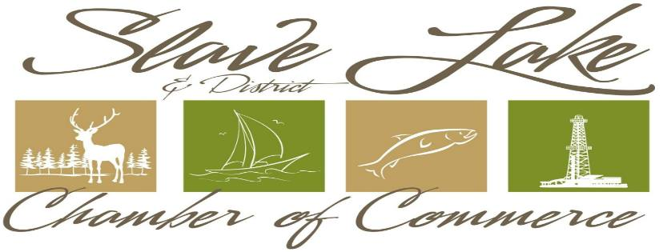

**Santa Clause Parade Registration Form**

Please Submit Registration Form and email to [admin@myslavelake.com](mailto:admin@myslavelake.com)

**Friday, November 16th – Please be at the Northern Star Hotel for judging at 6:00pm/ Parade starts at 6:30 sharp**

**Theme: Magical Christmas**

**NOTE: We already have a Santa for the parade**

Show us what this theme means to you… be creative!

** Registration forms must be submitted to the Slave Lake Chamber of Commerce no later than November 15, 2018 **

Organization/Business Name:

Contact Person:

Address:

Phone: (Work)

Email:

|  |  |
| --- | --- |
| **Float Category – Check ALL that apply;**  Business/Industrial/Commercial |  |
| Community Group/Organization/School |  |
| Dignitary: |  |
| Other (please describe) |  |
| Decorated Float | |
| Music/Sound System | |
| Domestic Animals | |
| Live Band on float or Marching Band | |
| Car/Truck  Walking | |
|  | |