The Slave Lake & District Chamber of Commerce 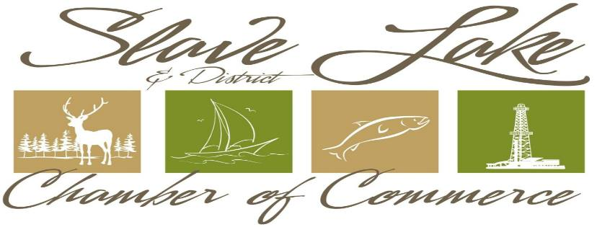

P.O. Box 190, Slave Lake, AB T0G 2A0

Ph. #780 849.3222 [admin@myslavelake.com](mailto:admin@myslavelake.com)

**APPLICATION FOR MEMBERSHIP 2019**

Membership is open to Businesses, Organizations, and Individuals

Name of Company/Organization: _____________________________________________

Mailing Address: __________________________________________________________

Street Address: ___________________________________________________________

Postal Code: ____________ Telephone #: _____________________Extension: _________

Email Address: ____________________________________________________________

Designated Representative & Their Position: _____________________________________

Optional: Website Address a/o Brief Description of Business (to be included in Chambers’ web page to promote your Company: ________________________________________________________________

_____________________________________________________________________________________ **Payment Schedule (5% G.S.T. # R10798 4924 RP0001)**

Amount G.S.T. Total

1 – 5 Employees $165.00 $ 8.25 $173.25

6 - 15 Employees $275.00 $13.75 $288.75

16 - 50 Employees $400.00 $20.00 $420.00

51 + Employees $500.00 $25.00 $525.00

Individual Membership $50.00 $2.50 $52.50

Non-Profit Organization $50.00 $2.50 $52.50

Home Based Business $100.00 $5.00 $105.00

Payment Enclosed: ______ Yes _____ No

Please invoice us for: $ ______________________

Contact us to process payment by Credit card: ________

I hereby apply for membership in the Slave Lake & District Chamber of Commerce and agree to be governed by the requirements of the by-laws and regulations of the Slave Lake & District Chamber of Commerce. Contact permission is hereby granted to contact us in keeping with Anti-Spam Legislation. Date: __________________ Signature: ________________________________________