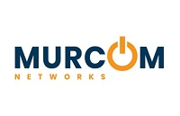

REDUCING THE COST OF DATA ASSURANCE

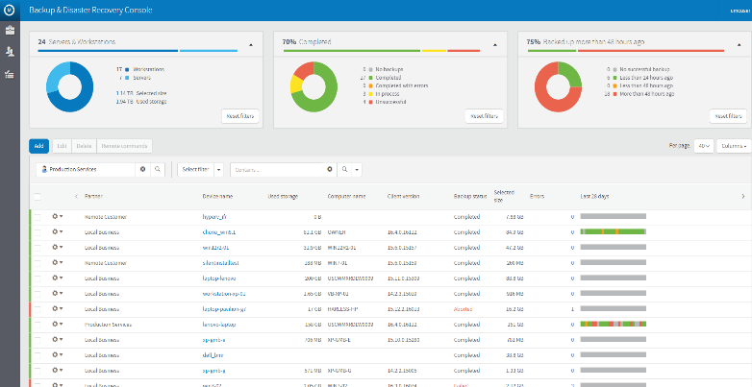
What would be the cost to your business if you lost your critical data?
Your business data is the lifeblood of your company and the amount you are collecting and storing is growing all the time. Imagine the impact if you lost a day’s data, a week’s data, a year’s data, due to inadequate or infrequent back-up processes. What would happen, could you recover?

A managed backup service from MURCOM Networks ensures that all files are automatically backed up as frequently as every 15 minutes if needed. And it will likely cost less than your monthly phone bill. So, how much is your data worth?

Key Features
Delta level technology means never having to do another full backup, drastically reducing the
backup time, storage space, network traffic, and
workload of your servers.

Recover Your Data to Dissimilar Hardware Can perform a bare metal restore of your data to dissimilar hardware. You don’t have to worry about purchasing that new server anymore.

Virtual Server Support
Backup your virtual servers with the same software that you use to back up your physical servers.

Supreme Flexibility
Recover your data from nearly any point in time,
whether it is just one file or a full restore.

Full Transparency Through Reporting Wide range of detailed reports are provided monthly to ensure that you know what is happening and that you can breathe easy knowing that your data is protected.

Fully Managed System
We monitor the software to ensure it is always working, and will act immediately if there is
an issue.

Benefits of a Managed Backup

Low Cost of Ownership
A fully managed data backup and restore solution for the same or less than a capital purchase that you have to manage yourself.

Total Peace of Mind
Thanks to centralized management and monitoring by our NOC team, you can rest assured that your business data is safe and being handled by experts. Which means you can focus on your business.

Reduce Your Day-to-Day Operating Costs
While most solutions require full backups periodically or in some cases daily, our solution only requires an initial full backup then from that point stores only
incremental file changes. Saving you money in storage space, data transfer costs
and server load.

Safeguard Business Information
Since the solution takes backups in terms of changes, you will be able to recover
files, even older revisions.

Ensure Business Continuity
Backup your most critical business applications to ensure that you can get quick access to restore systems that would have the most impact to your day-to-day operations if they were down.

Increase Productivity and Decrease Downtime
With our rapid restore capabilities, we will minimize the costs associated with lost productivity and downtime.

Detailed Reporting Information
No longer will you be unsure of how well your data is protected. We will provide you with reports monthly that let you know that your data is safe!

Why our clients choose our Managed Backup Solution

Reduced Costs:
- Less storage space required
- Less bandwidth needed
- Recover to dissimilar hardware if needed

Increased Awareness:
- Centralized NOC Management and Monitoring by our engineering team
- Detailed monthly reports on backup status

Improved Productivity:
- Back up more data in less time
- Minimize downtime with faster restore times

Increased Confidence:
- Regular backups minimize business downtime in the event of a data loss
- Backups are always scheduled and managed by experts

www.murcomnetworks.com
john@murcomnetworks.com
866-507-3474

©2021 MURCOM Networks - All Rights Reserved.
Threats facing SMBs today:
- Loss of Data
- Failed Restores
- Costly Upkeep
- Unreliable Systems
- Compliance
- Cost of Downtime

“75% of small and midsize businesses rank data loss as the most significant risk to their business.”
- Applied Research

Program Features Remote Backup Manager
Initial Data Assessment and Plan | Included | Our engineers will assess your critical data and develop a comprehensive backup plan that protects your critical data.
Disk Based Backup Deployment and Configuration | Included | Installation of our enterprise class disk based backup and recovery software.
Monthly Backup Capacity and Performance Reporting | Included | Regular reporting demonstrating the effectiveness of the backup  solution and ensuring efficient use of  resources.
Monitored and Managed by our NOC | Included | Our team of NOC engineers work in the background to ensure backups are successful and critical data is protected.
Remote Backup to Cloud | Included | Important files and folders are stored  in the cloud in case of critical failure.
Disaster Recovery Planning | Included | Advanced Disaster Recovery options are available to eliminate the risk of data loss and protect your business.
Essential Support  - Asset Discovery and Reporting  - Device Health Monitoring | Value Added Service | Our NOC team is available to assist with all your support needs by actively monitoring your systems for critical failure.

Don’t risk your business by being unprepared!

Call Today for a Custom Quote

