**2025 Jr. Show (Educational/ Audition Based AOO Show)**

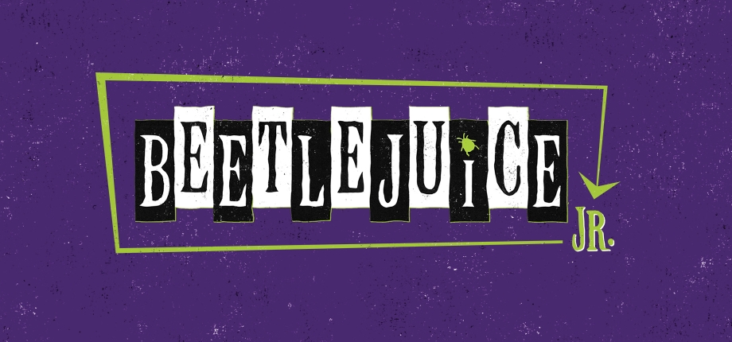

**Beetlejuice Jr. 12yrs.-18yrs. Tuition $425**

**Auditions Sunday April 27th 2:00-10:00pm**

**Callbacks Wednesday April 30th 5-9:00pm**

**Rehearsals:**

*June:*

Monday June 23rd 9:00am-2:00pm

Tuesday June 24th 9:00am-2:00pm

Wednesday June 25th 9:00am-2:00pm

Sunday June 29th 2:00-9:00pm (Ballet Adora)

Monday June 30th 9:00am-2:00pm

*July:*

Tuesday July 1st 9:00am-2:00pm

Wednesday July 2nd 9:00am-2:00pm

Monday July 7th 9:00am-2:00pm

Tuesday June 8th 9:00am-2:00pm

Wednesday June 9th 9:00am-2:00pm

Monday July 14th 9:00am-2:00pm

Tuesday July 15th 9:00am-2:00pm

Wednesday July 16th 9:00am-2:00pm

**Tech:**

Sunday July 20th 2:00-9:00pm

Monday July 21st 5:00-9:00pm

Tuesday July 22nd 5:00-9:00pm

**Performances: Five**

Thursday July 24th 7:00pm

Friday July 25th 7:00pm

Saturday July 26th 1:00pm and 7:00pm

Sunday July 27th 3:00pm