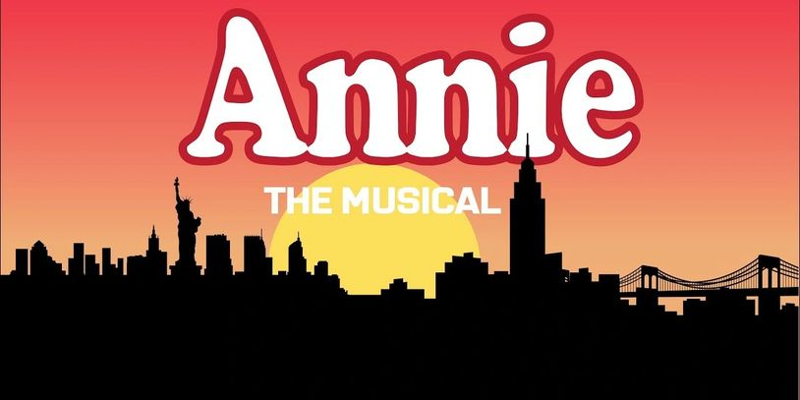

Audition Form:

Are you willing to accept any role?

________ (Yes! I trust my director!) Role Preferences: ________________________________

________ (No I will only take the following role(s): ____________________________________

Name: ___________________________________________________________Gender:_____

Age: _______ Height: _________Phone(s): _________________________________________

Email Addresses: **List ALL emails** you want to have communications with please:

Your Email_______________________________ Parents:____________________________

**What is your Vocal Range?** Female: ____SopranoC4-A5 ____Mezzo A3-F5 ____F3-D5Alto

Male: ____Tenor B2-G4 ____ Baritone G2-E4 ____Base E2-C4

**Dance Experience** *(Mark B=Beginner, I= Intermediate, A= Advanced):*

Tap____ Ballet_____ Jazz_____

List Specialized Dance Skills I.e. ... Aerial, Back Handspring, Pirouettes, Jump Split:

__________________________________________________________________ __________________________________________________________________

**Video Submissions**:

* Submit video Audition to **Mtshowstoppers@gmail.com by September 1st at 10:00pm**
* Include: Headshot, Resume and Video of you singing a 60 second or less cut of a song in the style of the show and 60 second or less comedic monologue (Please Slate: Name, Age, Reason you want to be in Annie)
* Include this Audition form, both videos, Headshot and Resume in ONE EMAIL (please make sure that your video is in a user friendly format such as YouTube link)

***CALLBACKS are in person at Capitol Theatre***: Sunday Sept. 7th 2:00-9:00pm

* Dance call at Callbacks for EVERYONE (except Daddy Warbucks)
* Lead roles: Sides and Songs will be emailed to you by Thursday Sept. 4th 10:00pm

Please mark **ALL OF YOUR CONFLICTS** (Communicate even if it is a possible undetermined conflict please)

Rehearsals will be Itemized for optimal productivity.

Rehearsals:

Sunday Oct. 19th 2:00-9:00pm (Attic and Stage)

Monday Oct. 20th 5:00-9:00pm (Attic and Stage)

Tuesday Oct. 21st 5:00-9:00pm (Attic and Stage)

Sunday Oct. 26th 2:00-9:00pm (Attic and Stage)

Monday Oct. 27th 5:00-9:00pm (Attic and Stage)

Tuesday Oct. 28th 5:00-9:00pm (Attic and Stage)

Sunday Nov. 2nd 2:00-9:00pm (Attic and Stage)

Monday Nov. 3rd 5:00-9:00pm (Attic and Stage)

Tuesday Nov. 4th 5:00-9:00pm (Attic and Stage)

Sunday Nov. 9th 2:00-9:00pm (Attic and Stage)

Monday Nov. 10th 5:00-9:00pm (Stage)

Tuesday Nov. 11th 5:00-9:00pm (Stage)

Monday Nov. 17th 5:00-9:00pm (Stage)

Tuesday Nov. 18th 5:00-9:00pm (Stage)

Sunday Nov. 23rd 5:00-9:00pm (Stage)

Monday Nov. 24th 5:00-9:00pm (Stage)

***Off for Thanksgiving 25th-29th***

TECH:

Sunday Nov. 30th 2:00-9:00pm

Monday Dec. 1st 5:00-10:00pm

Tuesday Dec. 2nd 5:00-10:00pm

PERFORMANCE DATES:

Thursday December 4th 7:00pm

Friday December 5th 7:00pm

Saturday December 6th1:00 and 7:00pm

Sunday December 7th 3:00pm

Thursday December 11th 7:00pm

Friday December 12th 7:00pm

Saturday December 13th 1:00 and 7:00pm

Sunday December 14th 3:00pm