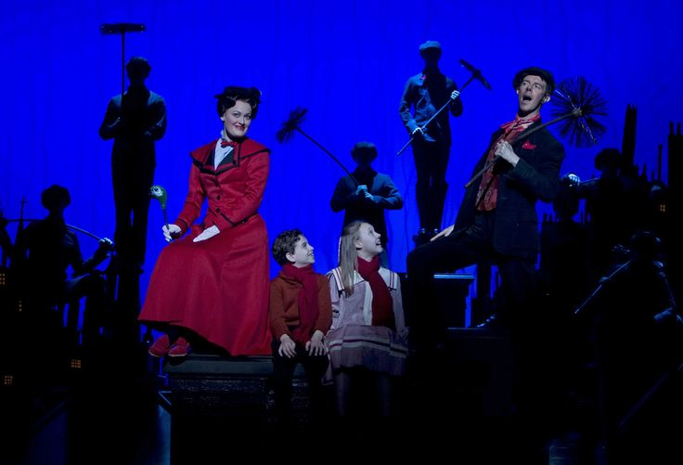

Capitol Players Pro and Audience of One Productions

Audition Form:

Are you willing to accept any role? **Yes! (I trust my director!)** ______

**No (I will only accept these Role(s):** ______________________________________________

**Role Preferences: ______________________________________________________**

Name: _____________________________Gender:_____ Age: _______ Height: _________

Shirt Size: _______ Pants Size:________ Dress Size: _______

Phone(s): _______________________________Parents phone: ________________________

Email(s): _______________________________ /___________________________________

**What is your Vocal Range?** Female: ____SopranoC4-A5 ____Mezzo A3-F5 ____F3-D5Alto

Male: ____Tenor B2-G4 ____ Baritone G2-E4 ____Bass E2-C4

**Tap Experience**: ___Beginner ___Intermediate ___ Advanced ____Do Not Tap

**List any Specialized Dance Skills I.e**… Aerial, Back Handspring, Pirouettes, Jump Splitect…__________________________________________________________

This show has both Educational and Professional opportunities.

Professionals will be offered contracts for selected roles (small stipend)

Student tuition is $425 *(To cover Additional Dance and Acting lessons included with this show)*

BRING THE FOLOWING TO YOUR AUDITION: **Check list:**

1. **Headshot and Resume**
2. **Choreography Ballet and Tap sequences prepared for dance call**
3. **Sheet Music (no more than) 32 Bar or Track *(make sure all notifications are turned off on your phone/ Bring your own speaker…ready to push play)***
4. **This Audition form and Liability Waiver**

# Please MARK ALL OF YOUR CONFLICTS: (only 3 allowed) (Mark ALL CONFLICTS/ POTENTIAL AND CONFIRMED)

**2025 Broadway Show (Mary Poppins)**

**Auditions: Sunday April 13th (Stage or Attic of Capitol Theatre)**

**Callbacks Wednesday April 16th 6-10 (Stage of Capitol Theatre)**

***Rehearsals:***

**May:**

Sunday May 11th 2-10

Monday 12th 5-10

Tuesday 13th 5-10

Sunday May 18th 2-10

Monday 19th 5-10

Tuesday 20th 5-10

Sunday May 25th 2-10

Monday 26th 5-10

Tuesday 27th 5-10

**June:**

Sunday June 1st 2-10 (Ballet Adora)

Monday June 2nd 5-10

Tuesday June 3rd 5-10

Wednesday June 4th 5-10

Sunday June 8th 2-10

Monday June 9th 5-10

Tuesday June 10th 5-10

Wednesday June 11th 5-10

**Tech:**

Sunday June 15th 2-10

Monday June 16th 5-10

Tuesday June 17th 5-10

Wednesday June 18th 5-10

**Performances**

Thursday June 19th 7:00 pm

Friday June 20th 7:00pm

Saturday June 21st 1:00 and show at 7:00pm

Sunday June 22nd 3:00pm

Thursday June 26th 7:00pm

Friday June 27th 7:00pm

Saturday June 28th 1:00 and 7:00pm

Sunday June 29th 3:00pm