AUDIENCE OF ONE PRODUCTIONS
Hello! We are so thankful for your interest in our program. Audience of One Productions is an educational theatre program focused on producing high level Broadway shows while helping performers grow in the arts. Audience of One Productions began with a dream to see young performers learn to see themselves through the eyes of Christ while being stretched to realize their greatest potential. Over the past seven years I have been continually blown away watching God grow us beyond ourselves. We enter into this next season prayerfully and with great expectation of the arts continuing to grow on the Capitol Theatre stage…we move forward with auditions for the remainder of our season.

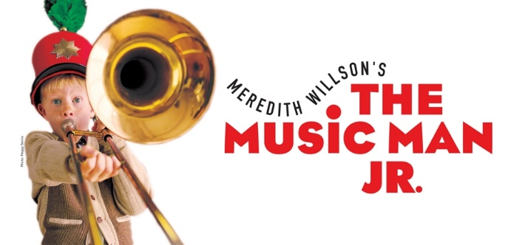
($425 Tuition)

This show has 18 Characters and Ensemble Characters.

Casting requirements range from ages 7-15yrs old
Auditions: at Capitol Theatre April 2nd 2:00-9:00
(Sign Up Genius Link coming soon)
1) 32 Bar Up-tempo song in the style of show (No Accapella, Track only)
Slate: Name, Age, role you are most interested in
2) Comedic or Dramatic Monologue (under 1 min)
3) Digital Headshot and Resume
4) Audition Form
5) Liability Waiver
Callbacks on Saturday April 8th 10:00am-1:00pm Live at Capitol Theatre
Remember one thing: At Audience of One Productions you are valued and loved by the only one who matters…Your creator! When you operate for THE AUDIENCE OF ONE… you should know that you are already CAST into the Kingdom, loved and more than enough.

