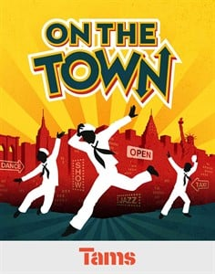
CHARACTERS (Ages 15 to Adult)
Ozzie: Male/ Lead/ Baritone
Gabey: Male/ Lead/ Baritone
Chip: Male/ Lead/ Baritone
Ivy Smith: Female/ Lead/ Mezzo-Soprano
Claire: Female/ Lead/ Soprano
Hildy: Female/ /Lead/ Mezzo-Soprano
Madame Dilly: Female/ Supporting/ Mezzo-Soprano
Pitkin W. Bridgework: Male/ Supporting/ Bass
Lucy Schmeeler: Female/ Supporting/ Spoken
First Workman: Male/ Featured/ Bass
Flossie: Female/ Featured/ Spoken
Flossie's Friend: Female/ Featured/ Spoken
Little Old Lady: Female/ Featured/ Spoken
Subway Bill Poster: Male/ Featured/ Spoken
Mr. S. Uperman: Male/ Featured/ Spoken
Waldo Figment: Male/ Featured/ Spoken
Master of Ceremonies: Male/ Featured/ Spoken
Rajah Bimmy: Male/ Featured/ Baritone
Diana Dream: Female/ Featured/ Mezzo-Soprano
Dolores Dolores: Female/ Featured/ Mezzo-Soprano
Tom: Male/ Featured/
Andy: Male/ Featured
Nightclub Girls: Female/ Ensemble/ Soprano, Alto
Residents of New York City: Either Gender/ Ensemble/ Soprano, Alto, Tenor, Baritone
Workman's Quartet (4): Male/ Ensemble/ Tenor, Baritone, Bass

