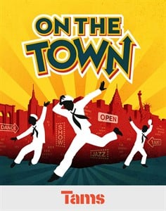

BOOK by [Betty Comden](https://stageagent.com/authors/1249), [Adolph Green](https://stageagent.com/authors/1250)

MUSIC by [Leonard Bernstein](https://stageagent.com/authors/129)

LYRICS by [Betty Comden](https://stageagent.com/authors/1249), [Adolph Green](https://stageagent.com/authors/1250)

The show follows the adventures of three sailors on leave for just 24 hours in the great city of New York before heading off to battle in World War II. Goofy ladies’ man Ozzie is looking for a date--maybe seven or eight--and studious innocent Chip, guidebook in hand, has several days’ worth of tourist attractions to check off his list. But when idealistic Gabey falls for the photograph of lovely Miss Turnstiles, a subway beauty queen, they all join in an ambitious scavenger hunt around the city to locate this dream girl -- and, on the way, find all of the romance, adventure, and New York atmosphere for which they could wish. Joined by Claire, a sophisticated anthropologist with a red-hot heart, and Hildy, a sweetly aggressive cab driver on the lam, the sailors careen through museums and nightclubs, Carnegie Hall and Coney Island, before Gabey and Ivy are finally united -- just in the knick of time. With brash, spectacular, and slightly bittersweet abandon, On the Town is a tale about seizing the day and living life to its fullest.

With a soaring score by Leonard Bernstein and humorous, highly intelligent lyrics by Betty Comden and Adolph Green, On the Town features the seductively upbeat “I Can Cook, Too”, the melancholically beautiful ballad “Lonely Town”, and that most iconic of tunes, “New York, New York.”