|  |
| --- |
| Email: karmalodge.ladakh@gmail.com Mobile: +91 7780852447 +91 9469515545 Address: Near Shanti Stupa, Yourtung, Leh, Ladakh 194101 |

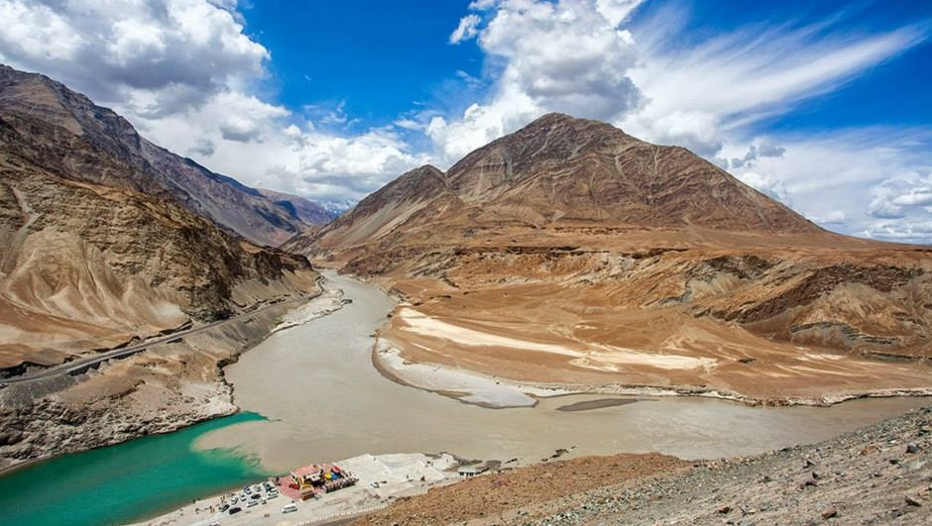

|  |  |  |  |  |  |  |
| --- | --- | --- | --- | --- | --- | --- |
| **PANORAMIC LADAKH 6 NIGHTS, 7 DAYS** | | | | | | |
| **2 PERSON** | **4 PERSON** | **6 PERSON** | **8 PERSON** | **10 PERSON** | **12 PERSON** | **EXTRA BED** |
| **Interested in our packages?**  Call or email us, and we'll be happy to send you a detailed price list within 24 hours. WhatsApp/Call us: +91 7780852447, +91 9469515545  Email: [karmalodg.ladakh@gmail.com](mailto:karmalodg.ladakh@gmail.com) | | | | | | |

**PACKAGE COST INCLUSION**

1. GST and service charge included.
2. Accommodation twin sharing basis.

* 3 Nights at Leh in Karma Lodge with Breakfast.
* 1 Night at Turtuk village in Guest House with Breakfast and Dinner.
* 1 Night at Hunder village in Guest House with Breakfast and Dinner.
* 1 Night at Pangong Lake in Deluxe Camp with Breakfast and Dinner.

1. Transportation as per itinerary point to point.
2. 2 to 6 Persons INNVOA or ZLYO
3. 7 to 12 Persons Tempo traveller.
4. Tourist Permit and environmental fees to Nubra valley and Pangong Lake.
5. Welcome tea or coffee with biscuits.
6. One first Aid oxygen cylinder for emergency altitude sickness.

**PACKAGE COST EXCLUSION**

1. Cultural tour guide
2. Monastery entrance fees.
3. Mineral bottle water, extra meals or tea or coffee.
4. Extra use of taxi will be chargeable.
5. Extensions of the tour program or changes in the tour itinerary for any reasons.
6. Any additional expenses incurred due to the same would be borne by the clients.
7. Anything which don’t mentioned under package cost inclusion.

**ITINERARY**

**DAY 1: WELCOME AT LEH KUSHOK BAKULA RIMPOCHEE AIRPORT.**

Upon arrival you will be welcome & met by our representative and transfer to Hotel for check in followed by welcome tea or coffee. Complete half day for rest acclimatize and Lunch will be serve in Hotel. Afternoon at 3:30 PM visit Shanti Stupa & Leh Market. Overnight stay at Leh in Jorchung Hotel or similar.

**DAY 2: FULL DAY SIGHTSEEING OF SHAM VALLEY. (140 KM 6 – 7 HRS)**

Today after breakfast at 9:00 AM leave to sightseeing around toward Sham valley; Hall of fame Museum, Spituk monastery, Gurdwara Pather Sahib, Magnetic Hill, confluence of Indus & Zanskar River. After photography at panoramic view of confluence drive straight to Alchi village on the way panoramic view of village and you will be reached Alchi village at 1:00 or 2:00 PM and have your Lunch in Zimkhang Holiday restaurant. After Lunch visit 11th century Alchi Choskor monastery listed in world heritage site. After sightseeing of Alchi monastery return back Leh by same route and you will be reached Leh at 5:00 or 6:00 PM. Overnight stay t at Leh in Jorchung Hotel or similar.

**DAY 3: LEH TO TURTUK VILLAGE. ( NUBRA VALLEY 204 KM 6 – 7 HRS)**

Today after breakfast 8:00 o’clock leave to Turtuk village of Nubra valley via Kardungla pass. Turtuk village is one of beautiful village of Nubra valley located on India – Pakistan border. On the way visit 14th century Deskit monastery and 100 Feet Maitreya Buddha and double hump camel ride at hunder Sand dune. After camel ride at Hunder sand dune drive to Turtuk village and you will be reached Turtuk village at 5:00 or 6:00 PM. Dinner and overnight stay at Turtuk village in deluxe camp. overnight stay at Hunder village in Turtuk Holiday camp or similar.

**DAY 4: TURTUK VILLAGE TO HUNDER VILLAGE. ( NUBRA VALLEY 82 KM 2 - 3 HRS)**

After breakfast at 9:00 o’clock visit ancient wooden mosque, stone potter and ancient poly ground. After sightseeing leave to Hunder by same route. You will be reached Hunder village at 12:00 or 1:00 PM check into camp for Lunch. After lunch relax and enjoy the leisure walk in village. Overnight stay Hunder village in Apple cottage camp or similar.

**DAY 5: HUNDER VILLAGE TO PANGONG LAKE VIA SHAYOK VALLEY. (170 KM 6 – 7 HRS)**

Today after breakfast at 8:00 leave to Pangong Lake via Shayok valley on the way visit Tangtse monastery and you will be reached at Pangong Lake in the afternoon around 1:00 or 2:00 pm and check into camp. Camp is located on the bank of Pangong Lake. Evening walk around the Lake to enjoy sun set view. overnight stay at Pangong Lake in Deluxe Camp

**DAY 6: PANGONG LAKE TO LEH VIA CHANGLA PASS. (140 KM 4 – 5 HRS)**

Today before breakfast around 5:30 a brief morning walk to enjoy the sun rise view of Lake and back to camp for breakfast and after breakfast at 9:00 leave to Leh via Changla pass. On the way visit Thiksay monastery the biggest monastery of Ladakh, Rancho school and Sindhu Ghat. You will be reached at Leh around 4:00 or 5:00 pm check into hotel for rest. Lunch at Thiksay in Chamba Restaurant. Evening explore the colourful Leh market. Overnight stay at Leh in Karma Lodge

**DAY 7: DEPARTURE.**

Today after early morning breakfast transfer to airport.   
  
Tour and service end!