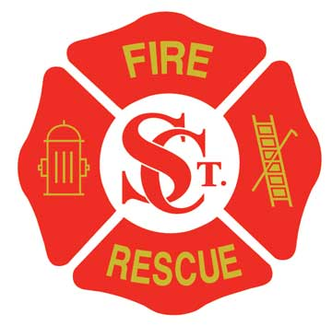

St. Clair Fire Protection District

Dedicated to preserve life and property

www.scfpd.org

January 22, 2018

HIRING PROCESS NOTICE

The St. Clair Fire Protection District will be accepting applications for the position of Firefighter/EMT. Interested persons may pick up an application package from the St. Clair Fire Protection District Administrative office located at 470 E North Street, St. Clair, MO 63077. Applications will be available beginning on January 22, 2018 and must be returned to the administration office by 4:00 p.m. CST on February 2, 2018. Completed Application packages can be given to either the Office Manager or Chief Sullivan. Application packages must be sealed.

Applicants must be a US citizen, at least 21 years of age, high school graduate or equivalent, and possess a valid Missouri driver’s license. Firefighter I & II certification through the Missouri Division of Fire Safety is required and Missouri certified Emergency Medical Technician is required.

St. Clair Fire Protection District is an equal opportunity employer. Equal consideration shall be given to all qualified applicants, regardless of race, creed, color, sex or religious affiliation.

