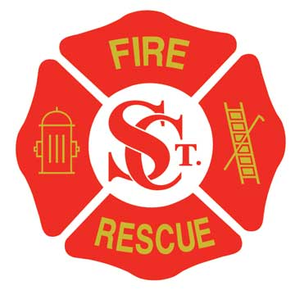

St. Clair Fire Protection District

Dedicated to preserve life and property

www.scfpd.org

INVITATION FOR BID

The St. Clair Fire Protection District is soliciting bids for the following: Upgrade of HVAC system at Fire Station #1, 470 E. North St. St. Clair, Mo. 63077.

Contract to provide equipment and any subsequent repairs to improve HVAC performance on second floor of Fire Station #1.

To set an appointment to tour Station #1 and gather information on the existing HVAC system, Contact Fire Chief Craig Sullivan at (636)629-2727.

All bids shall be delivered to St. Clair Fire Protection District Station #1, 470 E. North St., St. Clair, Mo. 63077, no later than 4:00 pm October 15, 2021.

The successful bidder shall submit an affidavit and documentation affirming compliance with section 285.530 of the Revised Statues of Missouri.

The successful bidder shall comply with the Missouri prevailing wage law.

St. Clair Fire Protection District reserves the right to accept the bid, which in its judgment is the lowest and best bid; to reject any or all bids; and to waive irregularities or informalities in any bids submitted.

St. Clair Fire Protection District

Craig Sullivan
Fire Chief
Office (636)629-2727

