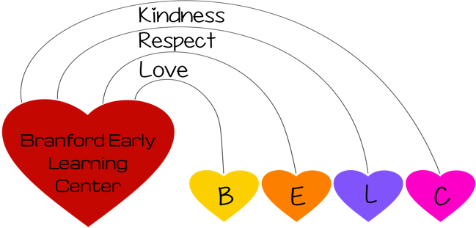
2
June 2022

MONTHLY NEWSLETTER

Spring is on the way, but we are not out of the winter woods yet! We are trying to give the children as much outdoor time as possible and hoping this wild weather will cooperate.

APPLE FUNDRAISER! We are kicking off our chocolate apple sale from Apples etc.! The apples are amazing and make a perfect treat for the Holidays or just because they are delicious! Sales sheets are available in every class. All order sheets must be returned by Friday, March 25th!
We will continue to wear masks until April 1 and will revisit the situation then, or until our children can be vaccinated. We will continue to have mask breaks.
Upcoming Events
Announcements
Hi! I am so happy to announce that our Brightwheel has been set up by the Amazing Isa and we are set to go! We will start off slowly by sending pictures.
A note from ISA:
BRIGHTWHEEL - We are now using the Brightwheel platform to share photos with our families. If you have not already done so, please download the Brightwheel: Child Care APP from the apple (iPhone ios) or google play (Android) store and be sure to enable notifications from the app. You will receive alerts when we update your child’s feed with photos or other announcements.

- Redetermination - The state has issued new guidance regarding OEC funded fee schedules. All of our families must bring in copies of applicable 2021 W-2’s by May 1st. Redetermination will be discussed with you and instituted in July, if there is a change in fee. If I do not have your redetermination paperwork the State requires you to pay full price for childcare, which is $840.00 per month starting July 1.

****** Reminders ******

- Please remember if Branford Schools are closed we are also closed. If Branford schools are delayed, we will be here as soon as possible. If snow should start during the day you will be texted, or called, and we will ask you to pick up your child/ren as soon as possible.

- FEES: Fees are due on the 1st of the month. Please give Diane the fee, or ask about making a Venmo, direct payment, or credit card payment. By September, I am hoping that all Billing will be through Brightwheel, but I will keep you posted! Payments received after the 15th of the month will incur a $25 late fee.

