House Church, September 26, 2021

Pride and Mercy

Luke 18: 9-14. Jesus told this parable to those who trusted in themselves and thought that they were righteous, while regarding others with contempt: Two men went up to the temple to pray, one a Pharisee and the other a tax collector. The Pharisee stood by himself and prayed: ‘God, I thank you that I am not like other people—robbers, evildoers, adulterers—or even like this tax collector. I fast twice a week and give a tenth of all I get.’ But the tax collector stood at a distance. He would not even look up to heaven, but beat his breast and said, ‘God, have mercy on me, a sinner.’ I tell you that this man, rather than the other, went home justified before God. For all those who exalt themselves will be humbled, and those who humble themselves will be exalted.

The Way of Pride: What’s Wrong with the Pharisee?

1. The Bible’s understanding of human motivation: Why do we do what we do?
- We were created in God’s image, whole, complete, secure, loving, collaborative, and purposeful. As we lived in perfect communion with God, we were constantly empowered by God’s presence and love. God provided everything we needed and consequently we felt complete, being everything that God intended us to be—God’s image in the world.
- Our relationship with God changed. We decided that we did not need God, we denied God’s grace and, as a result, we were separated from God, “cast out of the Garden.” For the first time, now apart from God, human beings have needs. Everything that God had done for us, we now needed to do for ourselves. Being God for ourselves is a tall order!
- What is sin? Sin is separation from God, which creates in us in a ruling disposition of self-centeredness that constantly motivates us to do for ourselves what God had previously done and desires now to do for us. Without God, we are on our own to make our way in the world. “Sin” (separation from God) generates “sins,” things that we do because we are separated from God, the source of life and our protector. To be saved from sin means that through God’s grace, we are brought back into communion with God. The separation has ended. This reunion with God will have consequences for how we see ourselves, and how we act in the world.
- Separated from God we are motivated to fill our own needs, by whatever means are expedient and effective. In communion with God, our desperate quest to fill our needs transforms into purpose-filled mission, to live in God’s love and to be open to how God will use us to serve the world God loves. In Christ, we are called back to our identity in the Garden of Eden, before the Fall, where we were fully in the image of God, where we enjoyed God’s presence, walking and talking with God and where, through our work, we served God by talking care of everything God has given us.

- The Bible’s understanding of human personality without God is aligned with the findings of modern psychology and neuroscience.
- Maslow’s Hierarchy of Needs: we are motivated by needs we have that must be met for us to feel secure, loved, purposeful, etc. We do what we do to get our needs met.
- B. F. Skinner (Behaviorism): we are on a constant quest to promote our own survival; thoughts and behaviors that promote survival are repeated, reinforced and learned. We act in ways that we have learned will promote our survival.
- Neuroscience. In 1/30 of a second, every perception is run through a neurological “filter’ to determine its level of threat. If we perceive a threat or an unmet need, unconsciously our body immediately prepare us to meet it.

3. The Human Condition: With God, we are whole and complete, growing toward all that God intended us to be, individually and with regard to others. Separated from God, from birth to death, we are on a constant quest to get our needs met, to find some sense of security, love and meaning. On our own, we go out into the world alone or, if we’re lucky, with our friends and allies, to find meaning and success.

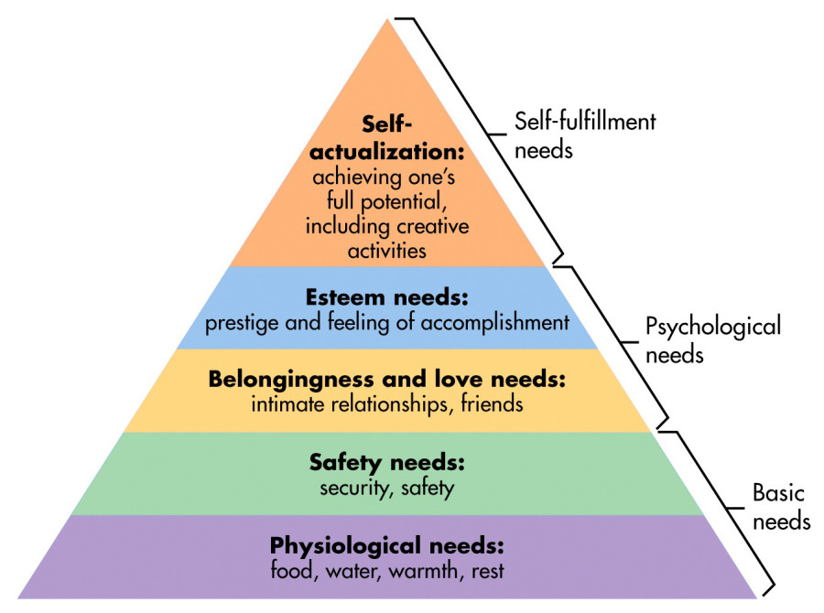
Maslow’s Hierarchy of Needs
Starting from the bottom, needs must be met before we can focus our attention of meeting the needs above.

4. There is an attitude that is consciously anti-God, that denies God’s grace and embraces the idea that everything God does and would do for me, I can do myself. I don’t need God. Everything I have achieved, has solely been the result of my own effort. This is the way of pride.

Pride is an extreme expression of the denial of God’s grace, a posture of being anti-God. Pride is dangerously corrupt selfishness, the putting of one's own desires, urges, wants, and sense of worth above that of others. Pride involves defining your own sense of worth by arrogantly comparing yourself favorably to other. Pride says, “I don’t need God. Look at what I have achieved. I am better than others. By means of my own cunning and resources, I have reached the top and I’m confident that I will stay there.”

Throughout the ages Christians have considered pride the worst of sins, because all other sins are motivated by it. Pride leads the list of the Seven Deadly Sins (pride, greed, wrath, envy, lust, gluttony and sloth). C. S. Lewis said, “Pride is the position in which the ego and the self are directly opposed to God: Unchastity, anger, greed, drunkenness, and all that, are mere fleabites in comparison. Pride leads to every other vice” (Mere Christianity).

5. It’s not surprising that pride and arrogance are condemned throughout the Old and New Testaments:
- Proverbs 8:13: God says: “I hate pride and arrogance, the way of evil and distorted speech.”
- National pride is denounced: “We have heard of the pride of Moab—and how proud he is! —he is arrogant, proud and insolent, but his boasts are false and he will be utterly stricken” (Isaiah 15:6). Thus says the Lord, “I will ruin the pride of Judah and the great pride of Jerusalem” (Jeremiah 13:9). “Israel’s pride testifies against the Lord” (Hosea 5:5).
- “Pride that goes before a fall” is rejected in favor of a lowly spirit (Proverbs 16:18).
- Pride is described as the root cause of atheism (Psalm 10:4).

Why does pride go before a fall?

The Old Testament view of pride is carried over into the New Testament:
- Jesus describes himself as “meek and lowly in heart (humble)” (Matthew 7:22).
- Paul describes the “insolent, boastful and proud” in his description of depraved pagan society (Romans 1:30).
- Arrogance and ostentatiousness are denounced by James (4:16) and John (1 John 2:16).
- 2 Timothy 3:1-5. But mark this: There will be terrible times in the last days. People will be lovers of themselves, lovers of money, boastful, proud, abusive, disobedient to their parents, ungrateful, unholy, without love, unforgiving, slanderous, without self-control, brutal, not lovers of the good, treacherous, rash, conceited, lovers of pleasure rather than lovers of God— having a form of godliness but denying its power.

Can you recognize any of this in our world?

6. Pride and Prestige (refer back to “Esteem Needs” in the Maslow diagram above). Often, those who are not secure in the love of God, define themselves and their sense of well-being, their worth and prestige by comparing themselves to others or to some arbitrary societal standard of success--by calculating how they measure up. What makes you beautiful, popular, wealthy, good, intelligent, successful? All these measures of success are relative and often very superficial. To answer these questions and feel secure in our identity, we look outside ourselves and compare ourselves to others. How many followers do you have on Twitter? How many friends on Facebook? What was your position in the business world? How do you look for your age? How much money is there in your bank account? Where did you go to school? How many square feet in your house? Did you ever get divorced? In what neighborhood to you live? Answers to all these questions can matter a lot to us in our estimation of our personal sense of worth and in our estimation of the worth of others. We take pride in the fact that when measured against others, we’re at the top. We call that success.

Much of our daily struggle is created by the friction between what society expects (in terms of success) and what we are actually able to achieve. Deep down, many people at the top feel like imposters, carrying deep doubts about their position and status. There will always be people who are more beautiful or less beautiful, more intelligent or less, wealthier or less. And so, we work harder to move up, or we rationalize our position (“I’m in the 90th percentile!) or we find fault with weaknesses of the successful (“He only made it because of his family’s wealth). In this way of defining our worth, we are on a constant treadmill, comparing and evaluating to confirm that we are measuring up, that we’re OK.

At the root of these calculations is pride. For many people without God, and sometimes for us also, pride in our accomplishments feels good. We’re proud of what we have accomplished and how we measure up. We also get angry and afraid when someone comes along who challenges the comfort we have in that hard-won identity. We are confident in our ability to meet our needs and to provide for our families until we no longer can be confident—until the fall comes that inevitably follows pride. No person can manage all the risks. Things happen outside our control that challenge our sense of security, our sense of worth, and make us wonder if we can ever be as useful as we used to be. Some innovation comes along that renders our company irrelevant, there’s an accident or an illness, banks fail or the market falls precipitously, our national security is threatened, someone from the opposing party wins an election, we get older and feel that we are only a shadow of what we used to be.

And so, the Pharisee of today might pray: “Thank you, God that I am not a democrat! Thank you, God that I am not a Muslim! Thank you, God that I live in Texas! Thank you, God, that I was born white. Thank you, God, that I am young. And by the way God, I’m a good man, not like all the deadbeats out there who don’t pay taxes and are making false unemployment claims, and by the way, Lord, you know I give a tenth of all that I have to important charities.”

Sometimes we feel that, like the Pharisee, we have to justify our own sense of worth, to ourselves, to others, and even to God. This is the way of pride. According to Jesus, that person will be humbled.

Now let’s talk about the way of mercy and love.

The Way of Mercy and Love: The Humility of the Tax Collector

1. In contrast to the Pharisee, according to Jesus, the tax collector’s humility led to him be exalted by God. We don’t know much about the tax collector in Jesus’ parable. We know that tax collectors in Jesus’ day were considered extortionists and were generally despised. But this tax collector, whatever he did before this moment, now filled with remorse, comes to pray. He knows the truth about his life and he knows that God knows it too. And so, he humbly says, “God be merciful to me a sinner.”

There is so much here that is lost, until we understand the meaning of the word that is translated “merciful.” We tend to think that the tax collector is asking for forgiveness—that whatever he did, he thinks that he should be punished for it, so he’s pleading for God to show mercy—to release him from the consequences of his sin. I think there some truth to this, but it’s only a small part of what’s happening here, of what the tax collector is asking God to do.

In Hebrew, the word mercy is the plural form of the word for a woman’s “uterus” (ra-cha-min). Luke has used this word before (6:36) to describe God, “You must be like a woman’s womb (merciful) as your Father in heaven is like a woman’s womb (merciful). What does this mean? How is God like a woman’s womb?

Think about sin as separation from God. Now through Jesus, by God’s sovereign choice, the Kingdom of God has come, the grace of God seeks to end the separation. Being in the womb of God is an image of intimacy and nurturance, of being one with God, surrounded and nourished by God, as one about born into a new way of living, now becoming what God intended us to be. This is what the tax collector wants. This is what it means to be saved. He wants to be one with God because he knows that for him everything depends on it.

This tax collector knows that he is separated from God, he understands that he had done nothing to deserve God’s love, but he trusts that God loves him enough to ask that he be brought up into “God’s womb” a place of continuous intimacy, where separation ends, where he might reside and be nurtured and nourished, as he is now born into a new way of living.

2. The Triangle (pool rack). Being a Christian is not about taking pride in the fact that you have a great resume, or a long list of accomplishments or that you are leaving a great financial legacy to your family. It’s not about an upward climb to the top of a mountain where we hope to meet God. That’s not how we get to God or gain God’s favor. Jesus said, “Stop this desperate quest to be what you think you need to be to feel secure and good about yourself. Instead rest in intimacy of God’s love, rest in God’s mercy, intimacy with God freely given to you, no matter if you succeed or utterly fail. God made you, God loves you, find your purpose in life by being God’s image in the world.

Jude 1:21. “Keep yourself in the love of God, look to the mercy of the Lord Jesus Christ, which leads to abundant life.”

Serving God: Learning, Becoming, Achieving and Finding the Meaning of Life

If our sense of worth rests not in our accomplishments or status, but in the love of God, should we stop learning, achieving, building our talents, earning money, providing security for our family, trying to be the best that we can be? Is the Christian faith an excuse for laziness or being average? No!

2 Timothy 2:15: “Study to show yourself approved, a worker who has no need to feel ashamed.” In the church, this verse has been used to encourage Christians to study the Bible. But when Paul said this to Timothy, there was no Bible yet—the canon of the Old and New Testament was set much later. I think that Paul means something else here.

What is the reason to study, to learn, to work, to earn, to achieve, to develop our talents and ourselves to our fullest potential? Paul calls Timothy a “worker”. As Christians we are all “workers” for God, we all exist to serve God. Created in the image of God, our purpose in life, the meaning of our lives is to do God’s work in the world. If God is to fix evil, prejudice, poverty, hunger or any of the world’s problems, God will work through the talents, resources, intelligence, strategies and leadership of those who love God and are called according to God’s purpose. For each of us, there will come a time, there will come time after time, many times when God will put us in a situation where what we have learned, what we know how to do, what we have achieved will be important to address the situation at hand. Paul is encouraging Timothy to study and learn, to master things so that when God puts him in situations where God needs him, Timothy will be ready to help, a worker who will not be ashamed.

Love is the antithesis of pride. We as Christians live among others not trying to be the best, not confirming our sense of worth by measuring ourselves against others or by some arbitrary standard of society; rather we engage the world with love. Knowing the love of God, out of a deep sense of personal security, we reach out to the world with love. “We love because God first loved us” (1 John 4:19).

Robert Fulghum, the famous author from Waco, who wrote Everything I Need to Know I Learned in Kindergarten and It was on Fire when I Lay Down on It, was somewhat of a wise guy. Whenever he attended a seminar or a conference, and the speaker, at the end of his or her talk, would ask, “Are there any questions?” Fulghum would always stand up and ask “What is the meaning of life?” Everybody would laugh, gather up their things and go. The question was never answered. Nevertheless, conference after conference, Fulghum kept asking the question because, as he said, “Sometime, someone might actually know the answer.”

One year, Fulghum attended a conference in Crete, at a conference center that was situated between two hills. The site had been the scene of a ferocious battle between the Germans and the Cretans during WWII. On the top of one hill were buried the Cretans who had fought the Germans with pitchforks and shovels, who were killed in battle or later died before a German firing squad. On the other hill were buried the German paratroopers who had died during that battle. The institute was set up in the valley between the hills and was dedicated to human understanding and peace, and especially to rapprochement between Germans and Cretans, which was an improbable task, given the bitter residue of the war.

The institute was led by a world renown philosopher, Dr. Alexander Papaderos, who had been born near the site of the battle and lived through it when he was a little boy. At that time, Papaderos was a living legend--a resident of Athens, a doctor of philosophy, teacher, and politician. Many books have been written about what he accomplished through his work at the institute.

Fulghum describes Papaderos, with these words: “One look at him and you saw his strength and intensity--energy, physical power, courage, intelligence, passion, and vivacity radiated from his person. And to speak to him, to shake his hand, to be in a room with him when he spoke, was to experience his extraordinary electric humanity. Few men live up to their reputations when you get close. Alexander Papaderos was an exception.”

Well, the two-week seminar ended. Papaderos turned to the attendees and asked the ritual question: "Are there any questions?" Quiet quilted the room. "No questions?" Papaderos swept the room with his eyes. So, Fulghum asked: "Dr. Papaderos, what is the meaning of life?"

The usual laughter followed, and people stirred to go.

Papaderos held up his hand and stilled the room and looked at Fulghum for a long time, asking with his
eyes if he was serious and seeing from his eyes that he was, Papaderos said, "I will answer your question."

Taking his wallet out of his hip pocket, he fished into a leather billfold and brought out a very small round mirror, about the size of a quarter. And what he said went like this:

"When I was a small child, during the war, we were very poor and we lived in a remote village. One day, on the road, I found the broken pieces of a mirror. A German motorcycle had been wrecked in that place. I tried to find all the pieces and put them together, but it was not possible, so I kept only the largest piece. This one, and by scratching it on a stone I made it round. I began to play with it as a toy and became fascinated by the fact that I could reflect light into dark places where the sun would never shine--in deep holes and crevices and dark closets. It became a game for me to get light into the most inaccessible places I could find.

"I kept the little mirror, and as I went about my growing up, I would take it out in idle moments and continue the challenge of the game. As I became a man, I grew to understand that this was not just a child's game but a metaphor for what I might do with my life. I came to understand that I am not the light or the source of light. But light—truth, understanding, knowledge—is there, and it will only shine in many dark places if I reflect it.

"I am a fragment of a mirror whose whole design and shape I do not know. Nevertheless, with what I have I can reflect light into the dark places of this world--into the dark places in the hearts of men and women and change some things in some people. Perhaps others may see and do likewise. This is what I am about. This is the meaning of my life."

And then he took his small mirror and, holding it carefully, caught the bright rays of daylight streaming through the window and reflected them onto Fulghum’s face and onto his hands folded on the desk.

Papaderos was the human face of God to many, many people, shining the light into the darkness.

What is the meaning of your life?

