Ventnor O Air Conditioning Systems

Our systems are split with a unit on the roof and an air handler in the middle of the hallway ceiling.
Air conditioners remove humidity from the air in our apartments. That humidity becomes condensate – water that drips into a pan in the air handler (this is similar to the pan that collects water at the bottom of most refrigerators). The refrigerator is a confined space and the water that collects in that pan just evaporates. The water in the A/C pan flows through a tube that is 3/8 to ½-inch in diameter that is connected to the main drain. A main drain is shared by all 4 apartments in a stack, e.g., 1048, 2048, 3048, and 4048 all share a common main drain. The main drains are PVC 2-inch diameter pipes that run from the roof and empty out at the rear building foundation. The more humid it is, the more the A/C runs and the more condensation is produced and drips into the pan and flows into the main drain. In the high heat months here, our A/C systems are running constantly.
The water that collects in the pan and flows into the main drains grows scum/algae. Without adequate maintenance, the scum grows and could clog the flow of condensation. That causes the pan to overflow and you get rain inside your apartment under the air handler. When you have Pride, ECM, or whomever come to service your A/C, before they leave, they drop a large tablet or two into the pan. Those tablets help stop the buildup of scum/algae. What needs to be understood is that those tablets dissolve in one to three months. If you have your A/C serviced once each year, at best there are 9 months that scum/algae could build up. Unless these tablets are placed into the pan every 3 or 4 months, one service per year here is not enough.
You should also consider replacing the filter in your air handler at least twice each year. Filters are 21 ¼” X 37 ½” X 1”, and can be purchased at Home Depot. These filters have “Effective up to: 90 Days” noted on the packaging.
ECM routinely tells their customers to tell us to clean the main drains. We do that twice each year, but the route of the problem is in our apartments. If the scum/algae are killed at the source, before it creates a problem, the main drains will be free of buildup.
While the association is responsible for the roof, unit owners are responsible for their respective refrigerant lines, electrical conduits, fuse boxes, etc. associated with their air conditioning systems. Some fuse boxes and conduits were found open to the weather. Rain can and does get into these openings and makes its way into the electrical panel in your apartment. Also, some refrigerant lines are not insulated. Refrigerant lines are very cold and when uninsulated, humidity freezes on them. When not so cold, that frost becomes water that could follow the lines down inside the wall in your apartment.
Any damage in your apartment caused by components of your air conditioning system is your responsibility.
We suggest that you have your air conditioning service people check and repair any issues that may exist with your systems – particularly components on the roof.
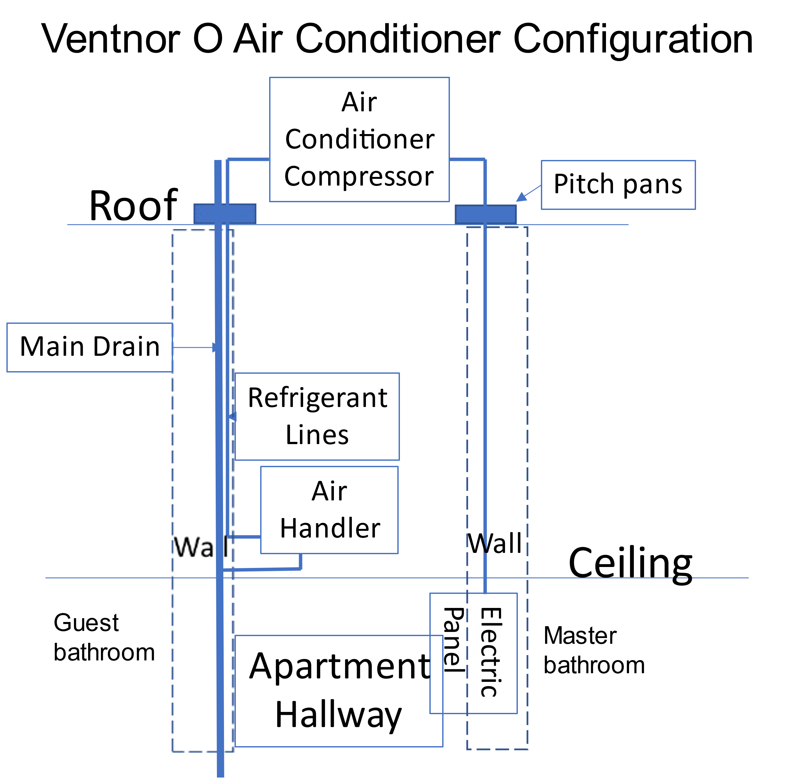
This diagram is of a typical even numbered apartment. Odd numbered apartments have components in the opposite walls, i.e., what is in the left wall, is in the right wall, and visa-versa.

