Board Presidents’ Handbook (July 2023 Edition)

Purpose/Introduction

As President of your building’s Board, you are taking on a job that can dramatically impact the pleasure, financial health and security of your building. Chances are, you may have only had a limited idea of what you were saying yes to this Handbook will hopefully help you and your Board know what’s needed and share the tasks. COOCVE has created this Handbook to give you the full picture of what’s involved and to provide you the step-by-step guidelines of how to do the job, what to do when, and the resources available to you to do it. Some of the tasks included are required by law, others are important to maintain our aging buildings, and some will increase the satisfaction and cooperation of your residents. The COOCVE Board Manual provides lots more detail about overall responsibilities, so we suggest using it often.

We’ve divided the manual into several sections, shown below:
- Overall responsibilities
- Regular Actions and Maintenance Tasks–A list of tasks, starting when you are elected and indicating when and how often they need to be done
- Conducting meetings and communicating
- Lists of documents to file and retain
- Resources to help you do your job (including Appendices)

- Overall Responsibilities:
- Ensure that legally required paperwork is filed
- Ensure that Board Meetings are scheduled and conducted as required by law
- Supervise Management Company to complete contracted tasks
- Post all Association rules
- Work with the Treasurer and Property Management Company to receive and review financials, direct payment of contractors, maintain financial data, identify and take action against delinquent owners
- Conduct regular building inspections as scheduled
- Interface with emergency personnel as needed (Fire Dept., EMT's, Inspectors)
- In coordination with Secretary, communicate building news and other important information to residents
- In conjunction with Board and property management company, ensure that all applicants to purchase, rent or reside in the building have satisfactorily completed background checks and screening. In conjunction with Board, review and approve applications for Occupancy of new owners, residents, or renters. Prepare a signed and sealed Certificate of Acceptance (COA) and give copies to the owner, resident or renter to take to closing or to the ID office. Ensure all leases are registered with the CenClub ID office.
- In conjunction with Board, conduct ‘Meet and Greet’ sessions with new residents
- In conjunction with Board, oversee revisions of Building documents and creation of rules
- In conjunction with Board, review Building insurance with agent
- Maintain, repair, and restore common areas of the condominium
- Enforce governing documents

Upon Election:
Immediately following election, do the following:
- The newly elected board must have an Organizational Meeting to elect Officers and report them to your Property Mgr.
- Have your completed Officer and Director (O&D) form signed, sealed and sent to COOCVE and Master Mgt. (Your Property Manager may do this). Post a copy in the building.
- Have your Treasurer or Property Manager update your Sunbiz.org listing, submit it and make payment. See attached directions in Appendices. You will need to present the updated listing to your bank to change signatories.
- Register for Board Certification course through local legal firms (on COOCVE.com website)-required of all new board members.
- Update Bank Signatories for new Board members at each bank you use. The requirements for documents to provide may vary, but you will need at least the Minutes from your Election meeting, your Board Organizational Meeting, your Sunbiz listing, and driver’s license. Call your bank(s) to confirm what’s needed and to make an appointment with the appropriate banker. Plan to spend up to several hours there and to possibly make a second trip with missing information. If banking online, ensure that your Officers have the banking websites, usernames and passwords for emergency access.
- Review your Property Management Contract to see when it expires and what it covers.

II. Regular Actions and Maintenance Tasks
Monthly:
- Ensure that the Treasurer can review monthly financials from property manager. If anyone has late fees, contact them and try to assist to make sure all are taken care of. Management companies usually send late notices to the owner after some time has elapsed. If the fees are not paid in a timely way, the matter could be escalated to a collection’s attorney.
- Ensure that the Treasurer checks Bank Assets monthly (The bank keeps a record for 7 years - but you can print monthly). Bank statements are usually included in monthly financial reports from the management company.
Annual:
- Prepare an Annual Budget. This needs to be completed to allow the required advanced notification time to be met. Creating the budget is one of the most important obligations of a condo board. It must include both a routine operating expense budget and a reserve budget for replacement and/or long-term deferred maintenance of common elements, such as your building’s roof, elevator, catwalks, etc. These budgets should reflect historical experience and plans for the coming year for each line item. Your building maintenance fees are based upon the funds needed, which should all be reflected in this budget.
- Ensure that the Annual Budget is adopted by a vote of the Association Board or vote of the membership. Ensure that copies of the proposed Annual Budget and meeting invitation are delivered to Unit Owners at least 14 days before the Annual budget meeting. May be done by Property Mgmt. company.
- Ensure that Property Mgr. or Association Treasurer files Annual Report with the DBPR.
- Update Census of Residents (to keep status as ‘Housing for Older Persons’ that allows you to refuse younger buyers / renters).
- Make sure the Annual Financial Statement is prepared and made available to Owners.
- Ensure fire alarm testing done in every apt. by the Fire Dept - usually scheduled by the Property Manager. Board member goes door to door with a technician with a master key. Repair/replace if necessary.
- Conduct overall Fire Inspection (shutters, signs, fire alarm boxes, smoke detectors, etc.)
- Feb or spring–roof inspection
- Gutter inspection–gardens
- Pest Control - once a year for entire building. Board member goes door to door with technician - lower baseboard spraying
- Termite inspection
- Elevator Inspection–High rise–Check elevator for proper working and compliance with current code. Check Elevator & Elevator Room – call for repairs when necessary. Make sure Property Mgr. schedules annual inspection before County Certificate of Operation expires Aug 31. Boards should consider having a maintenance contract with an elevator service company, which should include monthly inspections, and emergency call outs.
- High-rise Trash Chutes Alarm inspection (due every 5 years).
- Seal or power wash walkways, stairs and patio (as needed).
- Clean out A/C Main Drains (high rise). Clean A/C drain stacks semi-annually, ensuring the exit points are not obstructed by growth or resident’s items. Unit owners are fully responsible for their A/C and the horizontal drain lines, and typically pay a company for servicing. NOTE: When the tech services unit systems, they push slime from the connecting tube into the main drain. That slime can wash away, but can also pile up in the main drain. . Also, for high rise – AC techs should check and take pictures of equipment on the roof. Electrical conduits/wiring should not be open to the weather, and the refrigerant lines should be insulated.
- Trim/Prune Trees (1-2mos before hurricane season) with professional licensed arborist
- Lawyer retainer payment
- Review Hurricane guidelines for building preparation
Every few months:
- Fire extinguisher company inspects fire extinguishers for a current label. If the label is missing from the fire extinguisher, it has to be replaced.

Periodically:
- Check laundry equipment. Call for repair as needed.
- Collect laundry money (with a second person). Count it. Deposit it.
- Set and monitor rat or pest traps, if needed.
February:
- Fertilize Lawn and shrubs
- (Or Spring)--Roof inspection with roof maintenance contractor.–***garden apts. Make repairs if necessary. Send a copy to your insurance agent. Ask for a picture from the roof company before and after.
March:
- Prepare Income tax (Property Management Company may do this as part of contract or additional fee).

Every two years:
- Paint Parking Lines and Bumpers. (May be comped thru property management). Replace bumpers if broken.
- Paint exterior doors (may be comped by Property Management).
Every 3 yrs:
- Ensure Property Appraisal Valuation completed. Submit to Insurance company.
- Wind Mitigation Report NOTE: 5 yrs if no storms
Every 5 yrs:
- Pressure test for fire sprinklers
- Wind Mitigation Report if no storms
III. Conducting Building Meetings and Communication
- Conduct open Board Meetings on a regular basis (once a month, quarterly or whenever the board makes decisions). Post notices 48 hours ahead for most Board Meetings. See Chart for required notices (Appendices). Ensure that the secretary or the property manager takes minutes. Minutes need to be approved and signed by the President.
- Conduct Annual Meeting/Board election - Set date, location, and agenda in conjunction with your Property Manager. Make sure notices are properly sent out for meetings and elections. See attached schedule of required notices (Appendices). If more candidates are seeking election than there are vacancies, the election must be held by secret ballot. At least 20% of eligible voters must cast a ballot.
- Conduct Annual Budget Adoption Meeting. Make sure copies of the proposed budget and a meeting invitation were delivered to Owners at least 14 days before the adoption meeting. See Chart for required notices (Appendices).
- Post/communicate available contact hours for Board Members.
- Communicate building actions, news, etc. via email and/or posted on a regular basis.
- Have Owners sign an E-Mail Permission Form to allow them to receive official notices, etc. by e-mail. See attached Sample Form.
Screen Potential New Buyers, Occupants and Renters (https://coocve.com/occupancy-process)
- Review application for completeness. If incomplete, contact the Real Estate Agent or new buyer/renter to request missing information.
  - Clarify responses in the complete application or interrogatories that may be conflicting or incomplete (e.g. how many people will reside in the unit, why they said no bankruptcies when background check seems to show one, etc.).
- Review application and interrogatories to determine whether to approve occupancy
  - If denying occupancy, have property mgt. company issue ‘denial letter’ (Note: be sure to follow guidelines for denial that are listed in your documents). Until you have legally reviewed language, have such letters reviewed by an attorney before sending them. Also, they should be sent certified with return receipt requested.
- Conduct a “Meet and Greet” interview with approved new owners, occupants and renters.
  - Meet to get to know your new residents, ensure that they are aware of the rules required for living in their building, and provide them with daily basic info to navigate the building and village. (note: you can refer them to the sample Interview Checklist from Oakridge F and the extensive Sample from Prescott L on https://coocve.com/sample-association-info)
  - Give basic information and answer questions
    - Welcome Guide from COOCVE (https://coocve.com/welcome-guide-for-owners)
    - Association Rules–may want to have them sign receipt and agreement
    - Tailored manual or guidelines for your building which might include things like parking rules, bulk trash days, annual bug spraying procedures, etc. (see examples in https://coocve.com/sample-association-info)
Reports and Documents to File
- U.S. Income Tax Form 1120-H -- Must be filed by April deadline. Condominium associations in CVE are “corporations not-for-profit.” They are neither tax-exempt nor exempt from filing an annual tax return.
- Annual Financial Report to the DBPR - Each Association, as a corporation, must provide an annual report containing the names of all financial institutions with which you maintain accounts. An annual fee is required based on the number of residential units in the building ($4.99 per unit). The fee, payable to the Department of Business & Professional Regulation (DBPR), Division of Florida Land Sales, is due on January 1. Any association member may obtain a copy of that annual report from the DBPR upon written request. (F.S. 718.71 and 718.501 (2) (a)
- Annual Corporate Report/Sunbiz report -- The report must be filed with the Florida Division of Corporations between Jan. 1 – July 1. It lists your corporate name, federal tax id number, names and addresses of Board Members and Officers, the name and address of the Registered Agent (attorney) and the name and address of your Property Manager. A filing fee is required, payable to the Florida Dept. of State. Failure to file this report results in the dissolution of the corporation. (F. S. 617.1622) NOTE: This serves as the basis for the Sunbiz Annual listing which the property manager normally submits
- Annual Financial Statement -- This is prepared by the Association Treasurer or Accountant. Not later than 120 days after the end of the fiscal year it must be mailed, e-mailed, or hand delivered to each Owner (or a notice that a copy will be delivered upon written request.) (F.S. 718.111(13)) -. Must include a balance sheet showing current assets and liabilities for the past 12 months.
  - Compilation Report -- Condos whose revenue exceeds $150,000 per year must have a report prepared to compile the financial statements of the Association. This may cost $900 or more. (F.S. 718.111 (13) (b)
Documents to keep:
Required
- Census Report -- must be kept, listing all Owners/ Renters and their ages (or just an indication by each one that they are 55+ or not.). This must be kept with official records and must be available to show applicants / Real Estate agents if requested. The only exceptions are those in accordance with state or federal statutes.
- Frequently Asked Questions Sheet - this informs prospective owners concerning their voting rights, their financial obligations, the liabilities of the Association and the restrictions governing the use of the units. The sheet must be maintained and updated by the Condominium Association. (F. A. C., Ch. 61B-23.002 (7) (a), Rule 61B-17.001) See fillable pdf in Appendices.
- Minutes from all Board Meetings–must be kept indefinitely
- Roster of residents and emergency contacts
Optional Documents:
- Collection Policy for Late Fees (Collection Contract that works out a plan for payment of past due amounts)
- Remodeling / Contractor Application and Security Deposit
- Personal Data Sheet (with emergency contacts, condo sitter, age of water heater, etc.)
Additional Fees, Contracts and Registrations to keep current and filed:
- Insurance Premiums – meet with Agent to review coverages
- Association Lawyer - if yearly retainer is due
- Sunbiz.org – Registers any changes in Board. Pay fee.
- Management Company Contract – if time to renew
- Landscaping Contract – if separate from Management Company contract
- Roofing Repair Contract – if applicable
- Elevator Repair Contract – if applicable
- Laundry Machine Contract – if applicable

Resources to Help You Do Your Job
Resources:
- COOCVE.COM website
  - Board Manual (https://coocve.com/coocve-board-manual)
  - Contractor Listing (https://coocve.com/contractor-listing)
  - Buying Group offers (https://coocve.com/buying-group)
  - Officer and Delegate form (https://coocve.com/officer-%26-delegate-form)
  - Association Board Election Information and Flow Chart
  - Welcome Guide for Owners (https://coocve.com/welcome-guide-for-owners)
  - Occupancy Process (https://coocve.com/occupancy-process)
  - Government required forms (FAQs, etc.)
  - Sample Materials from Buildings (https://coocve.com/sample-association-info)
  - Meeting videos of all COOCVE meetings and other important webinars, etc.
  - Articles and white papers–on insurance, roofing, etc.
- Board Manual-contains board member requirements, budget information, communicating with owners, info on COOCVE, Insurance requirements, Interviewing buyers, contractor requirements, meeting notices and records, building rules, amendments, required government forms, resources for help - on COOCVE.COM website and at COOCVE Office.
- Samples from other buildings: (https://coocve.com/sample-association-info)
  - Meet and Greet checklists, Interview Package
  - General guidelines
  - Interrogatories
  - Sample Payment plan
  - Collection contracts
  - Request for Guest Occupancy
  - Building Manuals and Welcome Guides
  - Rules Statement and agreement form
  - Reserve and Financial Analysis
  - Service and Support animals rules
  - Owners Personal Data Sheet
  - Voting Certificate and instructions
  - Cleaning AC vents and stacks
- Copy of your Property Management Contract
- Copy of your current Documents and ways of getting access and new copies https://officialrecords.broward.org/AcclaimWeb/search/Disclaimer?st=/AcclaimWeb/search/SearchTypeName
- Building and Community Rules (Master Management and CenClub)-- https://cenclub.com/documents#eb24085b-0eb1-405d-bcdc-880e552a2677
- Important Village Phone numbers–see attached Appendices
- Key Website Links–Master Management (https://www.centuryvillageeast.com/), CenClub (https://cenclub.com/), The Reporter (cvereporter.com)--
- Insider Newsletter (https://www.centuryvillageeast.com/239/Insider-Newsletters)
- Condo Permit Regulations (https://www.deerfield-beach.com/294/Building-Services#condo)Code Enforcement contact info (https://www.deerfield-beach.com/358/Code-Compliance)
- Household Hazardous Waste Disposal Requirements (https://www.deerfield-beach.com/235/Drop-Off-Center#hhw)
- The Condominium Concept, 16th edition by Peter Dunbar
- List of lawyers’ Certification Courses Offerings–https://coocve.com/webinars-%26-certifications

Appendices

Requirements for Condo Meeting Schedules

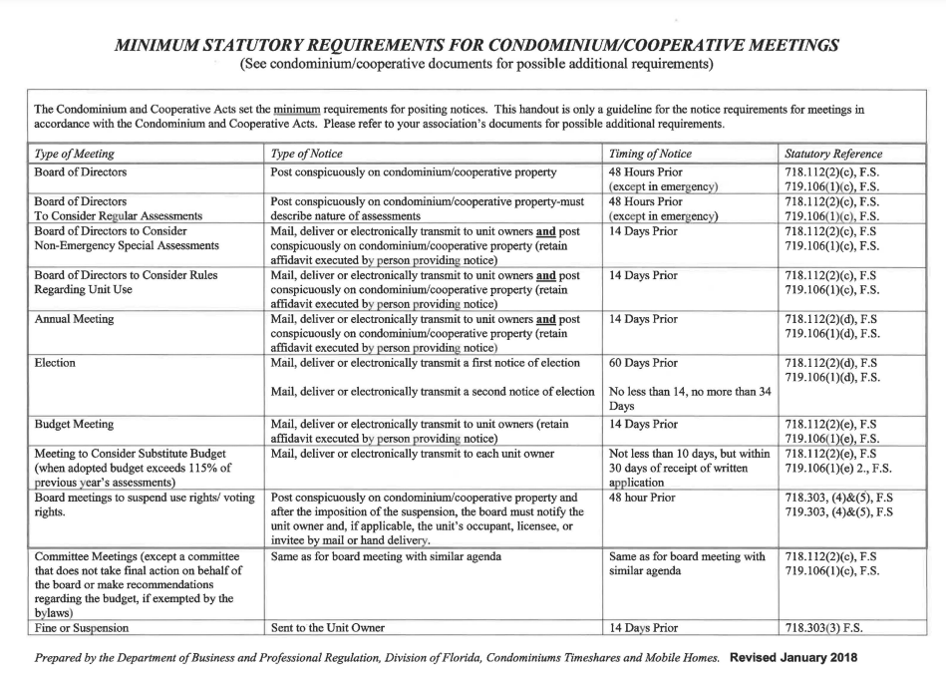
DBPR Frequently Asked Questions (fillable form)
http://www.myfloridalicense.com/dbpr/lsc/forms/DBPRFormCO6000-4eff122302.pdf
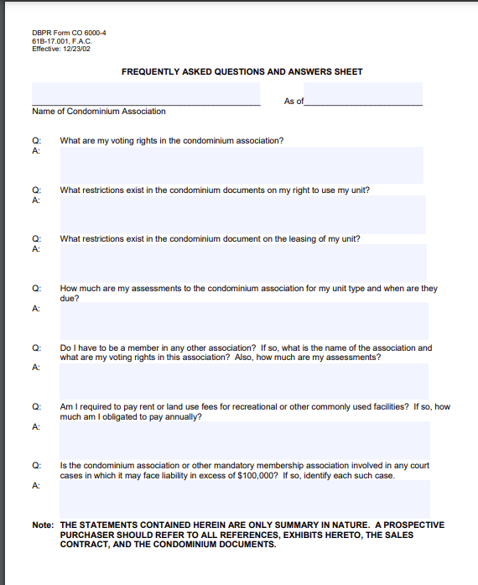

https://services.sunbiz.org/Filings/AnnualReport/FilingStart

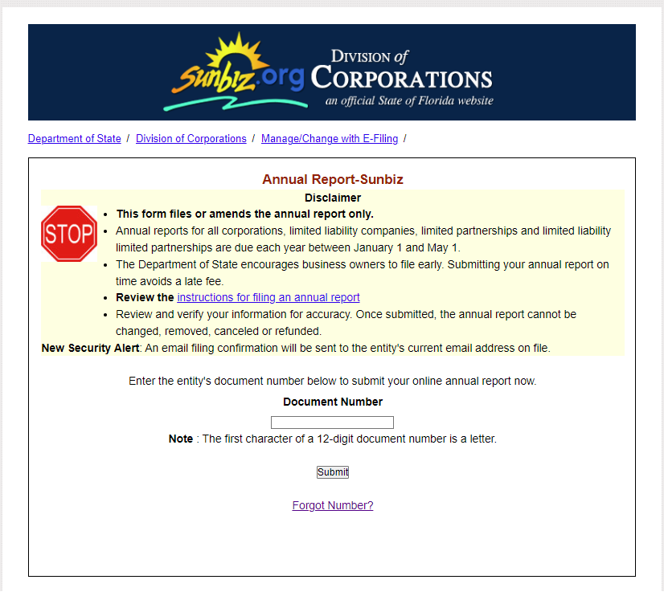

https://dos.myflorida.com/sunbiz/manage-business/efile/annual-report/instructions
