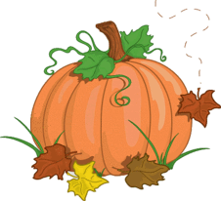East Moriches PTO News
Volume 1, Issue 2 October 2017

Don’t forget to join us for Loopy Art Day on Saturday, October 14th at 11:30 am! A fun filled day of art for the whole family. There will be music, games, food and of course prizes for all the winning art work designs! Please make sure to send in the attached forms to your child’s teacher.

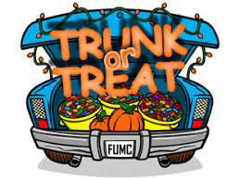
If you are a parent of a 5th or 6th grader and haven’t signed up to be a part of Trunk or Treat, then do so now! You don’t want to miss this event! The event follows the Halloween dance and is spooktacular. Kids will “trick or treat” to your car that you have decorated and you will hand out candy. This is always a great night and the kids and parents love it. Please see the attached flyer for more info!



The BoxTops for Education program is one of our continuing fundraising activities and is so simple to help with. Simply cut out the BoxTop label found on many of the food products that you are already purchasing and send them in with your child in a marked envelope.
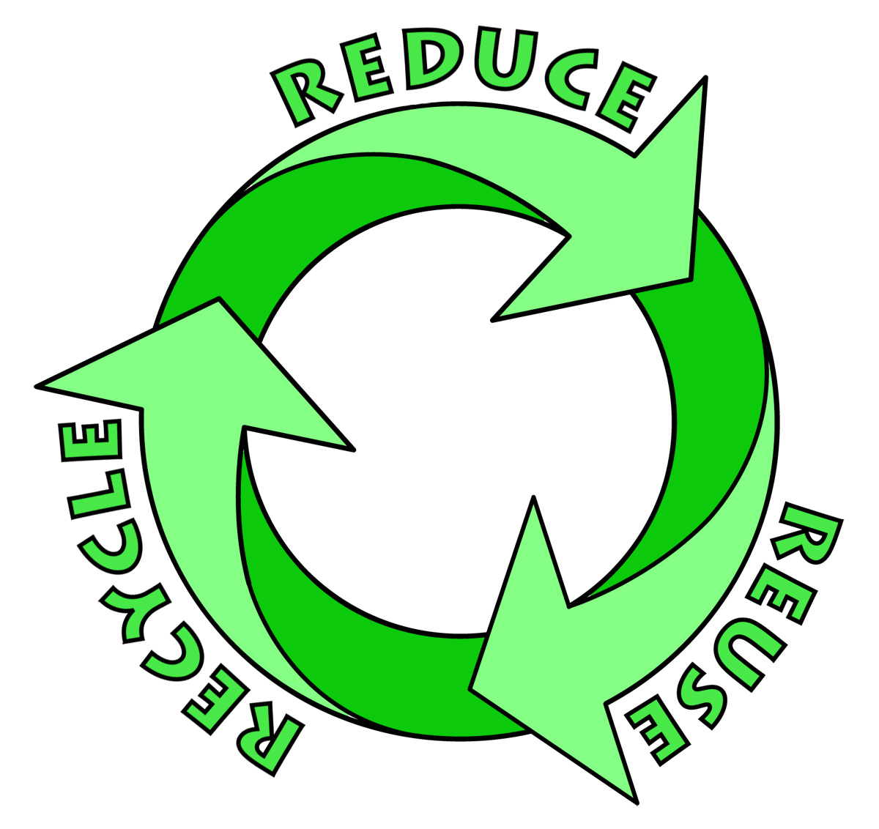

The Environmental Club will be collecting empty used toiletry items (toothpaste, mouth wash, deodorant etc.) from October 25th-27th. Collection boxes will be set up at the school for drop off. Please be kind and recycle!

Dates to Remember

October 2017
6- Spirit Wear Orders Due Back (Order form attached)
9 – SCHOOL CLOSED
10 – SCHOOL CLOSED
14 – Loopy Art Day 11:30 @ the ES
Send in those slips!
19 – Book Fair ES/MS during school hours
6:30 pm ES/MS Volunteers NEEDED!
24- PTO Meeting (7:00 pm ES)
25- Board of Ed Meeting (7:30 pm ES)
27- 5/6 grade Halloween Dance & Trunk or Treat (See flyer)
31- K-4 Costume parade @ the ES 2:00 pm

Loopy Art Day!

Get Active in the PTO!
PTO Meeting: Tuesday, Oct. 24th @ 7:00 p.m. in the ES as always children are always welcome! We will be nominating new board members so please be sure to come.


We are in NEED of a Middle School Book Fair
Chairperson and Volunteers!
Contact us at info@empto.org is you are interested!

Join us on the Remind App to stay updated on info
and events by receiving messages straight to your
phones.
https://www.remind.com/join/eastmorich

