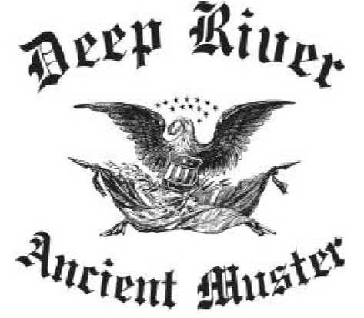
Deep River Ancient Muster, Inc.
Post Office Box 135
Deep River, CT 06417
Parade and Muster Registration Form
Name of unit/corps: __________________________________________________________
Origin of unit/corps (City, State, Country): ________________________________________
___________________________________________________________________________
Major or individual rendering salute: ____________________________________________
Please select type of unit: Jr. or Sr. Fife and Drum Cops, Militia, Bagpipe, and Other (Please
Describe):___________________________
Date Unit/Corps Organized: _________________ Distance from Deep River:_____________
Announcement: __________________________________________________________________
__________________________________________________________________
__________________________________________________________________
__________________________________________________________________
__________________________________________________________________
__________________________________________________________________
Stand piece (marching onto previous unit’s tune): _____________________________
__________________________________________________________________
__________________________________________________________________

Marching off to: ______________________________________________________________
___________________________________________________________________________

Due to the number of Units/Corps attending:
PLEASE limit on stand time to Five minutes or less TOTAL. This Muster is conducted with the Company Stand Format (your corps marches on stand to the music of the Corps exiting the field)

