**703 Edwards Street**

**P.O. Box 595**

**Chester, PA 19016**

**610-874-8565**

**www.stmaryschester.org**

[**stmarys@stmaryschester.org**](mailto:stmarys@stmaryschester.org)

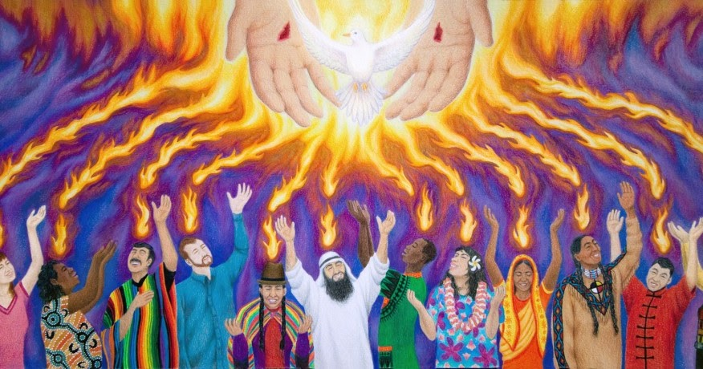

*God is calling St Mary's Church, Chester to minister to the world God so loved, to bring disciples to Christ and partner with God in bringing to completion God's work of peace.*

**Twenty-Sixth Sunday after Pentecost**

**November 17, 2024**

**Holy Eucharist Rite II**

**The Rev. Deirdre Whitfield**

*Celebrant*

**Welcome**

**Opening Hymn** *Praise my soul the king of heaven*  **HYM 410**

**Service of the Word BCP 355**

*Celebra*nt: Blessed be God: Father, Son and Holy Spirit

**People : And blessed be God’s kingdom, now and forever. Amen!**

*Celebrant* *continues*: Almighty God. …. **Amen.**

**Gloria (unison)**   **LEV 243**

Glory to God in the highest, and peace to his people on earth.

Lord God, heavenly King, almighty God and Father, we worship you, we give you thanks, we praise you for your glory. Lord Jesus Christ, only Son of the Father, Lord God, Lamb of God, you take away the sin of the world: have mercy on us; you are seated at the right hand of the Father: receive our prayer. For you alone are the Holy One, you alone are the Lord, you alone are the Most High, Jesus Christ, with the Holy Spirit, in the glory of God the Father. Amen.

**Collect of the Day**

*Celebrant*: The Lord be with you

**People : And also with you**

*Celebrant*: Let us pray.

Blessed Lord, who caused all holy Scriptures to be written for our learning: Grant us so to hear them, read, mark, learn, and inwardly digest them, that we may embrace and ever hold fast the blessed hope of everlasting life, which you have given us in our Savior Jesus Christ; who lives and reigns with you and the Holy Spirit, one God, for ever and ever. *Amen.*

**Daniel 12:1-3**

Blessed Lord, who caused all holy Scriptures to be written for our learning: Grant us so to hear them, read, mark, learn, and inwardly digest them, that we may embrace and ever hold fast the blessed hope of everlasting life, which you have given us in our Savior Jesus Christ; who lives and reigns with you and the Holy Spirit, one God, for ever and ever.

**Psalm 16**

***Refrain: Protect me, O God, for I take refuge in you.***

1 Protect me, O God, for I take refuge in you; *  
**I have said to the Lord, "You are my Lord,  
my good above all other."**

2 All my delight is upon the godly that are in the land, *  
**upon those who are noble among the people.**

3 But those who run after other gods *  
**shall have their troubles multiplied.**

4 Their libations of blood I will not offer, *  
**nor take the names of their gods upon my lips.**

5 O Lord, you are my portion and my cup; *  
**it is you who uphold my lot.**

6 My boundaries enclose a pleasant land; *  
**indeed, I have a goodly heritage.**

7 I will bless the Lord who gives me counsel; *  
**my heart teaches me, night after night.**

8 I have set the Lord always before me; *  
**because he is at my right hand I shall not fall.**

9 My heart, therefore, is glad, and my spirit rejoices; *  
**my body also shall rest in hope.**

10 For you will not abandon me to the grave, *  
**nor let your holy one see the Pit.**

11 You will show me the path of life; *  
**in your presence there is fullness of joy,  
and in your right hand are pleasures for evermore.**

### **Hebrews 10:11-14, 19-25**

Every priest stands day after day at his service, offering again and again the same sacrifices that can never take away sins. But when Christ had offered for all time a single sacrifice for sins, “he sat down at the right hand of God,” and since then has been waiting “until his enemies would be made a footstool for his feet.” For by a single offering he has perfected for all time those who are sanctified.

Therefore, my friends, since we have confidence to enter the sanctuary by the blood of Jesus, by the new and living way that he opened for us through the curtain (that is, through his flesh), and since we have a great priest over the house of God, let us approach with a true heart in full assurance of faith, with our hearts sprinkled clean from an evil conscience and our bodies washed with pure water. Let us hold fast to the confession of our hope without wavering, for he who has promised is faithful. And let us consider how to provoke one another to love and good deeds, not neglecting to meet together, as is the habit of some, but encouraging one another, and all the more as you see the Day approaching.

**Gospel /Hymn** *Halle, Halle, Halle*

**Mark 13:1-8**

As Jesus came out of the temple, one of his disciples said to him, “Look, Teacher, what large stones and what large buildings!” Then Jesus asked him, “Do you see these great buildings? Not one stone will be left here upon another; all will be thrown down.”

When he was sitting on the Mount of Olives opposite the temple, Peter, James, John, and Andrew asked him privately, “Tell us, when will this be, and what will be the sign that all these things are about to be accomplished?” Then Jesus began to say to them, “Beware that no one leads you astray. Many will come in my name and say, ‘I am he!’ and they will lead many astray. When you hear of wars and rumors of wars, do not be alarmed; this must take place, but the end is still to come. For nation will rise against nation, and kingdom against kingdom; there will be earthquakes in various places; there will be famines. This is but the beginning of the birthpangs.”

**Sermon**

**Nicene Creed (unison) BCP 358**

We believe in one God, the Father, the Almighty, maker of heaven and earth, of all that is, seen and unseen. We believe in one Lord, Jesus Christ,  
the only Son of God, eternally begotten of the Father, God from God, Light from Light, true God from true God, begotten, not made, of one Being with the Father; through him all things were made. For us and for our salvation he came down from heaven, by the power of the Holy Spirit he became incarnate from the Virgin Mary and was made man. For our sake he was crucified under Pontius Pilate; he suffered death and was buried. On the third day he rose again in accordance with the Scriptures; he ascended into heaven and is seated at the right hand of the Father. He will come again in glory to judge the living and the dead, and his kingdom will have no end. We believe in the Holy Spirit, the Lord, the giver of life, who proceeds from the Father and the Son. With the Father and the Son he is worshiped and glorified, he has spoken through the prophets. We believe in one holy catholic and apostolic Church. We acknowledge one baptism for the forgiveness of sins. We look for the resurrection of the dead, and the life of the world to come. Amen.

**Prayers of the People Form III BCP 387**

**Confession (unison) BCP 360**

Most merciful God, we confess that we have sinned against you  
in thought, word, and deed, by what we have done, and by what we have left undone. We have not loved you with our whole heart; we have not loved our neighbors as ourselves. We are truly sorry and we humbly repent. For the sake of your Son Jesus Christ, have mercy on us and forgive us; that we may delight in your will, and walk in your ways, to the glory of your Name. Amen.

**Absolution**

*Celebrant continues***:** Almighty God have mercy on you… **BCP 360**

**The Peace**

**Offertory/Hymn**

**Communion**

*Celebrant*: The Lord be with you.

**People : And also with you.**

*Celebrant*: Lift up your hearts.

**People : We lift them to the Lord.**

*Celebrant*: Let us give thanks to the Lord our God.

**People: It is right to give God thanks and praise.**

*Celebrant continues*: It is right and good and a joyful thing…

**Sanctus (unison) L255**

Holy, holy, holy Lord, God of power and might, heaven and earth are full of your glory. Hosanna in the highest. Blessed is he who comes in the name of the Lord. Hosanna in the highest.

**The Lord’s Prayer (unison)**

**The Breaking of the Bread**

**Fraction Anthem**

*Cantor*: *Alleluia, Christ our Passover is Sacrificed for us.* **S151**

**Communion/Hymn**

*(All baptized are welcome to receive the sacrament or cross arms over chest for a blessing.)*

**Post Communion Prayer (unison)**

Eternal God, heavenly Father, you have graciously accepted us as living members of your Son our Savior Jesus Christ, and you have fed us with spiritual food in the Sacrament of his Body and Blood.  
Send us now into the world in peace and grant us strength and courage  
to love and serve you with gladness and singleness of heart; through Christ our Lord. Amen.

**Blessing**

**Closing Hymn** *Down by the riverside*  **LEV 210**

**Dismissal**

**Thank you for worshipping with us today!**

**Please Join Us Again!**

# St. Mary’s Episcopal Church is a mission church in the Episcopal Diocese of PA., led by The Rt. Rev. Daniel G.P. Gutierrez. Its longest and most successful outreach ministry, the St. Mary’s Food Cupboard has been in operation since 1982 and continues to serve families in need every Thursday from 12:30-2:00pm during September to July. Serving an average of 70 families per week, St. Mary’s food cupboard is generously supported by local volunteers, various community businesses and several churches around the diocese and serves several Senior residences around the City of Chester. More information can be found on the website; stmaryschester.org. St. Mary’s Food Cupboard has been in operation for over 40 years. It continues to be St. Mary’s primary outreach to the City of Chester and surrounding communities. Serving an average of 70 families per week, St. Mary’s food cupboard is generously supported by local volunteers, various community businesses and several churches around the diocese and serves several Senior residences around the City of Chester. The food cupboard is open every Thursday from 12:30-2:00pm. More information can be found on the website; stmaryschester.org

# Bible Study - 1st and 3rd Sunday

**Women’s Fellowship -** 2nd Sunday

**Youth Saturday -** 3rd Saturday

**The Rev. Deirdre Whitfield, Vicar**

**Sarah Carter, Vestry/Warden; Blanche Price, Vestry/Food Cupboard**

**Ruby Moore; Vestry/Senior Program, Michael Dalie, Vestry**

**Ruby Benson, Vestry; Tasheka Thomas, Vestry**

**Musicians – Brenda Shotts, Organ; Jane Brown, Piano; Fred Powell, Guitar; Saudah Al-Akbar, George Whitfield, Cantors**

*The Flowers on the altar are given to the Glory of God for the all the saints who have gone before us in building up this body of Christ.*