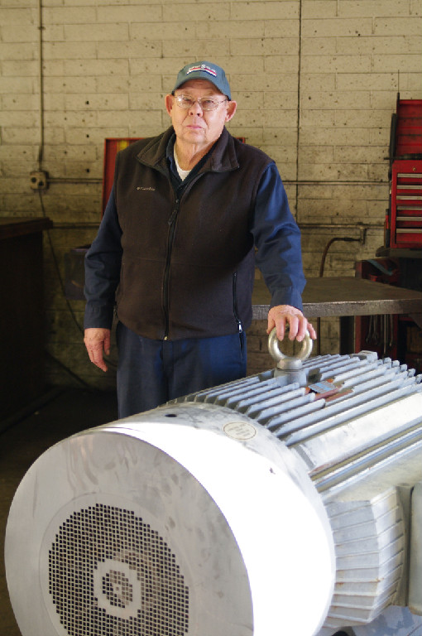
Photograph and profile by G.A. Villa. Copyright 2018 SNMTC.
When we focus our members' spotlight feature on Jerry Karr who joined within the past two years, we have an opportunity to highlight the fact that both long-time members and newer members of the Southern Nevada Model T Club enrich the club with their exceptional abilities. The Southern Nevada Model T Club is pleased to spotlight Mr. Karr.
Southern Nevada Model T Club member Jerry Karr brought his future abilities to the community of Blue Diamond, Nevada, from Grainsville, Idaho, in 1954 when he moved there with his parents. His dad worked mining gypsum at the Blue Diamond mine, and Jerry, having left his home town high school when the family moved, commuted to Las Vegas High School which was the only high school in the Las Vegas valley at that time. He modestly says that he had little direction in high school although he knew that he did have a perhaps undefined mechanical aptitude. Jerry finished high school in 1955, and with his father's help, he got a job at the Blue Diamond mine as an apprentice electrician. Jerry later went to work for Western Electric Motors in 1970, and in 1977 he was offered the business when the original owner decided to retire. Jerry bought the business, and his aptitude took it to considerable success as he had mastered the dynamics of restoring electric motors and maintaining and repairing the increasingly complex computerized welding equipment.
Mr. Karr explained during a tour of his Western Avenue facility that basically when restoring an electric motor, one end of the motor winding is cut off and extracted, and the motor is then put in a burn-out oven. This "baking" takes all the insulation and varnish off of the windings, and the windings are extracted in turn. The motor housing is then sandblasted, and the motor is then reinsulated and rewound. The slots in the motor where the windings lie are reinsulated by necessity as an important part of the process. The bearings in the motor are replaced, and the finished motor is repainted, re-varnished, and baked again to harden the insulation to a strong durability. Expert motor rewinding involves formulas that take into account wire size, the number of turns in a specific winding, types of connections, and slot sizes. This process is especially valuable for those customers who have specialty motors because refurbishing the motor is ultimately less costly than replacing it (specialty motors typically cost $2000 and more). The specialty motors are usually fractional horsepower equipment found in gearbox motors, little blowers, or in other applications where the motor is a component part of a larger piece of equipment. Once an electrical motor is in the 40 horsepower to 50 horsepower range and above, overseas manufacturers are often able to produce the motors for less than it would cost to refurbish the original equipment.
Western Electric Motors has serviced 1200-horsepower motors for borax mining operations in Nevada and large motors for elevators and hoists. He notes that they have maintained the 7000-pound 1000-horsepower electric motor that powers the fan for the Flyaway Indoor Skydiving attraction in Las Vegas. Mr. Karr notes, too, that motors under 1000 horsepower usually find application in rock crushers, air handlers, and are used to power the water pumps used by the Southern Nevada Water District. Jerry is pictured here with a 600-horsepower electric motor used in a rock crushing application.
Jerry attended the Lincoln Welding School at various times from 1980 to 1985 where he learned to service and repair welding equipment. Western Electric Motors has also served as a distributor for Baldor Welding Equipment, Lincoln Welding Equipment, and Miller Welding Equipment, and Mr. Karr mentioned all of this as an introduction to the fact that his son Mike is now the resident expert on the maintenance and repair of welding equipment for Western Electric Motors. One welding unit was opened and displaying, for this interviewer, a befuddling array of electronics and circuit boards with Mike Karr nearby and ready to apply his expertise. Daughters Tedi and Terry also work at Western Electric Motors with their brother Mike, and son Jimmy is a City Center engineer who does electrical and mechanical maintenance. The extended Karr family includes five grandchildren with fraternal twins.
Jerry and son Mike began their car rebuilding earlier with restorations of a 1966 Ford Mustang and a 1967 Chevrolet Camaro. In the past year, Jerry bought a 1926 Ford Fordor body and a rolling chassis to begin the restoration of his Model T Ford. Like other first-time Model T Ford restorers, Jerry admits that the process involves a good amount of learning as one goes, but he taps the extraordinary knowledge of the other Southern Nevada Model T Club members and marvels at the fact that they are able, among other things, to reproduce window parts no longer available. Jerry, in turn, helps with refurbishing Model T electric coils and parts in an ongoing demonstration of the generous give-and-take among club members.
Jerry Karr lends a positive presence to his time at the club, and the Southern Nevada Model T Club appreciates and welcomes his fellowship.

