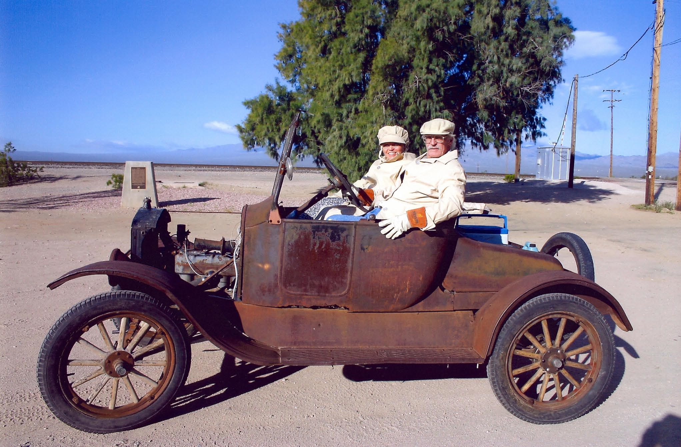
DeDe and Frog LaGrow, Mojave California Model T Tour, April 9, 2005. Photograph by John T. Craft. Copyright John T. Craft and SNMTC 2018. Profile by G.A. Villa, copyright G.A. Villa and SNMTC 2018.
Frog and DeDe LaGrow found their treasured 1925 Ford Model T Roadster in Mr. LaGrow's brother's backyard in 1985 in Salt Lake City. It was well protected with a covering of leaves and had a tree branch growing through a space between the engine and the frame. Brushing off the leaves and removing the tree branch, the LaGrow's made the car their own.
Subsequently while out on a Saturday morning in Henderson, Nevada, they saw a gathering of Model T Fords, and they approached the group and met and talked with Model T devotee Gary Cooper. Encouraged by Mr. Cooper and inspired in part by the Imperial Palace antique auto collection, the LaGrow's became part of the charter member group that worked to establish the Southern Nevada Model T Club. DeDe now shares the Tourmaster duties with John Warren and is alsois now a regular contributor to the Southern Nevada Model T Club newsletter, T Driver, with her column "Under DeDe's Hat." Ms. LaGrow writes about the fashions that were in vogue during the heydays of the Model T Ford, and she offers recipes to enliven the club members' kitchens. Included are her discussions of food prepared in the Model T cookers which attach to the exhaust manifold and cook food while the driver and passengers find their way to a destination.
DeDe was the Quest Diagnostics courier department trainer for more than a decade before retiring, and Frog was a miner in the United States for 30 years before his retirement. Mr. LaGrow's final stint as a miner was doing preconstruction tunneling work at the Nevada Test Site.
Frog and DeDe's car has become a signal vehicle in the club and represents the remarkable durability of Henry Ford's Model T cars. Mr. and Mrs. LaGrow add their considerable sartorial dignity and social good graces to the car and the club with each drive.

