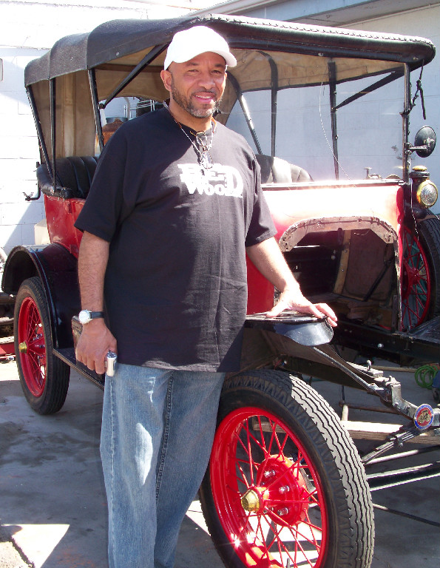
Pat Black was born in Mansfield, Ohio, and his interest in engines began there when he was about 10 years old. Pat began working on lawn mower engines and chain saw engines that were the common power plants for the go carts which he enjoyed as a youngster. He continued to grow in his knowledge of things mechanical through high school, and as a young married man with a new family, he served in the U.S. Air Force in Germany as a heavy equipment operator from 1976 to 1980. In addition to operating loaders, bulldozers, and dump trucks, Pat would be called upon to tow GI cars that had been impounded for more than 90 days to a junk yard. The entrepreneur in Pat found extra money for his growing family by salvaging Volkswagen parts for resale, and he learned Volkswagen mechanics in the atmosphere of German thoroughness and careful engineering.
Mr. Black developed skills to round out his mechanical expertise: he learned welding and bodywork and became a custom fabricator. In 1971 he built a Bradley GT with a gel coat body that was based on a Volkswagen chassis. Over the past two and one-half years, Pat has begun to transfer his considerable ability to the repair and overall of Model T Fords (note the missing engine and transmission in the picture!). He bought this Model T Ford from the wife of past Southern Nevada Model T Club President Jerry Tabor, and Pat speaks appreciatively of the late Mr. Tabor's generosity and friendship and knowledge of Model T Fords.
Mr. Black is a master plumber and cooling systems expert who before he retired, oversaw the Department of Real Property Management, Facilities Division, as a Maintenance Supervisor for Clark County, Nevada.
Mr. Black's expertise and his good fellowship are two of his many strengths that the Southern Nevada Model T Club is fortunate to add to its resume.
Photograph and profile by G.A. Villa. Copyright G.A. Villa and SNMTC 2018.

