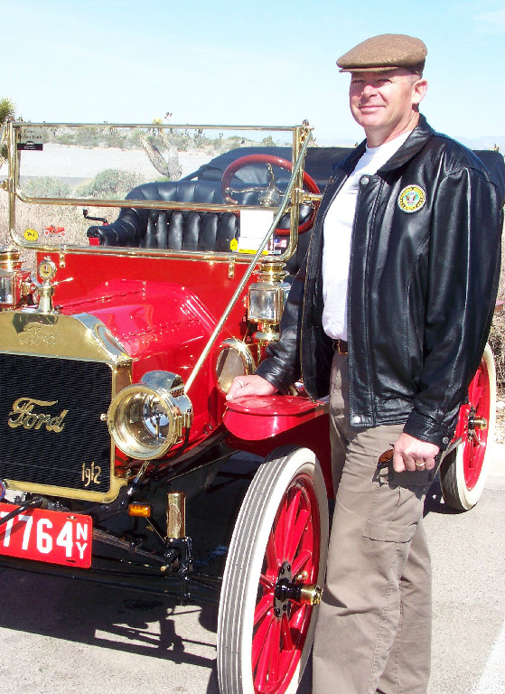

Bill and Mayra Carpenter met while they were both serving in the United States Army at Ft. Benjamin Harrison, Indiana. Their 27-year marriage is highlighted by their remarkable accomplishments and their ongoing public service.
Bill retired from the United States Army after 36 years of service, and he was actually hired by the Las Vegas Metropolitan Police Department (LVMPD) prior to his discharge as the G3 (Operations) Sergeant Major in the 311th Expeditionary Support Command. He has retired from the LVMPD after 20 years. Mayra retired from the United States Army after 20 years of service in supply, recruiting, and administration; she now works for the Nevada Department of Public Safety as a Pre-Sentence Investigation Writer for the courts. Recently, Mayra completed her Master's Degree in Emergency Management.
Bill and Mayra have reared four children: Rebecca, Joshua, Daniel, and Amanda. Their daughter Amanda is now a United States Army Captain in the Medical Corps. Captain Cousins (nee Carpenter) is a physician at Walter Reed Medical Center.
A schooled, careful, knowledgeable craftsman who did coursework in engine rebuilding at McPherson College, Bill rebuilt the engine, transmission, and drive train of the exquisite 1912 Ford Touring car that is in the picture here. Over a period of some years, Bill also rebuilt a 1915 Royal Mail Roadster, a 1927 Chevrolet Roadster that he salvaged from an Iowa junk yard. He also owns a 1929 Ford Model A. An avid motorcyclist, his collection includes a 1967 Superhawk, a 1970 Triumph Bonneville, a 1983 Goldwing, and a 1994 Kawasaki KLX. Not one to be limited by time, Bill also is a clock builder, a skier, and a scuba dive master! Mayra enjoys reading and collects original vinyl LPs as part of her love of music.
It would be impossible not to hope that everyone will have an opportunity to see Bill's magnificent red 1912 Ford Touring car. The Southern Nevada Model T Club is proud to have Bill and Mayra as members.
Photograph and profile by G.A. Villa. Copyright G.A. Villa and SNMTC 2018.

