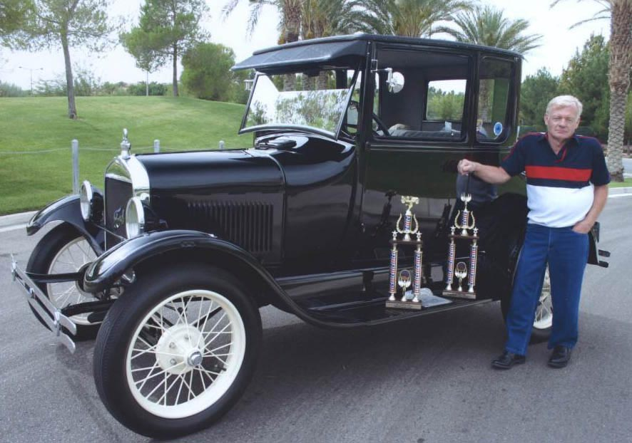
Terry Handy served as the Southern Nevada Model T Club Vice President for 2012; he was also Vice-President in 2003 and 2010 and club President in 2004 and in 2011. Born and raised in the flatlands of Kansas in Garden City, Terry found his way to Southern Nevada when he came to visit an older brother in 1975. A gifted master tradesman and electrician and mechanic, Terry's talents earned him a position in Las Vegas as a slot machine technician and eventually as a slot administrator, positions that he held for a total of 32 years. Things electrical and mechanical and adventuresome have occupied his interests genuinely: he built and enjoyed Garden Railroading for ten years and also built and flew fixed wing remote controlled model airplanes for more than ten years. He often flew the planes with other enthusiasts in Jean, Nevada, at the Dry Lake. A true "car man," Terry owned and maintained and raced Superstock Mopar Plymouths on local drag racing circuits in 1963, 1964, and 1965. The factory-built Plymouths were very popular at that time, and Terry turned 105.6 mph in the quarter mile in one of his cars. It could be said that Terry rode a train into the Southern Nevada Model T Club as he shared his Garden Railroading hobby with John Craft who introduced him to the Model T and had him drive his car a few times. Terry says that with that he was "hooked," and he bought his own Model T and became an avid owner and driver. Terry is respected as a gentleman, a knowledgeable and savy Model T owner, and his beautifully maintained cars are a club treasure. Terry owns a 1926 Model T Ford Coupe and a 1927 Model T Roadster Pickup.
Profile by G.A. Villa. Copyright G.A. Villa and SNMTC 2018.

