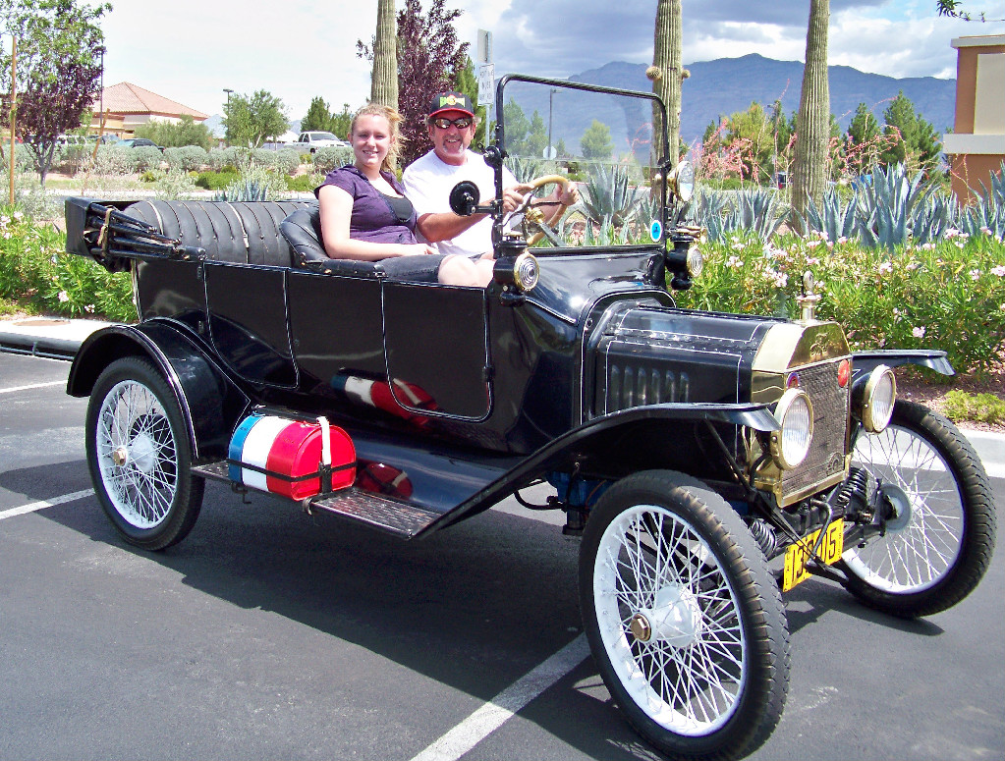
Mike Hill and his daughter, Brittany, in the family 1915 Ford Touring car. Photograph and profile by G.A. Villa. Copyright G.A. Villa and SNMTC 2010.
Mike Hill's grandfather restored the 1915 Ford touring car pictured here over the course of one year, completing it in 1954. It is a highly modified car capable of speeds up to 100 MPH, and the set up of the car includes a three-speed Warford transmission and a two-speed Ruckstell transmission. The T-Go head on the car was engineered by the late Jim Culbert in San Diego, California, and it is used in this car as it was used in the replica Ford Indy racers built by Culbert. Mike's granddad gave him the car, and it is a perfect fit with Mike's love of high performance and speed.
Among Mike's car projects are a T-Bucket hot rod "12-pack" (the car had six deuces or two-barrel carburetors); a 1968 Corvette; a 1970 Challenger 440 Magnum RT/SE (Road and Track Special Edition); and a 1970 Nova S 396 four speed. During his time in Sacramento County, California, Mike raced his cars on a drag strip that a friend had legitimate access to after hours. He was always pushing for more horsepower and speed, and Mike would "wreck" an engine and rebuild it for more speed and durability and blow it again and rebuild it. Such is the enjoyment of an unintimidated, grease-up-to-the-elbows mechanic who grew up in a family that has over 40 cars including a 1940 or 1941 12-cylinder Lincoln Convertible and a 1939 12-cyclinder Packard Limousine that got the needed mechanical and restoration attention they needed from various family members.
Brittany appears in the picture here, and she is one of three daughters that include Jacqueline and Kelly (and two grandchildren). Mike is a Southwest Gas Customer Service technician with important responsibilities including legal-speed responses to suspected and real gas detection alarms. Mike matter-of-factly and kindly notes that he was a professional bowler in 1975, 1976, and 1977 and that he bowled ten 300 games in his career!
He is obviously a gifted mechanic, a gifted athlete, and a welcome friend in the Southern Nevada Model T Club.

