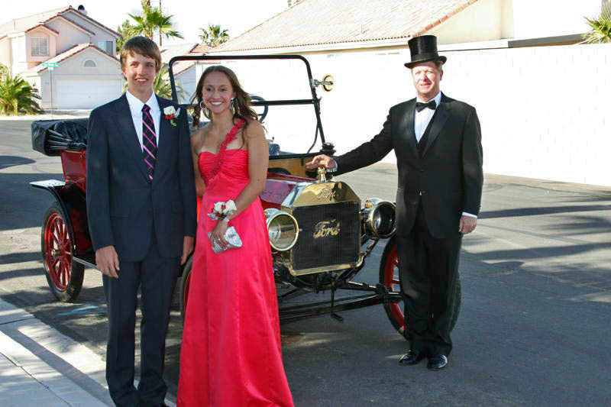
Christian Kolberg stands ready with his 1914 Ford Model T Touring car to chauffeur Camille, the Kolberg family's Brazilian foreign exchange student, and her escort . Photograph courtesy of the Kolberg family. Copyright the Kolberg family and SNMTC 2010. Profile by G.A. Villa, SNMTC.
Wallace and Christian Kolberg inherited the 1914 Ford Model T Touring car in this picture from Wallace's dad (Christian's granddad). The elder Mr. Kolberg bought the car at a flee market and restored it to such splendor that it became a featured part of not only the annual Southern Nevada Helldorado Day Parade, but also of William Harrah's annual antique car tour. The cars in the Harrah's tour drove to various locations in Nevada with a semi-truck following. The truck was outfitted with complete repair and parts support, and if a car broke down, it was loaded onto the semi where mechanics would repair it while moving and ready it for a return to the road at the next stop! Certainly, that is a high standard of road service. Wallace also drove the car with Christian and wife Lara from the church following their wedding to their reception site. Christian notes that the car also broke down during that trip but was readily repaired and delivered the couple with characteristic elegance to their waiting family and friends.
Christian decided recently that he wanted to share that elegance with the Kolberg family Brazilian foreign-exchange student, Camille, as she prepared for an important high-school formal event. The car, however, was not working, and Christian found his way to the Southern Nevada Model T Club and the expertise of two of its master mechanics, Gary Cooper and Harold Mann. Mr. Cooper and Mr. Mann were under the car and out in fairly short order, and the car was ready for its important appointment.
Wally Kolberg brings a distinguished executive resume to the Southern Nevada Model T Club as a retired Southwest Gas Corporation executive with 43 years of service. He also brings a near life-long interest and expertise in fountain pens which began simply enough as a high-school and college student who was given a gift pen and took him to the present day as a recognized expert and collector who travels extensively to share his expertise and to deal in rare pens. Christian, in turn, was the Las Vegas Review Journal marketing director for about 15 years with his natural talent for positive public relations enfolding the additional duty of working for the Donald Reynolds charitable foundation and serving on the Board for that organization for 7 years. A gifted speaker and a genuinely compassionate and public-service minded man, Christian's career path took him to that of a charity benefits auctioneer. His auctioneering involves work throughout North America where he adds finesse and dignity to celebrity and public and private charitable events.
Not surprisingly, his wife of 15 years, Lara (pronounced "Laura") has served the National Multiple Sclerosis Society in an executive capacity. They met during his travels as an auctioneer, and when Mr. Kolberg was asked to describe his wife, he said simply "beautiful" in such a way as to make clear that that adjective carried a strong spiritual significance. Lara and Christian have two sons ages 8 and 10 who are noted for their love for old cars.

