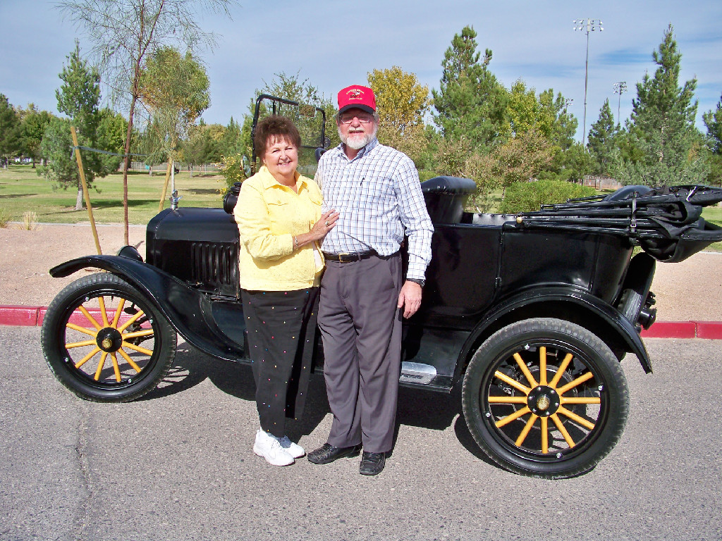
Sharon and Bob Larson, November 6, 2010, with their 1918 Model T Ford. Photograph and profile by G.A. Villa. Copyright G.A. Villa and SNMTC 2018.
Bob and Sharon Larson represent a kind of self-determination that is always admirable and that, in the world of today, is increasingly rare.
Sharon made a career for herself as a paralegal who works as a legal reader and respected legal office jack-of-all trades for attorneys in probate law and estate planning. Work of this sort requires not only people skills and office skills but also knowledge of the law and its practical applications in the responsibility-heavy world of the attorneys she serves, and Sharon has honed her talents in this field over the many years of her work. Sharon is at the pleasant juncture in her career where she works part-time as a paralegal, and she now spends more time tending to her one-half acre of gardens and her interests in Queen Anne/Victorian artifacts and her collections of toys and violins. Bob would probably say that her greater role has been as his wife of 52 years during which he shared his wisdom with hers.
Bob attended the University of Utah and graduated in 1969 with a degree in Art. He later served as a draftsman and as an architectural apprentice for 13 years before sitting for a two-day, nine-part examination to qualify as a licensed commercial architect
Our good fortune of having Bob and Sharon as members of the Southern Nevada Model T Club is based on a similarly patterned step-at-a-time, intriguing story in which the remarkable founding member Gary Cooper again plays a part.
Bob began collecting Model T parts throughout Utah when he was 16 years old: he bought a Model A Ford with the intention of scouring the desert roadside for parts. He found mostly Model T parts, and he actually built the car pictured here from the parts he found in the desert or purchased. He found an old sheep wagon which was a kind of covered wagon built on a Model T frame, and the wheels came with that frame. A journey to Pine Valley, Utah, turned up an old five-foot diameter sawmill blade that was powered by a Model T engine and transmission, and Bob bought those integral parts for $50. The radiator came with that find, and there is a touch of nature in the fact that it was had been used by squirrels for storage, and it was full of nuts. Other searches turned up fenders, etc., and the body of the Larson's car was found alongside the road, too, full of bullet holes. Bob met founding member Marvin Ray from whom he bought the seat springs, and he and the late member Marvin Robinson worked with wood plans to rebuild the frames of their respective Model T's.
Gary Cooper, a piano tuner by occupation, had come by to tune the Larson piano, and Bob found him out in the yard with his head and hands under the hood of his 1918 Model T adjusting the carburetor. Bob Larson says that unquestionably the car ran better after Gary's unexpected work on the car.
Bob is also a painter and watercolorist who has also handcrafted five violins as if a further demonstration of his considerable skills were needed after assembling a 1918 Model T Touring car essentially from catch-as-catch-can parts.
Both Bob and Sharon are kind, good people to talk to, and the Southern Nevada Model T Club is grateful for their skills, their friendship, and their devotion to their storied Model T Ford.

