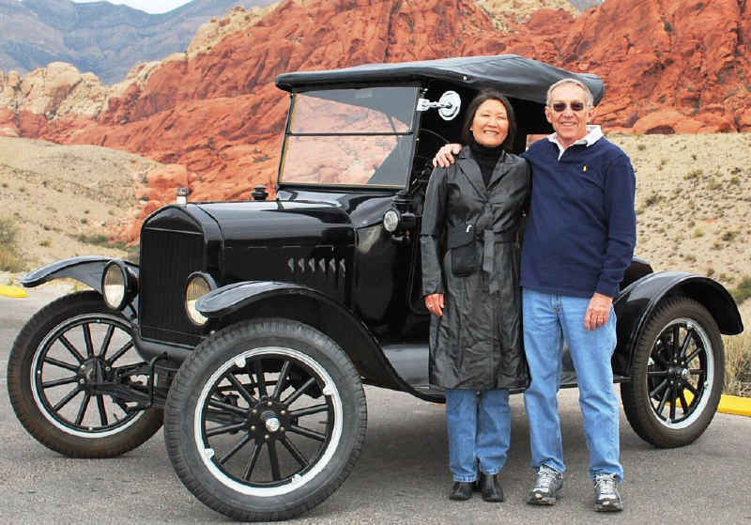  
Photograph by Terry Handy, November 2011.  Copyright Terry Handy and SNMTC, 2018. 

PRESIDENT 2018

Frank Ross is our President in 2018.  
  
Frank and his wife, Suk Hi Ross met and married in 1988. They have four adult children and three grandchildren.

They are both retired from the United States Air Force and enjoy living in Las Vegas and the activities of the Southern Nevada Model T Club.

Frank found their 1923 Ford Runabout in Puyallap, Washington in July, 2007 and taught himself to drive it. Since it was already in pretty good mechanical shape when he bought it, he has gradually replaced and repaired many of the little things that needed work including the windshield, windshield posts and frames, radiator, water pump, wood-spoke wheels, tires, ignition switch, interior upholstery, top and wheel bearings. Suk Hi loves the Model T and helps with repairs and likes to ride "shotgun" whenever she can.  She was especially helpful in mounting the tires on the split-rims, a job not for the faint of heart.