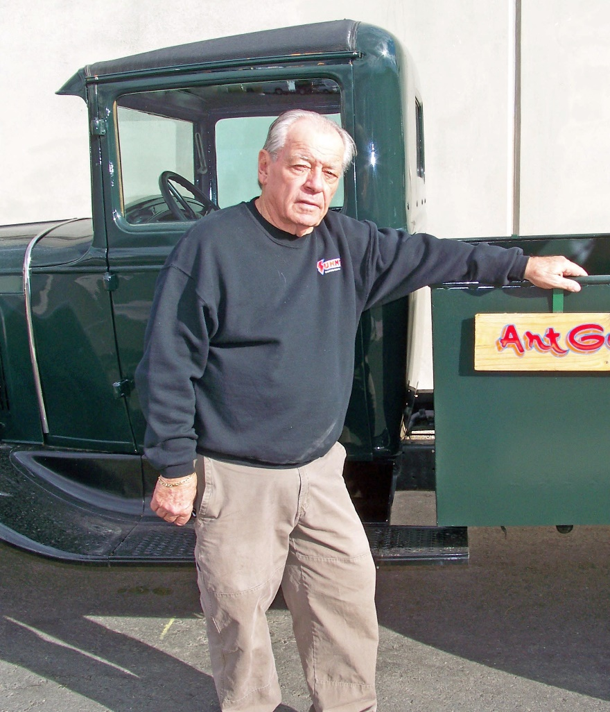

Art Goldstrom is a long-time member and supporter of the Southern Nevada Model T Ford Club. Art’s collection is housed under the title of Nostalgia Street Rods, Home of Art and Shirley's Private Car Collection, and it is difficult to visit the showroom and museum without emerging with a better sense of the history of diners and signs and automobiles of different eras (the particular work of his daughter, Sheri, who also organized the museum). The showroom includes carefully restored 1932 and 1940 Fords, Model T's (both original and those converted to hot rods or impressive street machines), and an unrestored but excellent 1910 Sears (a catalog car), among others. Mr. Goldstrom's abiding interest in cars is, by his own admission, with horsepower and drag racing. The collection includes more than 100 cars, many crafted with painstaking and detailed beauty, and many that are artifacts of particular eras. Included touchingly is a small slingshot dragster that his granddaughters drove at 90 mph when they were young. There is also wry humor in the Goldstrom collection in the form of not only a powerful eight-cylinder "wheelchair" with dragster capability that was presented to him on a birthday (he does not need a wheelchair), but also a Zamboni that has gone from the usual four cylinders to eight making it more suitable for drag racing than for resurfacing ice. There is even a small jet-powered slingshot dragster that Art advises would be unwise to sit in and drive. The range of automotive artifacts is so extensive and unusual that one can only note that common to almost all of them is the internal combustion engine. Included is an early Maytag washing machine powered by a gasoline engine! Mr. Goldstrom has many cars and trucks in storage awaiting restoration and others undergoing restoration now. In memory of Art's mother who suffered from Parkinson's disease, Art is devoted to helping to raise money in support of research about and care for those with the disease. Art is pictured here with one of his truck restorations.
Photograph and profile by G.A. Villa. Copyright G.A. Villa and SNMTC 2018.

