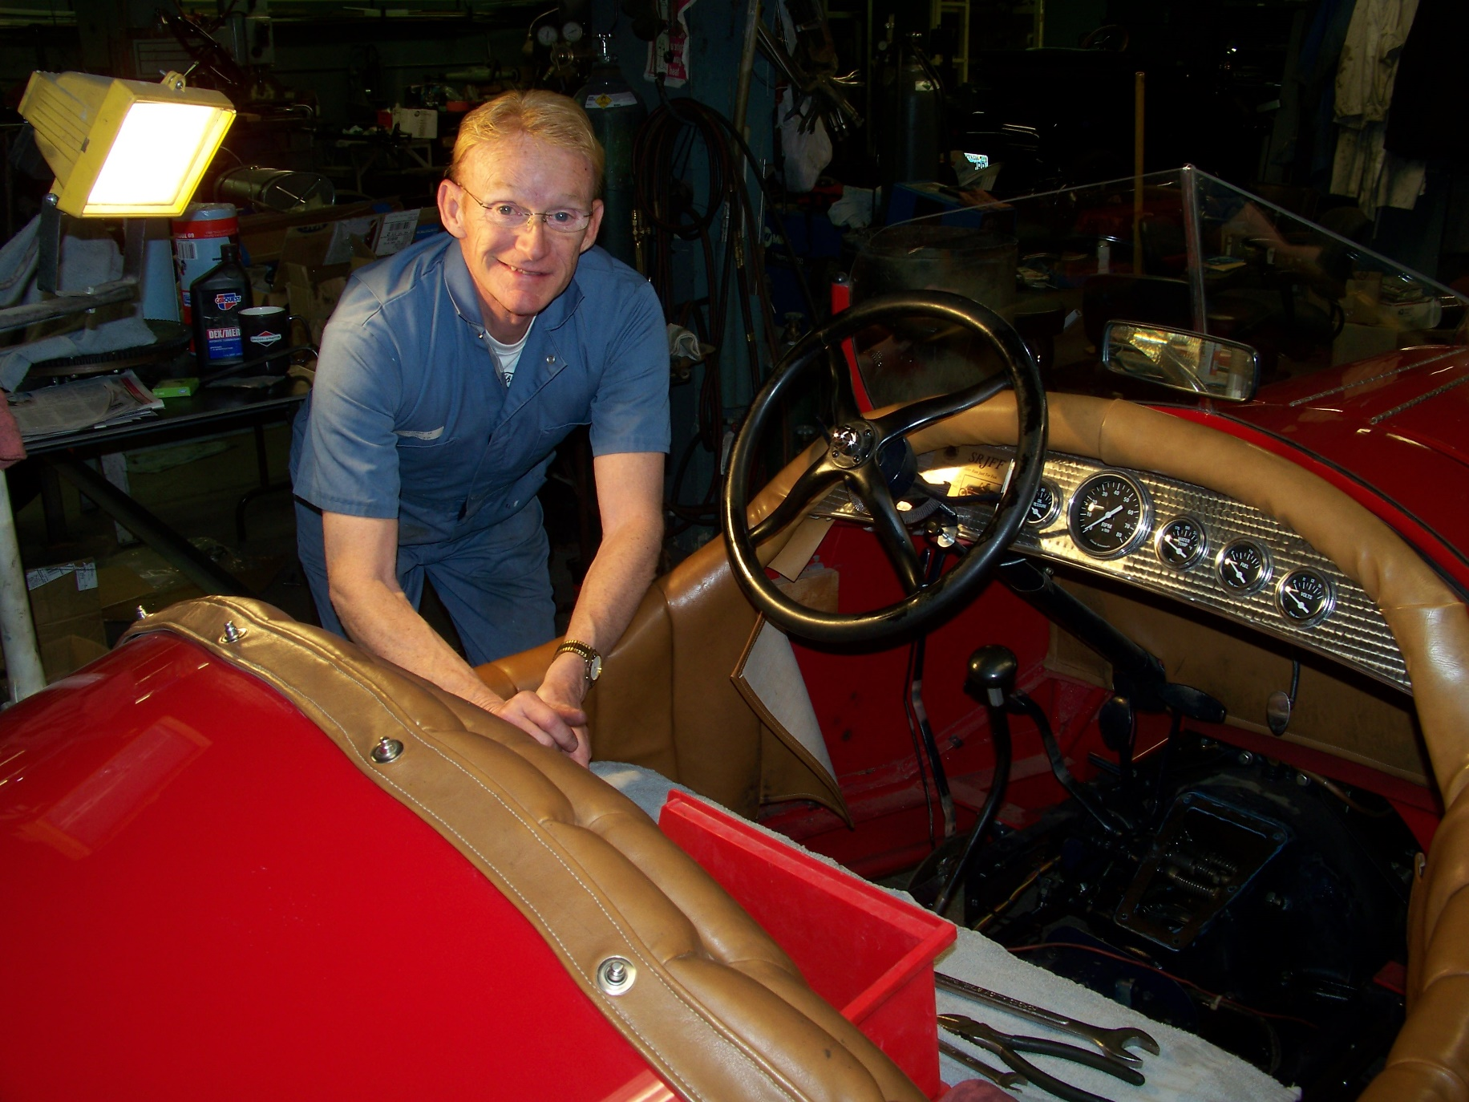
Dennis Rutkoskie working on his Model T frame and modified T transmission speedster. Photograph and profile by G.A. Villa. Copyright G.A. Villa and SNMTC 2018.
Dennis Rutkoskie's journey into a passion for collecting automobiles began in his early years in Kalamazoo, Michigan, where he attended Central High School. It was not long after he graduated from high school that Dennis began selling cars for a Kalamazoo Cadillac-Mercedes Benz dealership where he had six successful years. A consummately casual and thoughtful man, Dennis recognized the need to explore other opportunities, and he left the auto dealership and started his own insurance agency which his business talent took to considerable success. His insurance business in St. Joseph, Michigan, was licensed in all states east of the Mississippi, and he served large apartment projects, condominiums, and shopping centers among other commercial clients in that large geographical area. In 1999, Mr. Rutkoskie sold his business and moved to St. George, Utah, where he returned to his earlier career by joining as a partner in John Oreno's Garage which features "reasonable used cars and trucks" and "classic and antique autos." Dennis later became and continues as the sole owner of that business. Dennis and his wife Jackie and his son (who he notes has no interest in cars) live in a home in St. George, Utah, which is near a 10,500 square foot garage that he built to house his approximately 26 cars: three Model T's, three Model A's, five Cadillacs (1937, 1949, 1955, 1958, and 1964), a 1954 Ford wrecker, a 1948 chevy, and 1957 Lincoln, a 1948 Crosly, and a 1952 Kaiser, among others. The picture in this profile tells an accurate tale: Dennis is a knowledgeable and skilled mechanic whose primary interest is in racing whether it is the beautiful red, handcrafted speedster seen here and which he still races (more recently in Monterey, California, and New Mexico) or Corvettes or Mercedes SL sportscars which he raced from 1985 to 2000.
Dennis' common sense, automotive knowledge, and gentleman's demeanor are always a good addition to any meeting of club members. It is a privilege to have him as a Southern Nevada Model T Club colleague.

