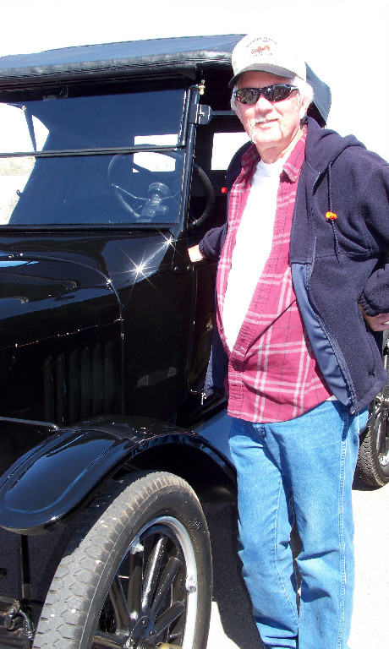
Photograph and profile by G.A. Villa. Copyright G.A. Villa and SNMTC 2010.
The car in this photograph was purchased by Denny Shaeffer's then 12-year-old cousin, Nolan, in the 1940's, and Denny says that his cousin "ran the car into the ground." Another of Denny's cousins offered to rebuild and restore the car if Nolan would pay for the parts, and Nolan agreed. One important part of the car was missing originally, and Nolan and his dad had driven to Oatman, Arizona, where by chance they found a deck in the desert. They decided to take it home with them to see if it would fit on their Model T. It fit perfectly and was the correct trunk for the car; a locksmith made a key for the lock, and the deck and key became part of the later restoration effort.
When Nolan passed away, his son inherited the car, and not knowing what to do with it, he sold it. Denny quickly found the car's new owner and bought it back to keep it in the family. The car has been in the Kingman, Arizona, area since its original purchase in the 1940's, and it is now firmly a part of the Shaeffer family history there.
Denny himself was born in Kingman, Arizona, where his dad worked as a mechanic at the Ford Testing Grounds in Yucca, Arizona. After he graduated from Mohave County Union High School in Kingman, Denny attended and graduated from a two-year community college program with an A.A. degree in "propulsion technology." Mr. Shaeffer notes that this was a label given to courses about internal combustion automobile engines at the time!
In November, 1972, Mr. Shaeffer joined his dad at the Ford Testing Grounds in Yucca as a test driver and mechanic. Later he was an engineering technologist who wrote reports on the prototype Ford cars that included a wide range of data (e.g., fuel economy and oil economy) for the cars from zero miles to 27,000 miles. He was again promoted to work in the instrument laboratory where he worked with pressure transducers and sensors on the cars in order to measure temperatures of the various components in the cars; in this job he was responsible for programming computers, assembling the data, and forwarding it to Dearborn, Michigan, for the Ford Motor Company. Mr. Shaeffer retired in 2007 after 34 years.
Denny speaks with pride of his two sons who have continued the mechanical and motor legacy of the family as an auto restorer and as a diesel mechanic.
It's always good to see Denny pull in from his trip from Kingman, Arizona, to join us for a Saturday morning drive and breakfast.

